Student ID number: ______________________________________

Instructions
- This exam is conducted under the Rice Honor Code. It is a closed-notes, closed-book exam.
- Fill in your name on every page of the exam.
- If you forget the name of a Java class or method, make up a name for it and write a brief explanation in the margin.
- You are expected to know the syntax of defining a class with appropriate fields, methods, and inheritance hierarchy. You will not be penalized on trivial syntax errors, such as missing curly braces, missing semi-colons, etc, but do try to write Java code as syntactically correct as possible. We are more interested in your ability to show us that you understand the concepts than your memorization of syntax!
- Write your code in the most object-oriented way possible, that is, with the fewest number of control statements and no checking of the states and class types of the objects involved.
- For each algorithm you are asked to write, 90% of the grade will be for correctness, and 10% will be for efficiency and code clarity.
- You have up to three hours to complete the exam.

Please State and Sign your Pledge:

1.) 10 | 2.a) 10 | 2.b) 5 | 2.c) 10 | 2.d) 10 | 2.e) 15 | 2.f) 5 | 3.a) 5 | 3.b) 10 | 3.c) 5 | 3.d) 15 | TOTAL 100

- (10 pts) Spies and Codes: Back in the glory days of the Cold War, spies from the West and the East lurked about in a never ending game of cat-and-mouse. To keep their communications secret, each spy would have a code book that would enable him/her to encode or decode their latest secret messages. But since codes were constantly being cracked, the spies would need to change their code book quite often to insure that they had the latest, “un-crackable” code. Since each side was constantly spending millions of dollars or rubles to break each other’s codes, the new codes would often have radically different implementations to keep the other side from figuring them out.

Design a system of interface(s) and classes that represents the relationship between a spy and their code books, including the fact that the code book may be changed from one implementation to another.

Draw the corresponding UML class diagrams and indicate which design patterns are being used.

Your UML diagram should clearly show at least the following:
- Name of the class or interface
- Notes as to whether or not a class or method is abstract.
- Only a simple example of the sort of methods that might be on the classes, with an indication as to what they would be used for.
- DO NOT GO INTO GREAT DETAIL WITH REGARDS TO METHODS AND FIELDS!
Use comment boxes to indicate the various design patterns in the diagram.

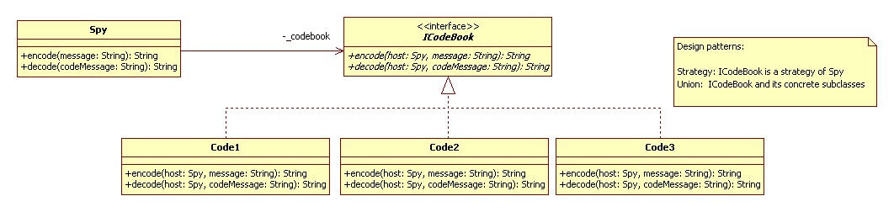

Also, interpretor pattern if you consider this to be a degenerate case where there is no recursion.
- (55 pts total) 3-Way Switches: A “3-way switch” is a configuration of switches that are used in houses and buildings to enable a person to switch a light on or off from two different locations. The wiring consists of two switches that can direct the current to/from a single terminal or wire from/to one of a pair of terminals. Below are two possible configurations for the 2 switches, resulting in a lamp being either on or off:
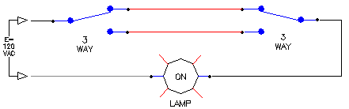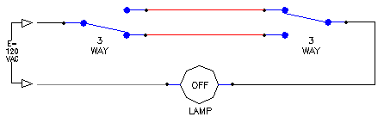
There two more possible switch configurations, left up/right down and left down/right down, that result in the lamp being off and on respectively.
To model this in Java, we run into a few restrictions and impose a few simplifications (reference the code on the following pages).
- Unlike real switches, information only flows one way through code, so we have to model the switch on the left, a 1-to-2 terminal switch (One2TwoSwitch), separately from the switch on the right, a 2-to-1 terminal switch (Two2OneSwitch).
- A 1-to-2 terminal switch (One2TwoSwitch) takes a wire input on the left and has two output terminals, one that the input wire connects to when the switch is “up” and the other that the input wire connects to when the switch is “down”.
- In order to distinguish the upper wire in the middle, which connects to the upper (“up”) terminal on the left-hand switch, from the lower wire, which connects to the lower (“down”) terminal on the left-hand switch, we are forced to use two different classes (SwitchUpWire and SwitchDownWire respectively).
- A 2-to-1 terminal switch (Two2OneSwitch) takes 2 wires as inputs and is equivalent to a single wire on its output. The voltage on the output is equal to the wire connected to the “up” terminal wire when the switch is “up” or the voltage on the “down” terminal wire when the switch is “down”.
- The 120 VAC input can be replaced with a battery (= a device that produces a voltage). The battery (Battery) is effectively just a wire that has a fixed voltage on it.
- The entire 3-way switch assembly (ThreeWaySwitch) can be modeled as a single entity that accepts a wire in (on the left) and results in a wire (on the right).
- To see if the lamp is on or off, we can simply measure the voltage on the wire coming out of the right side of the whole 3-way switch assembly (ThreeWaySwitch.getVoltage()).

package elec;  /**  * A 3-way switch system has two 2-way switches, switch A  * and switch B, that can be set UP or DOWN independently.  * A 3-way switch has one input wire and one output wire.  * The voltage on the output wire depends on the voltage of the  * input wire and how the 2-way switches are set.  */  public class ThreeWaySwitch implements IWire{  private One2TwoSwitch switchA;  private Two2OneSwitch switchB;  /**  * Constructor for the class  * @param inputWire The input wire to the 3-way switch  */  public ThreeWaySwitch(IWire inputWire) {  switchA = new One2TwoSwitch(inputWire);  IWire wireUp = new SwitchUpWire(switchA);  IWire wireDown = new SwitchDownWire(switchA);  switchB = new Two2OneSwitch(wireUp, wireDown);  }  /**  * Set switch A to UP  */  public void setSwitchAUp() {  switchA.setUp();  }  /**  * Set switch A to DOWN  */  public void setSwitchADown() {  switchA.setDown();  }  /**  * Set switch B to UP  */  public void setSwitchBUp() {  switchB.setUp();  }  /**  * Set switch B to DOWN  */  public void setSwitchBDown() {  switchB.setDown();  }  /**  * Get the voltage on the output wire  */  public int getVoltage() {  return switchB.getVoltage();  }  } | package elec;  /**  * Represents a wire that is  * connected to something and has  * one free end.  */  public interface IWire {  /**  * Get the voltage on the free end of the wire  */  public int getVoltage();  }
package elec;

/**
* Interface that represents a switch that
* can be set to either a UP or DOWN state.
*/
public interface ITwoWaySwitch {
/**
* Set the switch to its UP state
*/
public void setUp();
/**
* Set the switch to its DOWN state
*/
public void setDown();
}
package elec;

/**
* Represents a battery with an output wire.
* The ground wire is implicit, so only
* one wire is defined.
*/
public class Battery implements IWire {
/**
* The battery's voltage
*/
private int _voltage;

/**
* Constructor for the class
* @param voltage The voltage of this battery
*/
public Battery(int voltage) {
_voltage = voltage;
}

/**
* Get the voltage from the battery's output wire
*/
public int getVoltage() {
return _voltage;
}
}

package elec;  /**  * Represents a switch with one input wire and  * two output terminals.  * When the switch is UP, the input wire is connected  * to the UP output terminal.  * When the switch is DOWN, the input wire is  * connected to the DOWN output terminal.  */  public class One2TwoSwitch implements ITwoWaySwitch{  /**  * The input wire to the switch  */  private IWire inputWire;  /**  * The current state of the switch  */  private AOne2TwoSwitchState state = new One2TwoSwitchUpState();  /**  * The constructor for the class  * @param wire The input wire to the switch  */  public One2TwoSwitch(IWire wire) {  inputWire = wire;  }  /**  * Set the switch to UP  */  public void setUp() {  state = new One2TwoSwitchUpState();  }  /**  * Set the switch to DOWN  */  public void setDown() {  state = new One2TwoSwitchDownState();  }  /**  * The voltage on the UP Terminal  */  public int getVoltageUp() {  return state.getVoltageUp(inputWire);  }  /**  * The voltage on the DOWN terminal  */  public int getVoltageDown() {  return state.getVoltageDown(inputWire);  }  } | /**  * Abstract state of the switch  */  abstract class AOne2TwoSwitchState {  /**  * Gets the output voltage on the UP terminal  * @param wire The input wire to the switch  */  abstract int getVoltageUp(IWire wire);  /**  * Gets the output voltage on the DOWN terminal  * @param wire The input wire to the switch  */  abstract int getVoltageDown(IWire wire);  }
/**
* UP state of the switch
*/
class One2TwoSwitchUpState extends AOne2TwoSwitchState {
/**
* returns the voltage on the input wire
*/
int getVoltageUp(IWire wire) {
return wire.getVoltage();
}

/**
* Returns 0 volts, always (disconnected)
*/
int getVoltageDown(IWire wire) {
return 0;
}
}

/**
* DOWN state of the switch
*/
class One2TwoSwitchDownState extends AOne2TwoSwitchState {
/**
* Returns 0 volts, always (disconnected)
*/
int getVoltageUp(IWire wire) {
return 0;
}

/**
* returns the voltage on the input wire
*/
int getVoltageDown(IWire wire) {
return wire.getVoltage();
}
}

package elec;  /**  * Represents a switch that has two input wires  * and one output wire  * When the switch is UP, the wireUp is connected  * to the output wire.  * When the switch is DOWN, the wireDown is  * connected to the output wire.  */  public class Two2OneSwitch implements ITwoWaySwitch, IWire{  /**  * The UP input wire  */  private IWire wireUp;  /**  * The DOWN input wire  */  private IWire wireDown;  /**  * The current state of switch  */  private ATwo2OneSwitchState state = new Two2OneSwitchUpState();  /**  * Constructor for the class  * @param wireUp The wire that is connected  * when the switch is UP.  * @param wireDown The wire that is connected  * when the switch is DOWN.  */  public Two2OneSwitch(IWire wireUp, IWire wireDown) {  this.wireUp = wireUp;  this.wireDown = wireDown;  }  /**  * Set the switch to UP  */  public void setUp() {  state = new Two2OneSwitchUpState();  }  /**  * Set the switch to DOWN  */  public void setDown() {  state = new Two2OneSwitchDownState();  }  /**  * Get the voltage on the output wire  */  public int getVoltage() {  return state.getVoltage(wireUp, wireDown);  }  } | /**  * Abstract state of the switch  */  abstract class ATwo2OneSwitchState {  /**  * Returns the voltage on the output wire of the switch  * @param wireUp The UP input wire  * @param wireDown The DOWN input wire  */  abstract int getVoltage(IWire wireUp, IWire wireDown);  }
/**
* UP state of the switch
*/
class Two2OneSwitchUpState extends ATwo2OneSwitchState {
/**
* Returns the voltage on the UP input wire
*/
int getVoltage(IWire wireUp, IWire wireDown) {
return wireUp.getVoltage();
}
}

/**
* DOWN state of the switch
*/
class Two2OneSwitchDownState extends ATwo2OneSwitchState{
/**
* Returns the voltage on the DOWN input wire
*/
int getVoltage(IWire wireUp, IWire wireDown) {
return wireDown.getVoltage();
}
}

package elec;  /**  * A wire that connects from the UP terminal of  * a One2TwoSwitch  */  public class SwitchUPWire implements IWire {  /**  * The switch the wire is connected to  */  private One2TwoSwitch one2TwoSwitch;  /**  * The constructor for the class  * @param the One2TwoSwitch whose UP terminal  * this wire connects to.  */  public SwitchUpWire(One2TwoSwitch one2TwoSwitch) {  this.one2TwoSwitch =one2TwoSwitch;  }  /**  * The voltage on the UP terminal of  * the One2TwoSwitch  */  public int getVoltage() {  return one2TwoSwitch.getVoltageUp();  }  } | package elec;  /**  * A wire that connects from the DOWN terminal of  * a One2TwoSwitch  */  public class SwitchDownWire implements IWire {  /**  * The switch the wire is connected to  */  private One2TwoSwitch one2TwoSwitch;  /**  * The constructor for the class  * @param the One2TwoSwitch whose DOWN terminal  * this wire connects to.  */  public SwitchDownWire(One2TwoSwitch one2TwoSwitch) {  this.one2TwoSwitch =one2TwoSwitch;  }  /**  * The voltage on the DOWN terminal of  * the One2TwoSwitch  */  public int getVoltage() {  return one2TwoSwitch.getVoltageDown();  }  }
- (10 pts) UML Diagram: Draw a UML diagram of the following classes ONLY: Two2OneSwitch, ATwo2OneSwitchState, Two2OneSwitchUpState, and Two2OneSwitchDownState. Include all fields and methods!

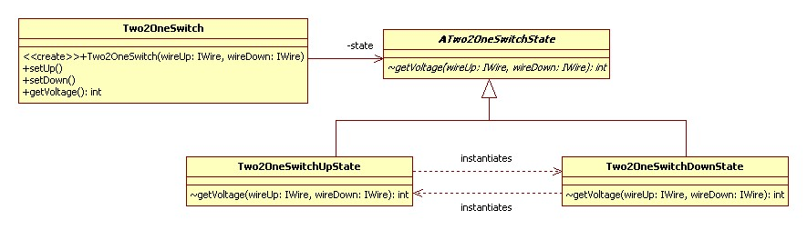

- (5 pts) What design pattern(s) best describes the UML diagram in part a above? Explain your reasoning.

Strategy design pattern: ATwo2OneSwitchState is a strategy for Two2OneSwitch to determine its output voltage. (Extra info: Since the strategy is entirely encapsulated by its context, this is actually a State design pattern.)
Union design pattern: Divides the invariant abstract state, ATwo2OneSwitchState, from the variant concrete states, Two2OneSwitchUpState and Two2OneSwitchDownState.

Also, Interpretor pattern if you consider this to be a degenerate case where there is no recursion.

- (10 pts) UML Diagram: Draw a UML diagram that include the following classes ONLY: ThreeWaySwitch, One2TwoSwitch, Two2OneSwitch, SwitchUpWire, SwitchDownWire. ITwoWaySwitch and IWire. Omit all field names and methods from your drawing (just include all inheritance and composition lines)!
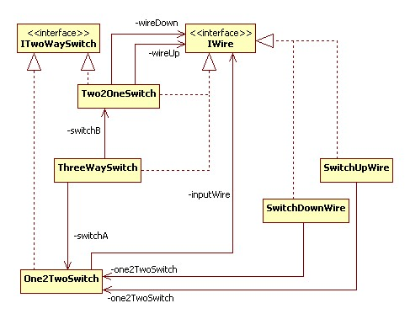

- (10 pts) Tracing the Delegations: Suppose one instantiates a ThreeWaySwitch object as follows:
ThreeWaySwitch a3waySwitch = new ThreeWaySwitch(new Battery(120));
Then we then “read” the output voltage as follows
int outputVoltage = a3waySwitch.getVoltage();
Trace the path of delegation from one object to another that will result in the final value for outputVoltage. Describe what class every object is and what method is called on the next object (give the name of the field). What is the value of outputVoltage?
  - a3waySwitch.getVoltage() delegates to switchB.getVoltage(), where switchB is a an instance of Two2OneSwitch.
  - Two2OneSwitch.getVoltage() delegates to state.getVoltage(), where state is an instance of Two2OneSwitchUpState.
  - Two2OneSwitchUpState.getVoltage() delegates to wireUp.getVoltage(), where wireUp is an instance of SwitchUpWire.
  - SwitchUpWire.getVoltage() delegates to one2TwoSwitch.getVoltageUp(), where one2TwoSwitch is a One2TwoSwitch.
  - One2TwoSwitch.getVoltageUp() delegates to state.getVoltageUp(), where state is an instance of One2TwoSwitchUpState.
  - One2TwoSwitchUpState.getVoltageUp() delegates to wire.getVoltage(), where wire is inputWire, a Battery.
  - Battery.getVoltage() returns 120 for the battery that was instantiated.

Thus the outputVoltage is 120.
- (15 pts) Test Outputs: Complete the following table:
Executed code: | Console output:
ThreeWaySwitch a3waySwitch = new ThreeWaySwitch(new Battery(120));  System.out.println(“Voltage = “+a3waySwitch.getVoltage()); | “Voltage = 120”
a3waySwitch.setSwitchADown();  System.out.println(“Voltage = “+a3waySwitch.getVoltage()); | “Voltage = 0”
a3waySwitch.setSwitchAUp();  System.out.println(“Voltage = “+a3waySwitch.getVoltage()); | “Voltage = 120”
a3waySwitch.setSwitchBDown();  System.out.println(“Voltage = “+a3waySwitch.getVoltage()); | “Voltage = 0”
a3waySwitch.setSwitchADown();  System.out.println(“Voltage = “+a3waySwitch.getVoltage()); | “Voltage = 120”
a3waySwitch.setSwitchAUp();  System.out.println(“Voltage = “+a3waySwitch.getVoltage()); | “Voltage = 0”

- (5 pts) Does It Work?: So, does this system of classes properly model a real 3-way switch system’s ability to turn a light on or off from either of two switches? Explain your reasoning.
Yes it does work. All 4 states of the switches are represented, where Up/Up and Down/Down both result in the light being on (120 Volts out) and both Up/Down and Down/Up have the lamp off (0 Volts output).
- (35 pts total) List Processing: The following problems refer to the code given at the end. Fill in the missing sections of that code with your answers (adding any fields and/or methods as deemed necessary).
  - (15 pts total) Backwards Printing of a List: Given a list, write the methods necessary to get the list to return a string with all of the String representations of its elements, but in backwards order.
IList aList = new NEList(“a”, new NEList(“b”, new NEList(“c”, new NEList(“d”, MTList.Singleton))));
String result = aList.backwards();
gives result = “dcba”.
Note: this is NOT the same as reversing a list! There are two ways of writing the algorithm however.

You are to write the method String backwards() that returns the a String with the list’s elements in backwards order.

  - (20 pts total) Mapping a Lambda over a List: It is often very useful to process every element of a list identically and create a new list with those processed values. For example, one might multiply every element of a list by some value or get some specialized String representation of every element of a list. But the processing of the list itself has some invariant qualities that are independent of whatever we are doing to the elements of the list. That is consider some generic, “f(x)”, then we can say that in general, we have the following process:

(x₀, x₁, x₂, x₃, x₄, …) ➔ (f(x₀), f(x₁), f(x₂), f(x₃), f(x₄), …)

independent of whatever f(x)is or does.

This process is called “mapping” and the name given to the generic function, f(x), is “lambda function”. We would describe the above as “mapping a lambda over the list”. “Map” is what is referred to as a “higher order function” because it is a function that takes another function as an input parameter.

To model a lambda function in Java, we define an interface ILambda (see the code on the following pages) that has only one method, Object apply(Object x), that takes in an Object and returns an Object. We called the method “apply” because a common way of describing the use of a lambda function is to say that we “apply the lambda”, which means to execute the function on some given input value.

Thus, if lambda is an ILambda implementation, then f(x) is the same as lambda.apply(x).

A couple examples of ILambda implementations and their usages with map are given on the following pages.

You are to write the method IList map(ILambda lambda) that returns a new list with the given lambda function applied to every element.

//--------------------------------------------------------------------------------
package fp;

/**
* Represents an abstract “lambda” function that takes an object as an input parameter,
* processes it and returns an object.
*/
public interface ILambda {
public abstract Object apply(Object x);
}

//--------------------------------------------------------------------------------
/**
* An example of a lambda function that multiplies the input object, assumed to be an integer,
* by a specified multiplier.
* Example usage: aList.map(new Multiplier(42));
* This will return a new list with every element multiplied by 42, for example:
* (2, -1, 10) ➔ (84, -42, 420)
*/
public class MultiplyBy implements ILambda{
private int _multiplier;

public MultiplyBy(int multiplier) {
_multiplier = multiplier;
}

public Object apply(Object x) {
return _multiplier*(Integer) x;
}
}

//--------------------------------------------------------------------------------
/**
* An example of a lambda function that adds a specified String onto the front of the String
* representation of the given object.
* Example usage: aList.map(new AddString(“The value is “));
* This will return a new list with every element a String of the form
* “The value is “+_first.toString():
* (2, -1, 10) ➔ (“The value is 2”, “The value is -1”, “The value is 10”)
*/
public class AddString implements ILambda{
private String _stringToAdd;

public AddString(String stringToAdd) {
_stringToAdd = stringToAdd;
}

public Object apply(Object x) {
return _stringToAdd + x.toString();
}
}

//--------------------------------------------------------------------------------
package listFW;
import fp.*;

/**
* Represents the abstract list structure.
*/
public interface IList {

/**
* Return a String with the String representations of all the elements
* in reverse order.
*/
public abstract String backwards();

/**
* Alternate solution to backwards
*/
public String backwards_alt();

public String backwards_alt_help(String acc);

/**
* Applies the given lambda on every element of the list, returning a new list
* with the new values. That is, the new first values are lambda.apply(_first).
*/
public abstract IList map(ILambda lambda);

}

//-----------------------------------------------------------------------------------
package listFW;
import fp.*;

/**
* Represents empty lists.
*/
public class MTList implements IList {

// Singleton Pattern
public final static MTList Singleton = new MTList();
private MTList() {
}

/**
* What is the String representation of an empty list, backwards?
*/
public String backwards() {
// Part a) STUDENT TO COMPLETE (5 pts)
return “”;
}

public String backwards_alt() {
return “”;
}
public String backwards_alt_help(String acc) {
return acc;
}

/**
* What is a lambda applied to every element of an empty list?
*/
public IList map(ILambda lambda) {
// Part c) STUDENT TO COMPLETE (5 pts)
return this;
}
}

//-----------------------------------------------------------------------------------
package listFW;
import fp.*;

/**
* Represents non-empty lists.
*/
public class NEList implements IList {
private Object _first;
private IList _rest;

/**
* Initializes this NEList to a given first and a given rest.
* @param f the first element of this NEList.
* @param r the rest of this NEList.
*/
public NEList(Object f, IList r) {
_first = f;
_rest = r;
}

/**
* Return a String with the String representations of all the elements
* in reverse order.
*/
public String backwards() {
// Part b) STUDENT TO COMPLETE (10 pts)

return _rest.backwards() + _first.toString();

}

public String backwards_alt() {
return _rest.backwards_alt_help(_first.toString());
}

public String backwards_alt_help(String acc) {
return _rest.backwards_alt_help(_first.toString()+acc);
}

/**
* Applies the given lambda on every element of the list, returning a new list
* with the new values. That is, the new first values are lambda.apply(_first).
*/
public IList map(ILambda lambda) {
// Part d) STUDENT TO COMPLETE (15 pts)

return new NEList(lambda.apply(_first), _rest.map(lambda));

}

}

