Student ID number: ______________________________________

Instructions
- This exam is conducted under the Rice Honor Code. It is a closed-notes, closed-book exam.
- Fill in your name on every page of the exam.
- If you forget the name of a Java class or method, make up a name for it and write a brief explanation in the margin.
- You are expected to know the syntax of defining a class with appropriate fields, methods, and inheritance hierarchy. You will not be penalized on trivial syntax errors, such as missing curly braces, missing semi-colons, etc, but do try to write Java code as syntactically correct as possible. We are more interested in your ability to show us that you understand the concepts than your memorization of syntax!
- Write your code in the most object-oriented way possible, that is, with the fewest number of control statements and no checking of the states and class types of the objects involved.
- For each algorithm you are asked to write, 90% of the grade will be for correctness, and 10% will be for efficiency and code clarity.
- You have two hours and a half to complete the exam.

Please State and Sign your Pledge:

1.a) 10 | 1.b) 10 | 2.a.i) 5 | 2.a.ii) 10 | 2.a.iii 15 | 2.b.i) 5 | 2.b.ii) 20 | 3.a) 10 | 3.b) 15 | TOTAL 100

- (20 pts total) Consider the following sequence of pictures which show a fractal called a “Sierpinski Gasket” of increasing “order”:

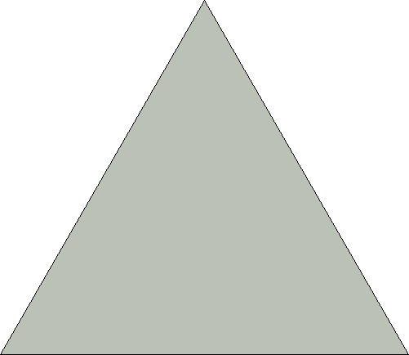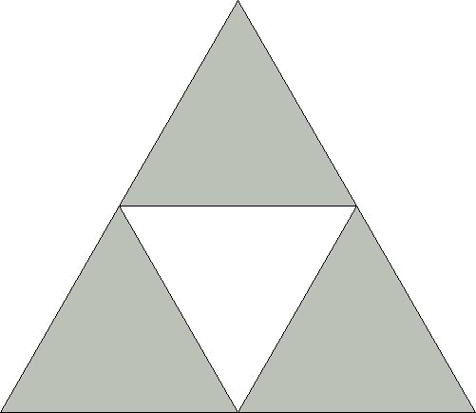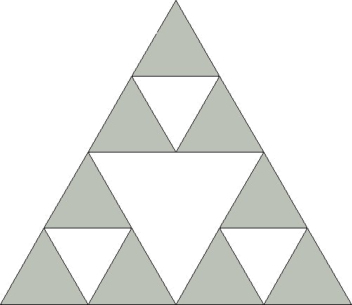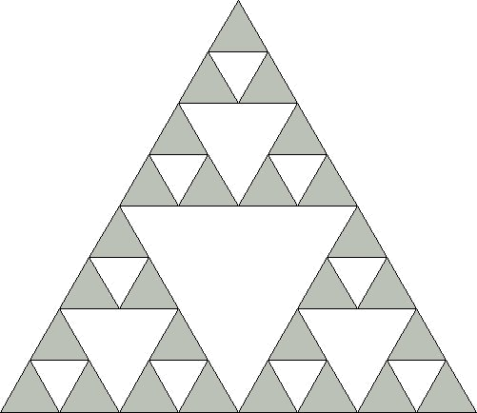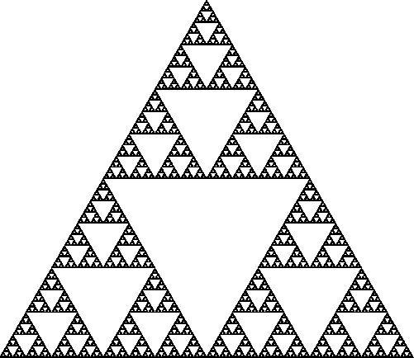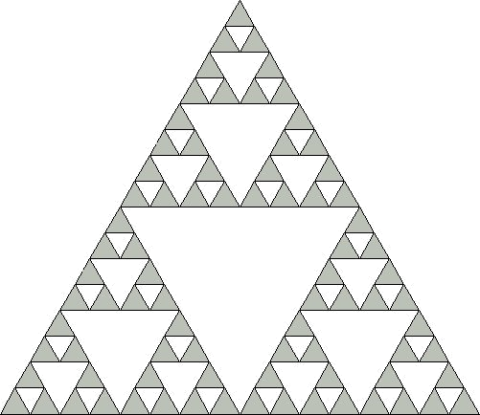
etc., etc.
Order 0
Order 1
Order 2
Order 3
Order infinity
Order 4

  - (10 pts) Draw a UML diagram that shows a system of class(es)/interface(s) that could be used to model the above pictures.

Your system should be able to represent any of the above pictures if one or more objects were instantiated from the classes in your system, including a picture with an arbitrarily large number of triangles in it.

Your UML diagram need not show any methods or fields, just classes (and interfaces, if needed) plus inheritance and composition lines.

Hints:
- Don’t worry about the size of a triangle, assume that the size is simply some private field value somewhere and that thus, anything can be any size it needs.
- Consider what the difference between the first and second pictures above. What is the relationship between those two pictures?
- Ask yourself, “how are the second and third pictures alike”?
- How can you describe all the other pictures in terms of your observations about the first three pictures?
- Think simple! Look for a solution with a minimum number of classes!

Use the next page for your UML diagram ➔

Draw your UML diagram here:

ISierpinski
BaseSierpinski
InductSierpinski
3

  - (10 pts) In a few short of sentences, describe all the design patterns used in your design for part a). For each of the patterns, clearly explain your reasons for using it.

Answer:

Union pattern: describes how the abstract ISierpinski represents any of the concrete drawings, BaseSierpinski and InductSierpinski.

Composite pattern: Describes how the InductSierpinski is really made up of 3 other abstract Sierpinski gaskets. A Sierpinski gasket is a recursive data structure.

- (20 pts total) Algorithms on a list:

  - (10 pts total) Multiplying a list: Implement a method of an IList called “multiplyBy” that returns a new list where all the elements of the original list were multiplied by the given int value (assume the list holds integers).

For instance, given listA = (5, -7, 2)

listA.multiplyBy(-3) ➔ (-15, 21, -6)

    - (5 pts) What does MTList.Singleton.multiplyBy(42) return?

Answer: It returns the empty list, e.g. this or MTList.Singleton.

    - (10 pts) In the space provided in the code on the next page, write the code for to make MTList a singleton.

    - (10 pts) Fill in the rest of the code on the next page for multiplyBy:

Write your code on the next page ➔

public interface IList {
public abstract IList multiplyBy(int x);
}

public class MTList implements IList {
Write singleton code here:

Answer:
public static final MTList Singleton = new MTList();

private MTList() {
}

public IList multiplyBy(int x) {
// STUDENT TO FILL IN CODE HERE
Answer:
return this;

}
}

public class NEList implements IList {
private Object _first;
private IList _rest;
public NEList(Object first, IList rest) {
_first = first;
_rest = rest;
}
public IList multiplyBy(int x) {
// STUDENT TO FILL IN CODE HERE

Answer:

return new NEList((Integer)_first*x,
_rest.multplyBy(x));

}
}
  - (25 pts total) Zipping a list: Implement a method of an IList called “zip” that weaves two ILists together like a zipper.

Here are the specifications of the zip method:

aList zipped with anotherList (an IList), i.e. aList.zip(anotherList), returns the following:

when aList is an MTList:

returns anotherList.

when aList is a NEList:

returns a new NEList whose first is aList’s first and whose rest is anotherList zipped with the rest of aList.

For instance, given

listA = (a, b, c)
listB = (1, 2, 3, 4, 5)

listA.zip(listB) ➔ (a, 1, b, 2, c, 3, 4, 5)
listB.zip(listA) ➔ (1, a, 2, b, 3, c, 4, 5)

Suppose mt is an MTList.

mt.zip(listA) ➔ (a, b, c)

- (5 pts) From the above specifications of zip, and using the above definition of listA as a NEList and of mt as an MTList, what does listA.zip(mt)return?

Answer:

It returns listA, i.e. the list (a, b, c).

- (20 pts) Finish writing the code for the zip method below:

public interface IList {
public abstract IList zip(IList other);
}

public class MTList implements IList {

//ASSUME MTLIST IS A SINGLETON

public IList zip(IList other) {
// STUDENT TO FILL IN CODE HERE
Answer:
return other;

}
}

public class NEList implements IList {
private Object _first;
private IList _rest;
public NEList(Object first, IList rest) {
_first = first;
_rest = rest;
}
public IList zip(IList other) {
// STUDENT TO FILL IN CODE HERE

Answer:
return new NEList(_first,
other.zip(_rest));

}
}
- (25 pts total) Consider the following system of classes:

//--------------------------------------------------------------------------------
package timepiece;

public class DigitalWatch {
private AWatchState _state = new TimeState();

public void pressButton() {
_state.pressButton(this);
}

public String toString() {
return _state.toString(this);
}

void setState(AWatchState state) {
_state = state;
}
}
//--------------------------------------------------------------------------------
package timepiece;

abstract class AWatchState {
abstract void pressButton(DigitalWatch context);
abstract String toString(DigitalWatch context);
}
//--------------------------------------------------------------------------------
package timepiece;

class TimeState extends AWatchState{

void pressButton(DigitalWatch context) {
context.setState(new StopwatchState());
}

String toString(DigitalWatch context) {
return "The current time is…now.";
}
}
//--------------------------------------------------------------------------------
package timepiece;

class StopwatchState extends AWatchState{

void pressButton(DigitalWatch context) {
context.setState(new AlarmState());
}

String toString(DigitalWatch context) {
return "The time elapsed is…a positive value.";
}
}
//--------------------------------------------------------------------------------
package timepiece;

class AlarmState extends AWatchState{

void pressButton(DigitalWatch context) {
context.setState(new TimeState());
}

String toString(DigitalWatch context) {
return "WAKE UP!!!!";
}
}

//--------------------------------------------------------------------------------
- (10 pts) Draw a complete UML class diagram of the above system, including all fields and methods for every class shown. Be sure to show the proper access specifiers (e.g. public, private, etc).

Answer: (dependency lines not required)
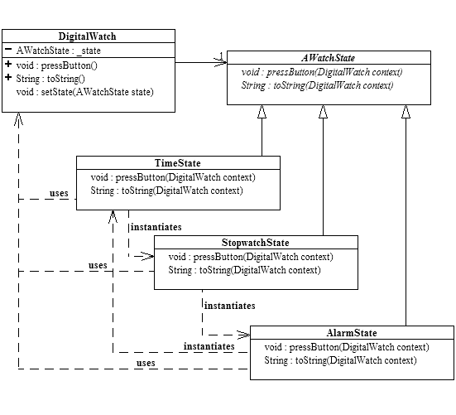

- (15 pts) What output will the following code produce? Why? Be specific and complete!

Operations executed in the following order: | Screen Output and reasons for that output:
timepiece.DigitalWatch watch =  new timepiece.DigitalWatch(); | No output to screen. New DigitalWatch instance being created.
System.out.println(watch.toString()); | Output: “The current time is…now.”  Defaults to TimeState.
System.out.println(watch.toString()); | Output: “The current time is…now.”  State hasn’t changed → same output.
watch.pressButton(); | No Output  State is changing to StopwatchState.
System.out.println(watch.toString()); | StopwatchState output: “The elapsed time is…a positive value.”
watch.pressButton();  System.out.println(watch.toString()); | Change state to AlarmState.  AlarmState output: “WAKE UP!!!”
watch.pressButton();  watch.pressButton();  System.out.println(watch.toString()); | Change state to TimeState.  Change state to StopwatchState.  Stopwatch state output: “The elapsed time is…a positive value.”

