Student ID number: ______________________________________

Instructions
- This exam is conducted under the Rice Honor Code. It is a closed-notes, closed-book exam.
- Fill in your name on every page of the exam.
- If you forget the name of a Java class or method, make up a name for it and write a brief explanation in the margin.
- You are expected to know the syntax of defining a class with appropriate fields, methods, and inheritance hierarchy. You will not be penalized on trivial syntax errors, such as missing curly braces, missing semi-colons, etc, but do try to write Java code as syntactically correct as possible. We are more interested in your ability to show us that you understand the concepts than your memorization of syntax!
- Write your code in the most object-oriented way possible, that is, with the fewest number of control statements and no checking of the states and class types of the objects involved.
- For each algorithm you are asked to write, 90% of the grade will be for correctness, and 10% will be for efficiency and code clarity.
- You have two hours and a half to complete the exam.

Please State and Sign your Pledge:

1.) 20 | 2.a.i) 5 | 2.a.ii) 5 | 2.a.iii) 5 | 2.b) 10 | 2.c) 15 | 2.d) 15 | 3.a) 10 | 3.b) 15 | TOTAL 100

- (20 pts) Ancestor Tree: An ancestor tree is a special type of family trees that keeps track of all known ancestors of a person. The following is the data definition of an ancestor tree.

- An empty ancestor tree is an ancestor tree.
- A non-empty ancestor tree is an ancestor tree that contains
  - a String representing the name of a person,
  - an int representing the year the person was born,
  - an ancestor tree for the person’s father, and
  - an ancestor tree for the person’s mother.

Design a system of interface(s) and classes that represent the above definition of ancestor tree. Your class design should make use of appropriate design patterns to model the recursive nature of the ancestor tree. Use the singleton pattern whenever appropriate.

Draw the corresponding UML class diagrams and indicate which design patterns are being used.

Your UML diagram should clearly show at least the following:
- All the fields with their types and accessibility (public, private, etc).
- All methods with their parameter lists and return types
- All field and method names should be self-explanatory
- All constructors with their parameter lists
- All private fields should have appropriate gettor accessor methods but not settors.
Use comment boxes to indicate the various design patterns in the diagram.

Answer:
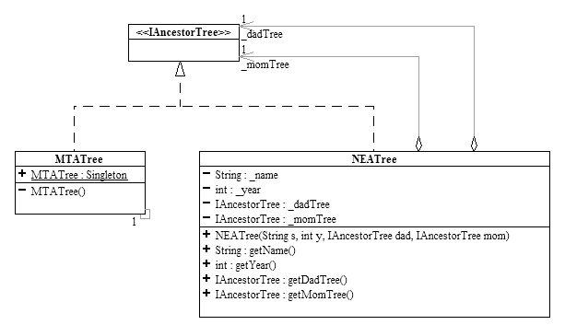

Union, Singleton, Composite Design patterns

- (20 pts total) Descendant Tree: Consider the following data definition of objects of type Person. A Person has a name, a birth year and a list of children, each of whom is a Person. The list of children may or may not be empty. Thus a Person is like a family tree where his/her children, the children of the children, etc represent all the descendants of this Person. Therefore a Person object represents the whole family tree starting from that person. The following is the UML class diagram that models Person. It is immutable by design and thus cannot have any circular reference.
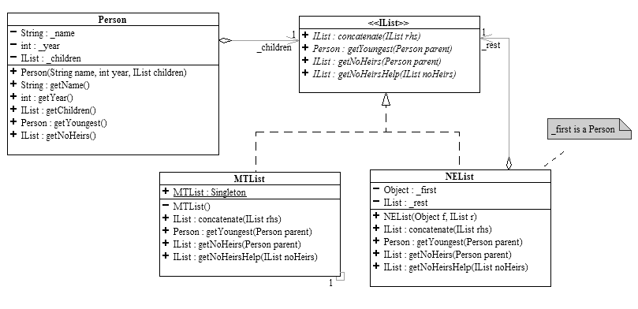
- In the following, write the code you would have written in DrJava’s Interactions pane to construct the following Person objects.
  - (5 pts) Define three variables named p1, p2, p3 each of which is a distinct Person without any children.
Answer:
Person p1 = new Person(“Frodo”, 1185, MTList.Singleton)
Person p2 = new Person(“Alf”, 1234, MTList.Singleton)
Person p3 = new Person(“Zeb”, 1100, MTList.Singleton)

  - (5 pts) Define a variable named p4 which is a Person with p1 and p2 as its two children. Suggestion: create the list of children first.
Answer:
IList kids = new NEList(p1, new NEList(p2, MTList.Singleton);
Person p4 = new Person(“Zeus”, 1000, kids)
  - (5 pts) Using p1, p2, p3, p4 from above, define a variable named p5 which is a Person with two children: one child has no children, the other has two children, each of whom does not have any children. All five Person objects must be distinct.

Answer:
IList children = new NEList(p3, new NEList(p4, MTList.Singleton);
Person p5 = new Person(“Venus”, 900, children)

In the supplied stub code on the following pages, read very carefully the specification given in the comments and
- (10 pts) Complete the method concatenate for IList and its concrete subclasses to append two lists together.
- (15 pts) Complete the method getYoungest for IList and its concrete subclasses to find and return the youngest Person in the given family tree.
- (15 pts) The method getNoHeirs for IList computes a list of all the Persons in the family tree that have no children. For example, p1.getNoHeirs() returns the NEList, (p1) and p5.getNoHeirs() returns the NEList, (p1, p2, p3). The code for getNoHeirs is given; it makes use of a helper method called getNoHeirsHelp. Complete the method getNoHeirsHelp for IList and its concrete subclasses. Carefully read the comments for both getNoHeirs and getNoHeirsHelp!

//-------------------------------------------------------------------------------------
package descendant;
import listFW.*;

/**
* A Person with his/her descendants.
*/
public class Person {
private String _name;
private int _year; // birth year

private IList _children; // contains younger Person objects if not empty.

public String getName() {
return _name;
}

public int getYear() {
return _year;
}

public IList getChildren() {
return _children;
}

/**
* Find and return the youngest Person in the whole family tree.
* If the Person has no children (i.e. empty children list), then
* return this Person as the youngest in the family.
* If there are more than one Person in the family with the same
* youngest age, return any one of them.
*/
public Person getYoungest() {
return _children.getYoungest(this);
}

/**
* Returns the list of all Person objects in this family tree that
* have no children.
*/
public IList getNoHeirs() {
return _children.getNoHeirs(this);
}
}

//--------------------------------------------------------------------------------
package listFW;
import descendant.*;

/**
* Represents the abstract list structure.
*/
public interface IList {

/**
* Append the input list to the end of this IList.
* For example, (a b c).concatenate((1 2)) returns the list (a b c 1 2).
* @param rhs the (right-hand-side) input list to be appended
* to this IList.
*/
public abstract IList concatenate(IList rhs);

/**
* Given a Person whose children list is this IList
* find and return the youngest Person in the whole family tree.
* If two or more Person objects in the family have the same
* youngest age, return any one of them.
* Assume the children (if any) in the list are all younger than the parent.
* @param parent the parent of this IList.
* @return the parent if the parent has no children, otherwise
* return the youngest one in the family tree.
*/
public abstract Person getYoungest(Person parent);

/**
* Given a Person whose children is this IList,
* return a list of Person objects in the family tree that have no children.
* If the given parent has no children then return an NEList containing only
* the parent.
* @param parent the Person whose children list is this IList.
* @return NEList
*/
public abstract IList getNoHeirs(Person parent);

/**
* Given a list of Person that have no children, compute and return the list
* that contains the given list and the list of Peson in this IList that
* have no children.
* @param noHeirs The IList so far containing the Persons with no children.
* @return An IList containing the Persons with no children.
*/
public abstract IList getNoHeirsHelp(IList noHeirs);
}

//-----------------------------------------------------------------------------------
package listFW;
import descendant.*;

/**
* Represents empty lists.
*/
public class MTList implements IList {

// Singleton Pattern
public final static MTList Singleton = new MTList();
private MTList() {
}

/**
* What does ().concatenate((5 6 8)) return?
* Do not recreate lists that need not be recreated.
* @param rhs the (right-hand-side) input list to be appended
* to this IList.
*/
public IList concatenate(IList rhs) {
//STUDENT TO COMPLETE

return rhs;

}

/**
* Hint: how many children does the input parent have?
* @param parent the parent of this IList.
* @return the parent if the parent has no children, otherwise
* return the youngest one in the family tree.
*/
public Person getYoungest(Person parent) {
//STUDENT TO COMPLETE

return parent;

}

/**
* The parent has no children in this case.
* @param parent the Person whose children list is this IList.
* @return NEList containing the parent only.
*/
public IList getNoHeirs(Person parent) {
return new NEList(parent, MTList.Singleton);
}

/**
* There are no more Persons to search.
* @param noHeirs The IList so far containing the Persons with no children.
* @return An IList containing the Persons with no children.
*/
public IList getNoHeirsHelp(IList noHeirs) {
//STUDENT TO COMPLETE

return noHeirs;

}
}

//-----------------------------------------------------------------------------------
package listFW;
import descendant.*;

/**
* Represents non-empty lists.
*/
public class NEList implements IList {
private Object _first;
private IList _rest;

/**
* Initializes this NEList to a given first and a given rest.
* @param f the first element of this NEList.
* @param r the rest of this NEList.
*/
public NEList(Object f, IList r) {
_first = f;
_rest = r;
}

/**
* Returns a new NEList which is a copy of this list
* with the input list appended to it.
* @param rhs the (right-hand-side) input list to be appended
* to this IList.
* @return NEList
*/
public IList concatenate(IList rhs) {
//STUDENT TO COMPLETE

return new NEList(_first, _rest.concatenate(rhs));

}

/**
* The parent has children in this case. The youngest Person may
* exist in either in the children of _first or in _rest.
* Assume the children (if any) in the list are all younger than the parent.
* @param parent the parent of this IList.
* @return the parent if the parent has no children, otherwise
* return the youngest one in the family tree.
*/
public Person getYoungest(Person parent) {

Person f = (Person)_first; //To eliminate further typecasting.

//Hint:
// Find the youngest in the children of f -- who is the parent here?
// Find the youngest in _rest -- who is the parent here?
// Compare the above results to return the youngest one.
//STUDENT TO COMPLETE

Person p1 = f.getYoungest();
Person p2 = _rest.getYoungest(parent);
return p1.getYear() < p2.getYear()? p1: p2;

}

// NEList CODE CONTINUES ON NEXT PAGE →
/**
* The parent has children in this case. Persons with no heirs may
* exist in both the parent's children and the rest of this list.
* Find the list of Person with no heirs in _first and passes on
* to _rest and ask for help to complete the job.
* @param parent the Person whose children list is this IList.
* @return NEList
*/
public IList getNoHeirs(Person parent) {
Person p = (Person)_first;
IList nh = p.getNoHeirs();
return _rest.getNoHeirsHelp(nh);
}

/**
* There may be Persons with no children in both _first and in _rest.
* @param noHeirs The IList so far containing the Persons with no children.
* @return An IList containing the Persons with no children.
*/
public IList getNoHeirsHelp(IList noHeirs) {

Person p = (Person) _first; // To eliminate further typecasting

//Hint:
// Concatenate the list of Persons with no children from _first
// with the given list.
// Use that result to process _rest.
//STUDENT TO COMPLETE

IList nh = p.getNoHeirs();
return _rest.getNoHeirsHelp(nh.concatenate(noHeirs));

}
}

- (25 pts total) TV and Remote: While rummaging through your attic you come across an old television and remote control. The TV is so old it appears to have only three channels, corresponding to three appropriately labeled buttons on the remote. Unfortunately, there is one button on the remote whose label has worn off and there is nothing to indicate its use. But, being the resourceful person you are, you take the remote control back to your lab and are able to decipher the internal code that run it. You discover that there is one main class, called TVRemote that has four public methods corresponding to the four buttons on the remote. TVRemote also has one method, “showChannel” that displays the current channel on the TV screen. In addition there are four other, non-public, classes that support the operation of the remote and TV. Your job is to determine the behavior of the remote control and TV by looking at the code that runs it.

package tv;  public class TVRemote {  private AChannel chan = Channel1.Singleton;  private AChannel prev = chan;  void setChan(AChannel c) {  chan = c;  }  AChannel getChan() {  return chan;  }  void setPrev(AChannel c) {  prev = c;  }  AChannel getPrev() {  return prev;  }  public void one() {  chan.one(this);  }  public void two() {  chan.two(this);  }  public void three() {  chan.three(this);  }  public void unknown() {  chan.unknown(this);  }  /**  * "Shows" the current channel on screen.  */  public void showChannel() {  System.out.println(chan.toString());  }  } | package tv;  abstract class AChannel {  abstract void one(TVRemote host);  abstract void two(TVRemote host);  abstract void three(TVRemote host);  void unknown(TVRemote host) {  host.setChan(host.getPrev());  host.setPrev(this);  }  }

package tv;  public class Channel1 extends AChannel {  static final Channel1 Singleton = new Channel1();  private Channel1() { }  void one(TVRemote host) {  }  void two(TVRemote host) {  host.setChan(Channel2.Singleton);  host.setPrev(this);  }  void three(TVRemote host) {  host.setChan(Channel3.Singleton);  host.setPrev(this);  }  public String toString() {  return "Channel 1";  }  } | package tv;  public class Channel2 extends AChannel {  static final Channel2 Singleton = new Channel2();  private Channel2() { }  void one(TVRemote host) {  host.setChan(Channel1.Singleton);  host.setPrev(this);  }  void two(TVRemote host) {  }  void three(TVRemote host) {  host.setChan(Channel3.Singleton);  host.setPrev(this);  }  public String toString() {  return "Channel 2";  }  }
package tv;

class Channel3 extends AChannel {

static final Channel3 Singleton = new Channel3();

private Channel3() { }

void one(TVRemote host) {
host.setChan(Channel1.Singleton);
host.setPrev(this);
}

void two(TVRemote host) {
host.setChan(Channel2.Singleton);
host.setPrev(this);
}

void three(TVRemote host) {
}

public String toString() {
return "Channel 3";
}
}

- (10 pts) Draw a complete UML class diagram of the above system, including all fields and methods for every class shown. Be sure to show the proper access specifiers (e.g. public, private, etc). To save time and space, you may omit the names of any implemented methods in the concrete subclasses. Also, simply write the word “abstract” next to anything that should be indicated as such.

Answer:

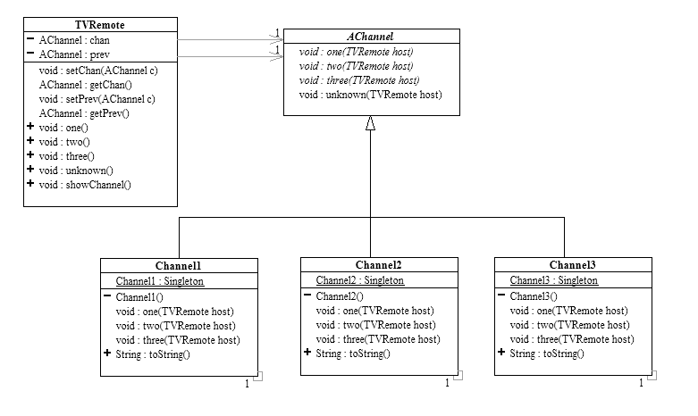

- (15 pts) What output will the following code produce? Why? Be specific and complete!

Operations executed in the following order: | Screen Output and reasons for that output:
TVRemote tvr = new TVRemote();  tvr.showChannel(); | Output: “Channel 1”  New instance of TVRemote is created. Defaults to channel 1.
tvr.three();  tvr.showChannel(); | Output: “Channel 3”  Internal state (as represented by the chan field) changes to Channel3
tvr.unknown();  tvr.showChannel(); | Output: “Channel 1”  State changes back to previous channel which was Channel1
tvr.unknown();  tvr.showChannel(); | Output: “Channel 3”  State changes back to previous channel which was Channel3
tvr.one();  tvr.unknown();  tvr.showChannel(); | Output: “Channel 3”  State changes first to Channel1 then back to previous channel which was Channel3
tvr.two();  tvr.unknown();  tvr.showChannel(); | Output: “Channel 3”  State changes first to Channel2 then back to previous channel which was Channel3
tvr.two();  tvr.one();  tvr.one();  tvr.unknown();  tvr.showChannel(); | Output: “Channel 2”  State changes first to Channel2 then to Channel1. Hitting Channel1 again does nothing, so then back to previous channel which was Channel2.

