Student ID number: ______________________________________

Instructions
- This exam is conducted under the Rice Honor Code. It is a closed-notes, closed-book exam.
- Fill in your name on every page of the exam.
- If you forget the name of a Java class or method, make up a name for it and write a brief explanation in the margin.
- You are expected to know the syntax of defining a class with appropriate fields, methods, and inheritance hierarchy. You will not be penalized on trivial syntax errors, such as missing curly braces, missing semi-colons, etc, but do try to write Java code as syntactically correct as possible. We are more interested in your ability to show us that you understand the concepts than your memorization of syntax!
- Write your code in the most object-oriented way possible, that is, with the fewest number of control statements and no checking of the states and class types of the objects involved.
- For each algorithm you are asked to write, 90% of the grade will be for correctness, and 10% will be for efficiency and code clarity.
- You have up to three hours to complete the exam.

Please State and Sign your Pledge:

1.a) 10 | 1.b) 5 | 2.a) 15 | 2.b) 5 | 2.c) 5 | 2.d) 15 | 3.a) 5 | 3.b) 15 | 3.c) 5 | 3.d) 20 | 3.e) 5 e/c | TOTAL 100

- (15 pts total) Electronics: Let us consider the relationships between the various parts of an electronic system, such as a computer and how we might model such a system in software.

First a few brief descriptions for those less familiar with these terms (Read these definitions carefully!):
- Resistors are circuit components that are used to regulate how much current passes through.
- Capacitors are circuit components that are used to temporarily store electrical charges.
- Transistors are circuit components that enable one voltage or current to control another current.
- Integrated circuits are circuit components that, internally, have interconnected resistors, capacitors, transistors and possibly other integrated circuits which are packaged into a single electronic component that can be used as if it were as single circuit component.
- Circuit boards have a collection of interconnected circuit components as well as possibly other circuit boards where those circuit components and circuit boards are used to perform various electronic operations for the circuit board that holds them.

  - (10 pts) Design a system of interface(s) and classes that represents the relationships between the parts of an electronic system: transistors, resistors and capacitors, integrated circuits and circuit boards.

Draw the corresponding UML class diagrams and indicate which design patterns are being used.

Your UML diagram should clearly show at least the following:
- Name of the class or interface, noting as to whether or not it is abstract.
- You are not required to add any methods to your classes unless you feel that it helps support your conclusions. DO NOT GO INTO GREAT DETAIL WITH METHODS AND FIELDS!
- You do not need to explicitly label any fields that are already indicated as a relationship.
Use comment boxes or the like to indicate the location of various design patterns in the diagram.

IComponent
IntegratedCircuit
CircuitBoard
Transistor
Capacitor
Resistor
Union Pattern
Composite Pattern
Strategy Pattern
Strategy Pattern

  - (5 pts) Adding a graphics card: If you buy a computer these days, internally, there is a circuit board, the “motherboard” that contains the central processing unit (“CPU”), memory and other support circuitry and components. Often the graphics circuitry is however on a separate circuit board that plugs into the motherboard. The motherboard hands tasks of taking data and creating the proper video signals from it to display on the monitor are given to the graphics board. But as new games and other graphics-demanding applications come out, it is common to replace the graphics board with a new one that is faster and that can handle more colors, more resolution and/or more monitors at once. In terms of applicable design patterns and the notions of variant and invariant, describe an object-oriented viewpoint of the relationship between the motherboard and the graphics board in a computer.

The graphics board is a strategy that the motherboard uses to display its video information. The motherboard invariantly uses an abstract graphics board. Each graphics board manufacturer implements that invariant interface in its own variant manner, which is the union design pattern.

- (40 pts total) Modeling Neurons: A neuron is a marvelous bio-electrical device that transmits the effect of a stimulus as a voltage pulse propagating down its length. Specifically, we will look at modeling the voltage pulse that travels down one of the elongated “arms” or “axons” of the neuron. (Note: The biology of a neuron has been greatly simplified in this problem to better illustrate the computer science concepts for this exam. Please do not treat this model as biologically accurate as given.)
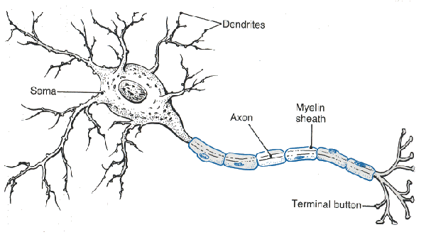
Figure 1: A typical neuron (from www.mindcreators.com/NeuronBasics.htm)
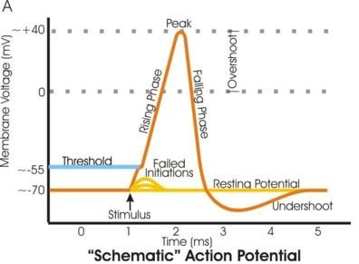
Figure 2: Voltage vs. time in a neuron’s axon (from en.wikipedia.org/wiki/Action_potential)
We will treat a neuron as an object of class Neuron that has the following simple behaviors (methods):
- stimulate() : Stimulate the end of the neuron (“terminal button”) in attempt to cause the neuron to “fire” its voltage pulse down the axon at the current point in time. This will also advance the time by ~1 millisecond.
- getVoltage() : Measure the membrane voltage, in millivolts, on the axon at the current point in time. Time will not advance.
- wait1ms() : Advance the current point in time by approximately 1 millisecond.
For simplicity’s sake, we will divide up the time periods involved with the voltage pulse into the following general areas, ~1 ms long, with an average voltage:
- Resting state: -70.0 mV
- Rising state: 0.0 mV
- Falling state: -25.0 mV
- Undershoot state: -80.0 mV

package neuron;  public class Neuron {  private AState _state = RestingState.Singleton;  void setState(AState state) {  _state = state;  }  public double getVoltage() {  return _state.getVoltage(this);  }  public void wait1ms() {  _state.wait1ms(this);  }  public void stimulate() {  _state.stimulate(this);  }  } | package neuron;  abstract class AState {  abstract double getVoltage(Neuron host);  abstract void wait1ms(Neuron host);  abstract void stimulate(Neuron host);  }
package neuron;  class RisingState extends AState {  static final RisingState Singleton  = new RisingState();  private RisingState(){  }  double getVoltage(Neuron host) {  return 0.0;  }  void wait1ms(Neuron host) {  host.setState(FallingState.Singleton);  }  void stimulate(Neuron host) {  host.setState(RisingState.Singleton);  }  } | package neuron;  class RestingState extends AState {  static final RestingState Singleton  = new RestingState();  private RestingState(){  }  double getVoltage(Neuron host) {  return -70.0;  }  void wait1ms(Neuron host) {  }  void stimulate(Neuron host) {  host.setState(RisingState.Singleton);  }  }
package neuron;  class UndershootState extends AState {  static final UndershootState Singleton  = new UndershootState();  private UndershootState(){  }  double getVoltage(Neuron host) {  return -80.0;  }  void wait1ms(Neuron host) {  host.setState(RestingState.Singleton);  }  void stimulate(Neuron host) {  host.setState(RestingState.Singleton);  }  } | package neuron;  class FallingState extends AState {  static final FallingState Singleton  = new FallingState();  private FallingState(){  }  double getVoltage(Neuron host) {  return -25.0;  }  void wait1ms(Neuron host) {  host.setState(UndershootState.Singleton);  }  void stimulate(Neuron host) {  }  }

- (15 pts) UML Diagram: Draw a UML diagram that includes all the above classes. Include all fields and methods and indicate whether something is abstract, public, private or package visible!

Only the Neuron class is public, all others only have package visibility.

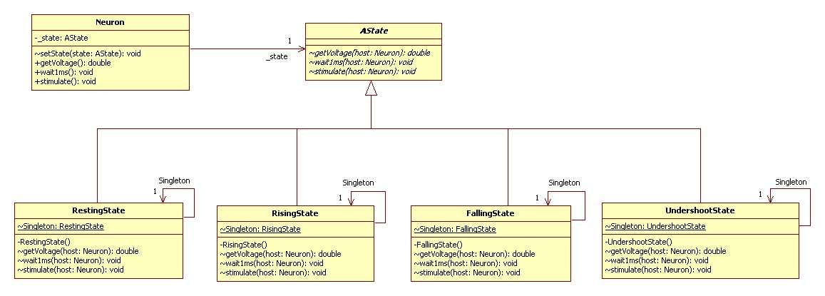

- (5 pts) What design pattern(s) best describes the UML diagram in part a) above? Explain your reasoning.

The relevant design patterns are the Strategy pattern for the neuron-state relationship and the Union pattern for the abstract-concrete state relationship. The states act like strategies because for the behaviors of waiting, getting the voltage and stimulating, the neuron invariantly delegates to the state which has variant behavior, depending on which state is installed at the moment. The Union pattern describes the polymorphic relationship between the abstract state and the concrete states.

- (5 pts) What do you see from the outside? From outside the neuron package, what classes and methods can you see? That is, which of the 6 classes described above is visible and hence usable from a class that is not in the neuron package? In the visible class(es), what methods are visible? In such, how much control could any outside class possibly have over how a Neuron object behaves? Explain your reasoning.
Suggestion: You might want to complete part d) before fully answering this question.

Only the Neuron class is visible from outside the package. Only its methods getVoltage(), wait1ms() and stimulate() are visible. Since none of the states and the setState() method are not visible, an outside object cannot directly control how the neuron behaves. The only way that a neuron changes behavior is if its own code in its strategies changes its own strategies.

- (15 pts) Test Outputs: Complete the following table:
Suggestion: Write down the value of value of the _state field of Neuron at each step.
Executed code: | Console output:
Neuron n = new Neuron();  System.out.println(“Voltage = “+ n.getVoltage()); | -70.0 (RestingState)
n.wait1ms();  System.out.println(“Voltage = “+ n.getVoltage()); | -70.0 (RestingState)
n.stimulate();  System.out.println(“Voltage = “+ n.getVoltage()); | 0.0 (RisingState)
n.wait1ms();  System.out.println(“Voltage = “+ n.getVoltage()); | -25.0 (FallingState)
n.wait1ms();  System.out.println(“Voltage = “+ n.getVoltage()); | -80.0 (UndershootState)
n.wait1ms();  System.out.println(“Voltage = “+ n.getVoltage()); | -70.0 (RestingState)
n.stimulate();  System.out.println(“Voltage = “+ n.getVoltage()); | 0.0 (RisingState)
n.stimulate();  System.out.println(“Voltage = “+ n.getVoltage()); | 0.0 (RisingState)
n.wait1ms();  System.out.println(“Voltage = “+ n.getVoltage()); | -25.0 (FallingState)
n.stimulate();  System.out.println(“Voltage = “+ n.getVoltage()); | -25.0 (FallingState)
n.wait1ms();  System.out.println(“Voltage = “+ n.getVoltage()); | -80.0 (UndershootState)
n.stimulate();  System.out.println(“Voltage = “+ n.getVoltage()); | -70.0 (RestingState)

- (45 pts total) List Processing: The following problems refer to the code given at the end of this problem. Fill in the missing sections of that code with your answers (adding any fields and/or methods as deemed necessary).
  - (20 pts total) Filtering a List: Given a list, write the methods necessary to get the list to return a new list such that all the elements satisfying a given comparison criterion are included and all those elements that do not satisfy the comparison criterion are excluded. That is, filtering is essentially the same as copying except that some elements are omitted from the result.
First, let us talk about how to define a comparison criterion. Java supplies an interface, called java.util.Comparator, just for this purpose:

public interface Comparator {
/**
* Compares two values
* Returns +1 if x is “greater than” y
* Returns 0 if x is “equal to” y
* Returns -1 if x is “less than” y
*/
public int compare(Object x, Object y);
}
Note that “greater than”, “equal to” and “less than” can be defined to mean whatever we want them to mean. For instance we could define the symbol “>” to be our “less than” in the above discussion, so that myComparator.compare(5, 8) would return -1 if myComparator were defined in this manner (see below), i.e. “5 > 8” returns “-1”.

Let’s take a simpler view and say, if the compare method returns -1 (or <0), then the comparison “passes” and if it returns anything else, it “fails”.

That is, in our filtering algorithm, we want to say that if we have method of our list, filter(Compartor comp, Object x), then for a NEList, if comp(_first, x) passes (i.e. returns -1) then we keep _first in our filtered list. Otherwise, we reject _first from our filtered result. What do you think filtering of an empty list should do?

Here’s a simple Comparator that checks to see if x is mathematically greater than y:

class GreaterThanComparator implements Comparator {
public int compare(Object x, Object y) {
return (Integer)x > (Integer) y ? -1 : +1;
}
}

So if our filtering method is called filter then if we wish to remove all the elements less than or equal to the number 7, we could do it as such:

IList aList = new NEList(9, new NEList(7, new NEList(15, new NEList(5, MTList.Singleton))));
IList result = aList.filter(new GreaterThanComparator(), 7);
gives result = (9, 15).
You are to write the method IList filter(Comparator comp, Object x) that returns the an IList with only the original list’s elements that are “less than” the given x, as determined by the given Comparator. Write your answer in the code that follows the next problem section. A skeleton of the if-else construct using the Comparator is supplied for your use if you desire. There are multiple possible solutions, at least one of which do not use the if-else and only take a single line of code.

  - (25 pts total) Folding a Lambda over a List: In numerous examples in class, lab and homework, we have written reverse accumulation algorithms. The odd thing about what we have been doing is that with each new reverse accumulation algorithm, we have been repeating an invariant: the fact that the algorithm is reverse accumulating. That is, in every algorithm we see the following invariants:

- The base (empty) case always returns some specific value, the “base value”, e.g. 0 for summing and 1 for the product.
- The inductive (non-empty) case always
  - takes the returned value from delegating to the rest of the list (the “recursive result”), and then
  - processes the current first value and the recursive result in some manner (e.g. adds its first to the recursive result) and finally
  - returns that new recursive result value.

So, if this process in invariant, why don’t we just write it once and for all?

Mathematically, we can express the above statements in terms of the elements of the list and some function of two variables. That is, consider some generic function, “f(x, r)”. We can then say that in general, we have the following process for reverse accumulation:

(x₀, x₁, x₂, x₃, x₄, … x_{n})
➔ f(x₀,f(x₁,f(x₂,f(x₃,f(x₄, …, f(x_{n}, base)))))

independent of whatever f(x, r)is or does.

This process is called “folding” or more specifically, “folding right” and the name given to the generic function, f(x, r), is “lambda function”. We would describe the above as “folding a lambda over the list”. “Fold” is what is referred to as a “higher order function” because it is a function that takes another function as an input parameter. (Note: the previous filter method is also technically a higher order function because it takes the Comparator as an input.)

To model a lambda function in Java, we define an interface ILambda (see the code on the following pages) that has only one method, Object apply(Object x, Object r), that takes in two Objects and returns an Object. We called the method “apply” because a common way of describing the use of a lambda function is to say that we “apply the lambda”, which means to execute the function on some given input value.

Thus, if lambda is an ILambda implementation, then f(x, r) is the same as lambda.apply(x, r).

Looking at the above verbal description of the folding process, the phrase “processes the current first value and the recursive result in some manner” would this translate into lambda.apply(_first, r) where r is the recursive result.

A couple examples of ILambda implementations and their usages with the fold-right method, foldr, are given on the following pages.

You are to write the method IList foldr(ILambda lambda, Object base) that returns an Object value resulting from folding the given lambda function over the list with the given base value.

//--------------------------------------------------------------------------------
package fp;

/**
* Represents an abstract “lambda” function that takes two Objects as an input parameters,
* processes them and returns an Object.
*/
public interface ILambda {
public abstract Object apply(Object x, Object r);
}

//--------------------------------------------------------------------------------
/**
* An example of a lambda function that multiplies all the elements of a list together.
* We will use the standard base value of 1 (one) here.
* Example usage: aList.foldr(new Product(), 1);
* This will return the product of all the elements of the list, for example:
* (2, -1, 10) ➔ -20
*/
public class Product implements ILambda{

public Object apply(Object x, Object r) {
return (Integer) x *(Integer) r;
}
}

//--------------------------------------------------------------------------------
/**
* An example of a lambda function that returns a String with all the elements of the
* list separated by spaces and terminated by a given base value String.
* We will use two exclamation points as our base value here.
* Example usage: aList.foldr(new ToString(),”!!”);
* This will return a String with all the elements plus two exclamation points:
* (2, -1, 10) ➔ “2 -1 10 !!”
*/
public class ToString implements ILambda{

public Object apply(Object x, Object r) {
return x.toString()+ “ “ + r.toString()
}
}

//--------------------------------------------------------------------------------
package listFW;
import fp.*;

/**
* Represents the abstract list structure.
*/
public interface IList {

/**
* Filter the list, returning a new list with only the elements
* that are "less than" the given Object x, as determined by the
* given Comparator, i.e. returns -1 for comp.compare(_first, x).
*/
public IList filter(Comparator comp, Object x);

/**
* Folds (right) the given lambda over the list, returning the resultant value.
* This is the invariant part of the reverse accumulation process.
*/
public abstract Object foldr(ILambda lambda, Object base);

}

//-----------------------------------------------------------------------------------
package listFW;
import fp.*;

/**
* Represents empty lists.
*/
public class MTList implements IList {

// Singleton Pattern
public final static MTList Singleton = new MTList();
private MTList() {
}

/**
* If you filter our elements of an empty list, what is left?
*/
public IList filter(Comparator comp, Object x) {
// Part a) STUDENT TO COMPLETE (5 pts)

return this;

}

/**
* Folding right over an empty list is just the base case value.
*/
public Object foldr(ILambda lambda, Object base){
// Part c) STUDENT TO COMPLETE (5 pts)

return base;

}

}

//-----------------------------------------------------------------------------------
package listFW;
import fp.*;

/**
* Represents non-empty lists.
*/
public class NEList implements IList {
private Object _first;
private IList _rest;

/**
* Initializes this NEList to a given first and a given rest.
* @param f the first element of this NEList.
* @param r the rest of this NEList.
*/
public NEList(Object f, IList r) {
_first = f;
_rest = r;
}

/**
* Includes current element along with the rest of the filtered list
* if the current element is "less than" the given Object x, as
* determined by the given Comparator.
*/
public IList filter(Comparator comp, Object x) {
// Part b) STUDENT TO COMPLETE (15 pts)
// A skeleton of the comparison test has been provided.
// Add code anywhere you feel is necessary.
// You are not required to use the if-else code.

if(comp.compare(_first, x) < 0) {
// "Passes" compare test, include current element in the result.

return new NEList(_first, _rest.filter(comp, x));

}
else {
// "Fails" compare test, do not include current element in result

return _rest.filter(comp, x);

}

// Alternative one-line solution
// return (comp.compare(_first, x) < 0) ?
new NEList(_first, _rest.filter(comp, x)) : _rest.filter(comp, x);

}

// Code continues on the next page
/**
* Folding right over a non-empty list returns the application of the lambda
* to the first element and the recursive result.
*/
public Object foldr(ILambda lambda, Object base) {
// Part d) STUDENT TO COMPLETE (20 pts)

return lambda.apply(_first, _rest.foldr(lambda, base));

}

}

- (5 pts) Extra Credit: The Evolution of Design: In terms of design patterns, inheritance, composition and the ideas of variant vs. invariant, compare the evolutions of the following two systems: 1) the evolution of the reverse accumulation algorithms from those you’ve previously written to your new foldr + ILambda system and 2) the evolution of Ballworld that you performed in your last homework assignment that took it from its previous (original) design to its latest design.

In both systems, there was a transition from an inheritance-based model to a composition-based model. In Ballworld, new balls were originally defined as new subclasses of an abstract ball. In the original reverse accumulation algorithms, new algorithms were defined by adding a new method to the superclass IList and then the empty and non-empty lists would polymorphically implement that algorithm. In the new Ballworld, the variant behaviors were separated out from the invariant ball by use of a strategy pattern. The new Ball class was concrete and invariant and was composed with variant strategies that added specific variant behaviors. With foldr, only the invariant part of the reverse accumulation process is defined and the variant parts of the reverse accumulation algorithms are embodied as separate ILambda functions. The ILambda subclasses only contain the part of the algorithm specific to that algorithm, not the reverse accumulation part. The total algorithmic behavior is thus the combination of the foldr and ILambda. In a way, the ILambda is like a temporary strategy that the foldr uses to perform the reverse accumulation algorithm.

