CosmosWorks Three Material Thermal Study (draft 2 2/20/06)

Introduction

When you are learning a powerful system like SolidWorks and CosmosWorks it is wise to reproduce problems with known solutions to verify that you have properly mastered the interface. The purpose of this study is to demonstrate how to combine parts with different material properties in a thermal analysis. The basic outline is that you must create a SolidWorks part file for each single material part, combine them into a SolidWorks assembly, and mate the touching surfaces. Then you can open the assembly in CosmosWorks, specify the material properties of each part, bond surfaces where needed, apply loads and restraints and solve the equations. Usually you will also need to post-process the results for items of interest.

Here you will utilize a known 1D solution to verify your use of a 3D code. Then you should have no trouble mastering parts of arbitrary 3D geometry. The popular heat transfer text by Chapman [1] provides several analytic and numerical studies that can be used a validation exercises. One such application (Example 2.2, [1]) gives the analytic solution for steady temperature and heat flow through a flat wall made of three layers of bonded materials. The outside of the wall has natural convection to air at 35 C with a convection coefficient of h₁ = 30.0 W/m^2 C. The outer facing brick has a thermal conductivity of k₁ = 1.32 W/m C and a thickness of 10 cm. It bonds to a 15 cm layer of common brick with k₂ = 0.69 W/m C. It in turn is covered with plaster that is 1.25 cm thick having k₃ = 0.48 W/m C. Finally, the plaster convects to inside air at 22 C and has a convection coefficient of h₂ = 8 W/m^2 C. You want to know the inner and outer surface temperatures, and the heat flux (per unit area) through the wall.

In a 1D solution the temperature through a flat wall (without internal heat generation) will wary linearly with position in each region of constant conductivity, k. It will be continuous at the bonded material interface but the slope is discontinuous where k changes. Likewise, the heat flux should be constant and the same in each material.

You need to determine the two wall surface temperatures at the air, and the heat flow through the wall. At the end of this study the analytic 1D temperatures and head flux will be compared to the computed results.

The three material part geometries

Face brick part
Since CosmosWorks defaults to 3D solids you will need to build three different solid parts, one for each segment of the wall. The respective lengths are specified above. The thickness and width of each brick shape (to define the wall area) needs to be the same. Their values can be arbitrary and are usually picked to give good aspect ratios for the elements. Here, the vertical height is assumed to be 2 cm, and the horizontal width is 1 cm. Start SolidWorks and begin by specifying the units to be utilized in building the first part:
- Use Tools→Options→Document Properties→Units.
- In the Units panel check CGS (cm, gram, sec) as your Unit system.
- If you wish, select feet as the optional Dual units for dimensions. These units’ choices are seen in Figure 1.

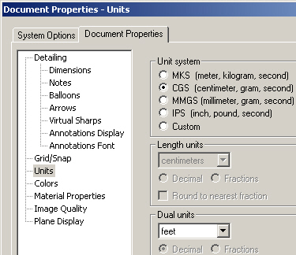

Figure 1 Selecting the units for the first part

The first part (facing brick) will simply be an extruded rectangle. Build it with:
- Right click on Front→Insert Sketch→Rectangle.
- Start one corner at the origin, drag out the rectangle. Smart dimension the length to 10 cm, and the (arbitrary) height to 2 cm.
- Pick Extrude Bass/Boss icon to get the Extrude panel.
- Use a blind extrusion in Direction 1 of (arbitrary) width of 1 cm, OK.
- File→Save as filename Face_Brick.sldprt (see Figure 2).

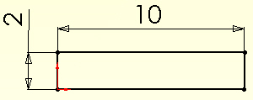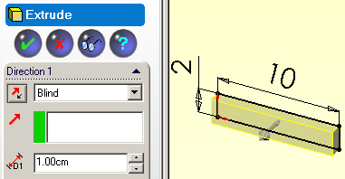

Figure 2 Sketch, extrude, and save the face brick

Common brick and plaster parts
Follow a similar process to create the Common_Brick part, and the Plaster part, as summarized in Figure 3. Remember to start with Tools→Options→Document Properties→ Units.

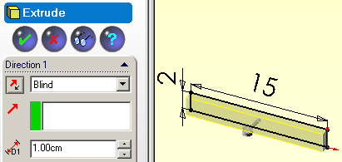

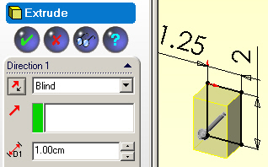

Figure 3 Forming the next two wall layers

Building and mating the assembly
Next you must move all the parts of different materials into an assembly and mate them as needed:
- New→Assembly→OK.
- Right click on Window→Tile Horizontally to see the original three parts and the assembly insertion progress (see Figure 4).
- In the Insert Component panel highlight the Face_Brick part to start the assembly and to locate all other parts relative to it.
- Click on the Common_Brick part and drag it into the assembly.
- Finally, click on the Plaster part and drag it into the assembly.
- Click on the Assembly name bar→Window→Cascade to visually check the group of parts, as in Figure 5.
- Use the Move Component icon to grasp the last two parts and move them so the surfaces intended for mating are close to each other, OK.
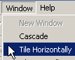

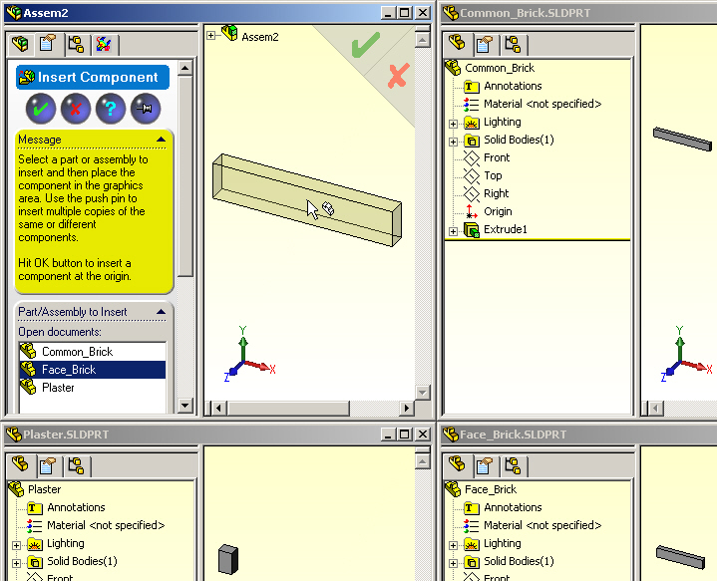

Figure 4 Starting the assembly process

Mate the touching surfaces

For each of the three material interfaces you can require them to by making two pairs of perpendicular edges be coincident:
- Select the paper clip Mate icon (just above the Move Component icon).
- Pick the inside (1 cm) top horizontal edge of the face brick and the corresponding top outer edge of the common brick.
- In the Coincident panel select coincident as the Standard Mate, OK.
- Use the vertical front edges, intersecting the above two edges, and in the Coincident panel select coincident as the Standard Mate, OK (see Figure 6).
- Use the same pair of coincident mates at the common brick-plaster interface.
- Verify the mated assembly of the three different materials, as in Figure 6.
- Use File→Save as to create the Assembly name of House_wall,OK (Figure 7).

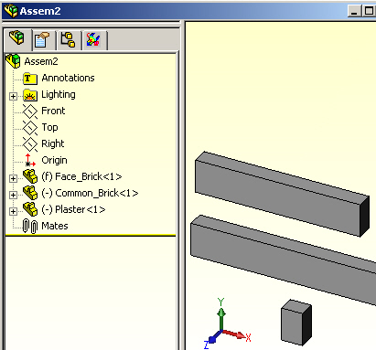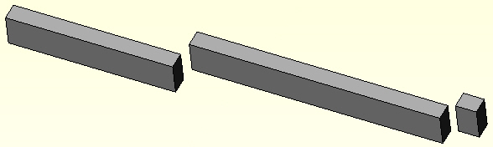

Figure 5 Check and rearrange the assembly of three parts

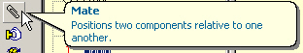

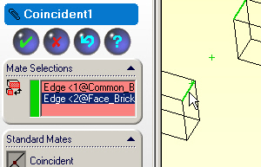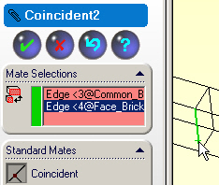

Figure 6 Mate the facing and common brick interface

Now you have built a solid assembly which is equivalent to the 1D verification problem. This was clearly a lot more work (just to get started) than the full 1D analytic solution. But after mastering these concepts the finite element approach readily extends to arbitrary three-dimensional domains, while the corresponding analytic approaches bog down and become very difficult, and impractical.
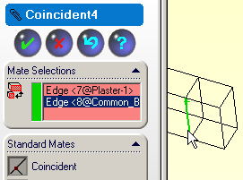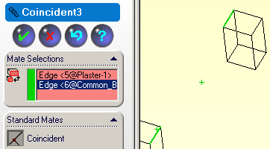

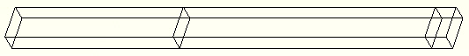

Figure 7 Geometrically mate the brick-plaster interface and save the assembly

Beginning the CosmosWorks Model

Pass the completed and saved assembly to the CosmosWorks analysis system:
- Pick the CosmosWorks icon (fourth from the left).
- Right click on the Assembly name→Study to get the Study panel.
- There, enter a Study name, pick thermal as the Analysis type, and select a shell as the Mesh type (try repeating this later with a solid mesh), OK (see Figure 8).

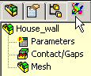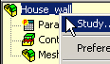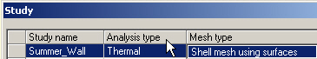

Figure 8 Beginng a thermal study of an assembly

Select the shells and assign materials

Had you picked a solid mesh type you could next directly define the three sets of material properties. For the chosen shell type of mesh, using surfaces, you must first select the three (connected) surfaces to be meshed with shells. Since the problem is really 1D you could select any of the four sets of three connected faces running through the wall thickness. Here the front face of the assembly will be employed. (Now you are using a 2D model to solve the 1D problem). Start with the face brick:
- Right click on Shells→Define by Selected Surfaces to get the Shell Definition panel.
- In the Shell Definition panel, set the Type to thin, pick the model front surface of the facing brick as the Selected entity (as illustrated in Figure 9).
- Set the Thickness to 1 cm, OK. Especially note this step, since the extrusion thickness would automatically be assigned in a mid-surface shell. However, that option is not available here. (What would happen if you inconsistently type in 2 cm here, but use 1 cm for the next two sets of shells?)
- In the manager panel Shell 1→Apply/Edit materials to get the Material panel.
- Check Custom defined, enter Face_Brick as the Material name, type the thermal conductivity value (KX) as 1.32 W/m^2 C, OK (see Figure 10).
- Repeat this process for the next two materials (as in Figure 11 and Figure 12).

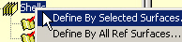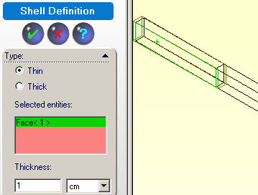

Figure 9 Define the facing brick shell surface area

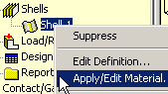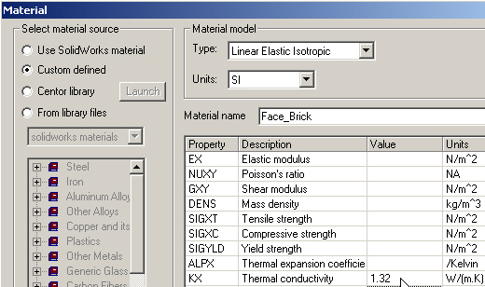

Figure 10 Input the custom material property for the face brick

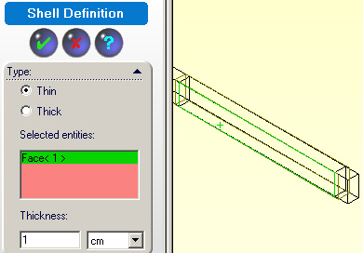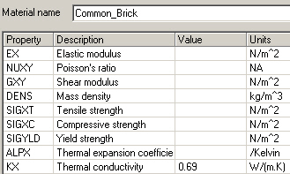

Figure 11 Set the shell surface, thickness, and property for the common brick

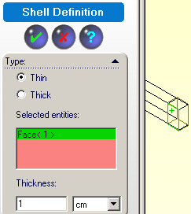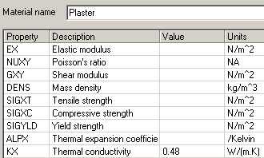

Figure 12 Set the shell surface, thickness and property for the plaster

Control and create the mesh

Knowing the analytic result, each layer of the wall could be solved exactly with one rectangular element or two triangular elements (forming the rectangle). However, you will generate a general 2D (or 3D) mesh with a few coarse elements to avoid long skinny (high aspect ratio) elements which usually adversely affect the accuracy:
- In the manager panel, right click on Mesh→Apply Control.
- In the Mesh Control panel, select the three faces (or three bodies if 3D) as the Selected Entities and set Control Parameter (element size) to a relatively large number like 1 cm, OK, (see Figure 13 for example).
- Mesh→Create→Mesh panel enter similar coarse element sizes, OK.

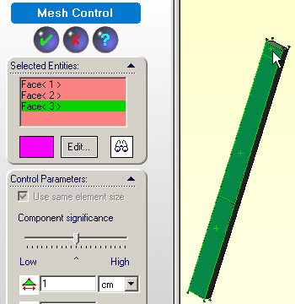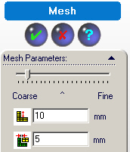

Figure 13 Select the shell regions and force a crude mesh

After the mesh generation phase is created you need to visually verify the mesh (use Mesh→Show mesh). Mainly you need to look for bad aspect ratios. For shell elements assure that the color coded top (or bottom) sides of all elements (i.e., their normal vectors) are the same. (That is very important in shell bending structural models.). Here, they should be all gray or orange (bottom side) color coded. Note that the common brick region of elements needs to be “flipped” To fix that:
- Place the cursor on the region (top of Figure 14) control click the region.
- Mesh→Flip shell elements, OK. Double check the mesh.

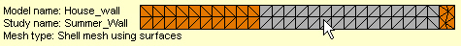

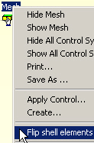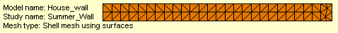

Figure 14 Assure that all 2D elements have the same top orientation

Impose convection loadings

Apply the two loads (at the two face convection surfaces) from the manager panel:
- Load/Restraints→Convection to open the Convection panel.
- At the inside wall pick the edge (or face in 3D) as the Selected Entity.
- Set Convection Parameters to h = 8 W/m^2 C, and 295 K as the air temperature, OK. Note the inconsistent need to convert the air to degrees Kelvin (Figure 15). While it is an easy external unit’s conversion, it introduces the possibility of a user error (garbage in, garbage out).
- Repeat step 3 for the outside convection edge (face in 3D).

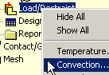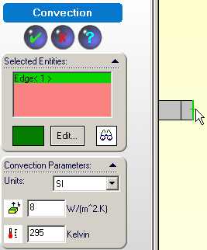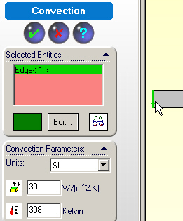

Figure 15 Set the inside and outside convection loads

Insulated segments

You have taken the wall segments to be horizontal. Thus, you have assumed that the section through the wall to be insulated on its top and bottom surfaces. This does not require any user action because that is the “natural boundary condition” in finite element analysis if no other boundary condition is applied to a surface.

Essential boundary condition

A thermal analysis usually requires an “essential boundary condition” which is specifying at least one known temperature point (via Load/Restraints→Temperature). Here you have done that indirectly because of the nature of any convection boundary condition. Thus, no additional action is needed to have an algebraic equation system that can be solved for the unknown temperatures.

Solve for the temperatures
Invoke the equation solver in the manager: right click Assembly name→Run. If you wish,
You can rename the mesh regions and/or loads and restraints so your study will mean more to you if you have to come back to it in a few weeks or years. The results of such renaming can be seen in Figure 16.

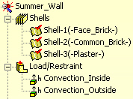

Figure 16 Rename the material regions and convection loads

Post-processing
After all the temperatures are obtained you usually want to post-process them for your analysis study report. You also want to check other items computed from the temperatures. Remember, in any finite element analysis the nodal temperatures are the most accurate quantities. The temperature gradients and heat flux are the least accurate. You should always check the temperatures and heat flux since one may depend simply on the part shape while the other also involves the material properties.

Temperature results
As expected, the temperature varies linearly through each material layer and has a change of slope at the interfaces. That is a little hard to see in a standard contour plot ().

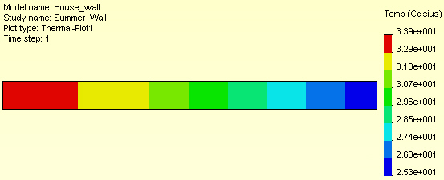

Figure 17 Linear temperature drops through each material

A slightly more informative set of information is to probe for the convection surface (and possibly the interface temperatures):
- Right click in the graphics area and select Probe.
- Pick points at the outside air (they are about 33.9 C).
- Pick points at the inside air (they are about 25.3 C), as in Figure 18.
Note that these values also appear in a Probe panel along with the point position and the part name where the probe occurred.

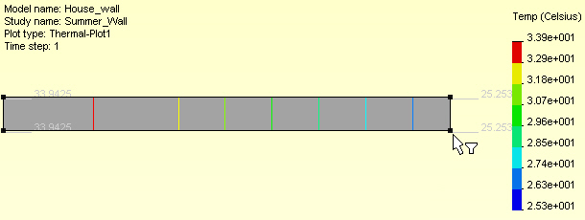

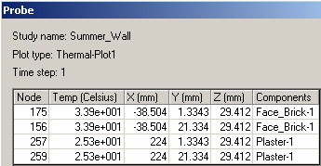

Figure 18 Probing the temperature extremes

Graphing Temperatures

Once the temperatures have been displayed you can produce graphs or lists of their values on selected lines or surfaces with:
- Right click in graphics area, List Selected
- Select a line of interest, say the facing brick base.
- In the List Selected panel click on Update. The top on that panel will give the nodal summary for the line (see Figure 19). Each nodal value is listed in the panel.
- In the List Selected panel click on Plot to get a graph of temperatures vs. relative position on the line (Figure 20, top).

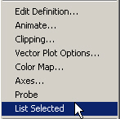

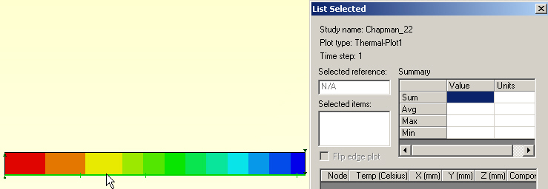

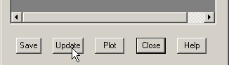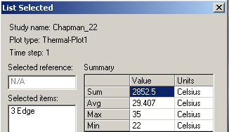

Figure 19 Selecting facing brick to list temperatures

In a similar fashion, you can pick the base of the common interior brick to list and graph (Figure 20, lower left) its temperatures. The plaster temperature graph also appears in Figure 20 (lower right)

Heat flux results

Here, the heat flux should be constant. The default contour plot looks variable until you notice that the numbers are the same except for some round-off errors. Check the plot ranges:
- Right click in the graphics area, Edit Definition→Settings
- Examine the Legend and text options for the automatic maximum and minimum contour range levels. Since they are both the same (27.2 W/m^2) a contour plot is not needed.

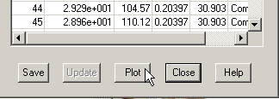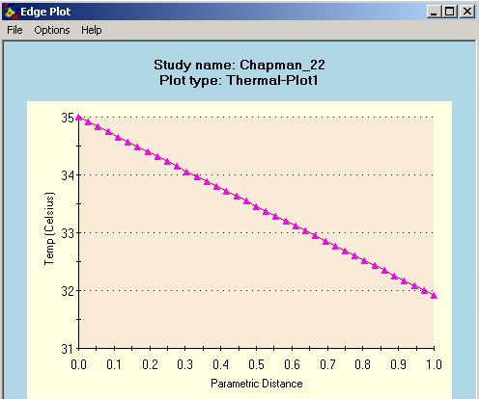

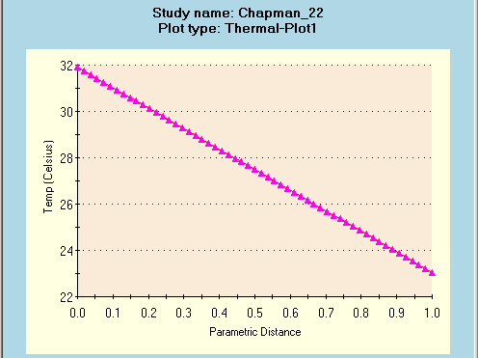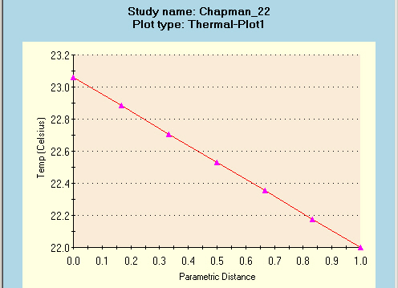

Figure 20 Graphing the listed line temperatures

- To double check this, click in the graphics area and select Probe (Figure 21).
- Picking nodes on the plaster and facing brick verifies the heat flux result.

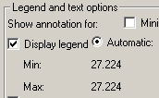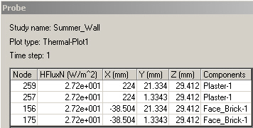

Figure 21 Probing the constant heat flux

You can also create a similar list of the maximum nodal values found in the mesh. The list can be saved to place in your analysis report. Use
- Under the study name, Thermal→List→List Thermal panel.
- Set Units to W/m^2, Option extreme absolute max, and resultant heat flux (HFLUXN) as the Component, OK.
- The List Results panel will appear, as seen in Figure 22.

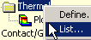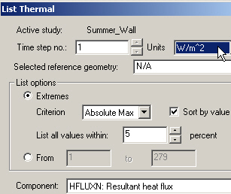

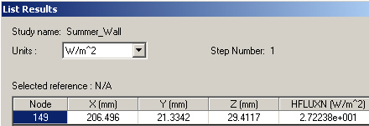

Figure 22 List the maximum heat flux found in the mesh

Validation

These computed results agree very well with the analytic solution [1]. That gives the inside plaster surface temperature to be 25.4 C (77.7 F), and the constant heat flux (per unit area) to be 27.2 W/m^2 (8.63 Btu/h ft^2). This problem was also solved with a 1-D finite element solution using three conduction elements and two convection elements. It was implemented using Matlab. The temperature plot and script source are shown in Figure 23 and Figure 24, respectively.

Reference
- Alan J. Chapman, Fundamentals of Heat Transfer, Macmillan, New York, 1987.
- J. Ed Akin, Finite Element Analysis with Error Estimators, Elsevier, 2005.

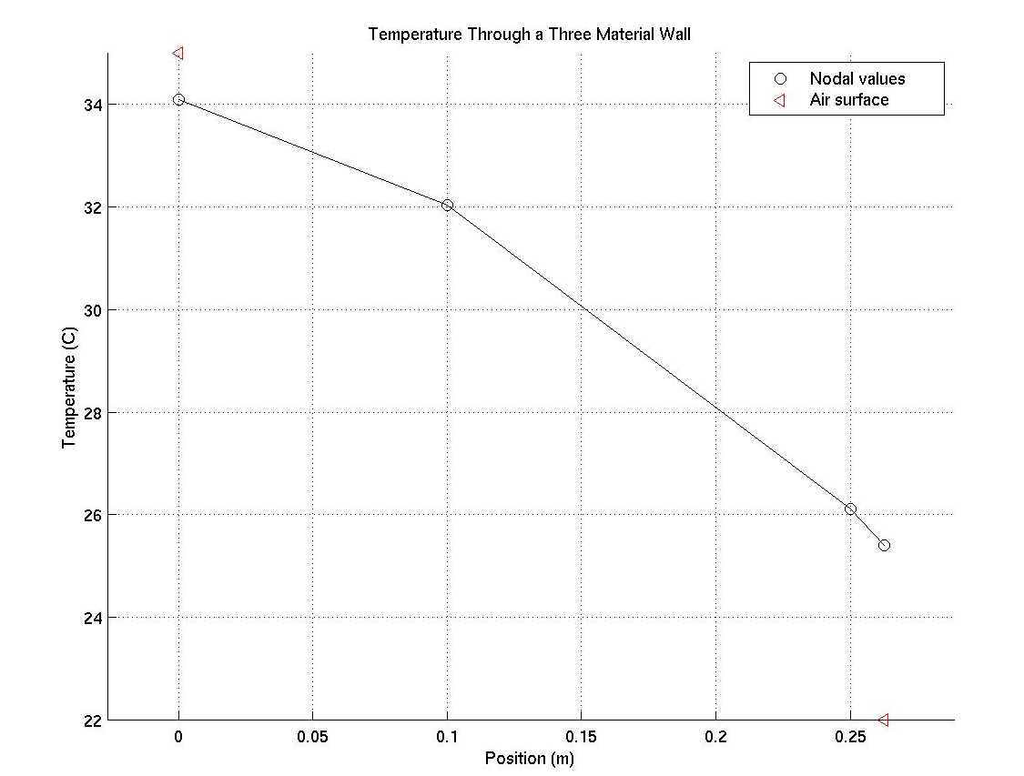

Figure 23 One-dimensional validation plot

% Conduction through three layered planar wall with convection.
% Ref: A.J. Chapman "Fundamentals of Heat Transfer", Macmillan,
% 1987. Example 2.2, pages 46-47.
%...................................................................
% Outside (_o) convection at 35C to facing brick (_f) to brick (_b)
% to wall plaster (_p) to inside (_i) convection at 22C. Note the
% essential BC are hidden in the convection air temperatures

% convection x_1 x_2 x_3 x_4 convection
% [air, h_o, T_o] *---(1)---*---(2)---*---(3)---* [air, h_i, T_i]
% T_1 T_2 T_3 T_4
% (P1) (L2) (L2) (L2) (P1)
% Connectivity list: e i j
% 1 1 2 % L2
% 2 2 3 % L2
% 3 3 4 % L2
% 4 1 0 % P1
% 5 4 0 % P1
%....................................................................

% Set given constants
L_f = 0.1 ; L_b = 0.15 ; L_p = 0.0125 ; % conduction lengths
K_f = 1.32 ; K_b = 0.69 ; K_p = 0.48 ; % thermal conductivities
T_o = 35 ; T_i = 22 ; % air temperatures (out, in)
h_o = 30 ; h_i = 8 ; % convection coefficients

% Manually assemble 4 by 4 square matrix terms
%DOF: 1 2 3 4
S=[(K_f/L_f+h_o), -K_f/L_f, 0, 0, ; ...
-K_f/L_f, (K_f/L_f+ K_b/L_b), -K_b/L_b, 0, ; ...
0, -K_b/L_b, (K_b/L_b+K_p/L_p), -K_p/L_p, ; ...
0, 0, -K_p/L_p, (K_p/L_p+h_i)]

C = [h_o*T_o; 0; 0; h_i*T_i] % Assemble 4 by 1 source terms
T = S \ C % Solve for four temperatures (C)
q_f = -K_f * (T(2) - T(1)) / L_f % heat flux through wall (W/m^2)

Figure 24 Script for 1-D FEA model

