Local Singularity Conduction Convection Example (draft 2 12/3/05)

Introduction
A hot duct work consists of thin aluminum square tube that is 1.2192 m (4 ft). on each side that contains a hot gas at 298.9 C (570 F) and is surrounded with a layer of insulating fiberglass that has an outer radius of 1.2192 m (4 ft). The insulation material has a thermal conductivity of K = 3.462e-2 W/m C (0.020 BTU/hr ft F). The duct is surrounded by free air convection having a convection coefficient of h = 408.8 W/m^2 C (72.0 BTU/hr ft^2 F) and the air is at 23.9 C (75 F). Assume the aluminum is so thin that it causes the same temperature on the inter-most square surface of the insulation. Use CosmosWorks to determine the maximum surface temperature of the duct outer surface and the distribution of the internal heat flux vectors. For a typical duct unit length of 1 m (3.281 ft) estimate how much heat flows into the air. Note that the square duct causes a re-entrant corner in the insulation. Thus, there will be a local singularity in the temperature gradient at that point.

SolidWorks Geometric model
First select the working units (and dual dimension display):
- Use Tools→Options→Document Properties→Units
- Set Unit System to meters, and Dual units to feet, OK
- Use Tools→Options→System Options→Detailing
- In Dimensioning standard turn on Dual dimension display, OK

The problem has a one-eight symmetry, so model the first 45 degree segment.
- Use Top→Insert Sketch
- Insert a 0 and 45 degree construction line
- Place and dimension the (insulation-air) arc
- Place and dimension the vertical (aluminum) line
- Connect the remaining two symmetry lines, as in Figure 1.
- Select Extruded Boss/Base (Figure 2).
- In the Extrude panel set distance D1 to 1 m, and method to Blind, OK

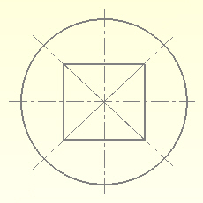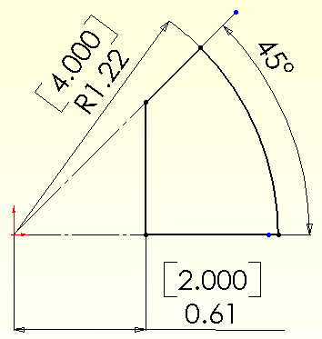

Figure 1 Sketch for the part extrusion

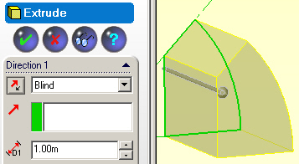

Figure 2 Extrusion of insulation material

CosmosWorks model

After saving the extruded part you are ready to move to the CosmosWorks option. Pick the CosmosWorks icon to activate its manager panel.

Analysis type and material selection
In the Manager panel
- Right click on the Part name and select Study
- In the Study panel set the Study name, static Analysis type, and mid-surface shell Mesh type.
- Under the part name right click Mid-surface shell→Apply Material to all (Figure 3).
- A review of the Material panel standard materials yields no match. Thus turn on Custom defined and type in 3.462e-2 for Thermal conductivity, OK (Figure 4).



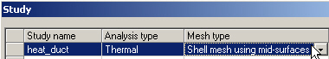

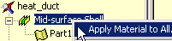

Figure 3 Starting the CosmosWorks study

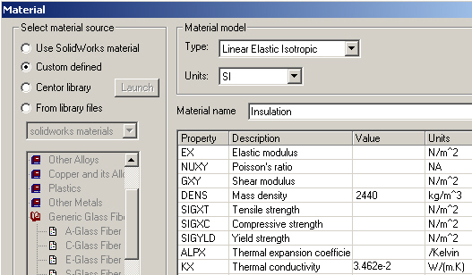

Figure 4 Setting the custom thermal conductivity value

Temperature restraint
Apply the only “essential boundary condition” (the known temperature) here:
- Use Load/Restraint→ Temperature to open the Temperature panel.
- There set the Temperature to 298.89 C and pick the face by the aluminum as the Selected Entity, in Figure 5, OK.

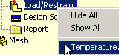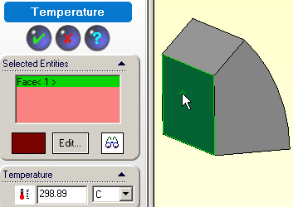

Figure 5 Setting the essential boundary condition

Convection load
Invoke the only loading condition:
- Use Load/Restraint→Convection to open the Convection panel.
- There pick the curved face as the Selected Entity
- In Convection Parameters set the convection coefficient, h = 408.8 W/(m^2 C)
- Set the air temperature to 296.9 K (75 F)
- Preview, OK. This is illustrated in Figure 6.

Remember that when you create a shell mesh it will be assigned the above extrusion thickness (in Figure 2), and will use it to compute the effective surface area that is subjected to the air convection.
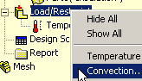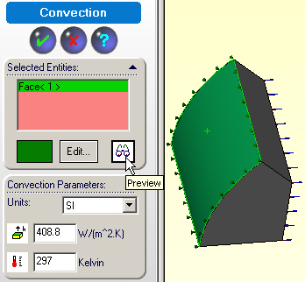

Figure 6 Setting the convection load

Insulated surfaces
The insulated surfaces, which correspond to the two symmetry planes, require no action. That is because in any finite element thermal analysis that state (of zero heat flux) is a “natural boundary condition”.

Mesh generation
For the preliminary analysis accept the default mesh size, as in Figure 7:
- Use a right click Mesh→Create
- In the Mesh panel select OK for a default mesh (which is rather crude).

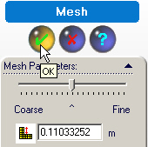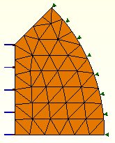

Figure 7 Create a default crude mesh

Temperatures computation
Start the temperature solution with right click on the Name→Run. 

Post-processing

Temperatures
Under Thermal double click on Temperature→Plot 1. The default contour plot of temperatures would appear as a smoothed (Gouraud) color image. Usually a stepped shaded image gives a better hint of a bad mesh. Create that with:
- A right click in the graphics window, Edit Definition→Thermal Plot→Display.
- Set Units to Celsius, as highlighted in Figure 8.
- Change Fringe type to discrete filled, OK.
- Right click in the graphics window, select Color map.
- In the Color Map panel pick 6 colors of thin Width and 2 Decimal places, OK.

Note that the highest temperature contour, near the upper symmetry plane of Figure 9, is wiggly. That indicates that this mesh is too crude in the high temperature gradient (and high hest flux) region. For another type of view generate a temperature line contour:
- Right click in the graphics window, Edit Definition→Thermal Plot→Display.
- Change Fringe type to Line, OK, for the results in Figure 10.
It also shows the warning wiggles that the default smoothed plot tends to hide (try one).
You observe that the maximum surface temperature is barely above that of the air.

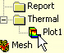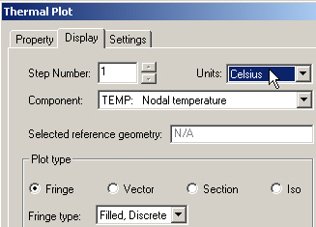

Figure 8 Controlling the second temperature contour plot

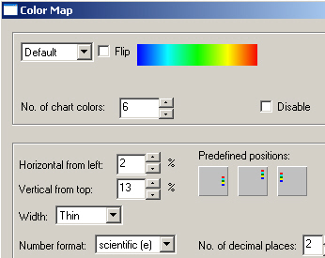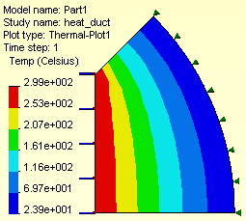

Figure 9 Pick the color bar location and size

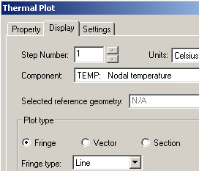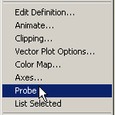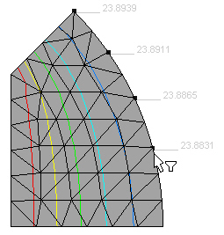

Figure 10 Activating and probing temperature line contours

Heat flux

The heat flux is a vector quantity defined by Fourier’s Law: q = -K ∆T. Thus, it is best displayed as a vector plot using typical controls given in Figure 11.
- Right click in the graphics window, Edit Definition→Thermal Plot →Display
- Set Units to W/m^2
- Pick Component resultant heat flux
- Plot type vector
- Fringe type line, OK
- Dynamically control the plot with right click in the graphics window, Vector Plot Options
- Vary the Size and Density (of the percent of vectors displayed)
The heat flux vector plot is shown in Figure 12 along with the heat flux magnitude. The latter line contour plot of the magnitude of the heat flux may also identify where the mesh is too crude and needs to be re-built with engineering judgment (via Mesh→Apply Control).

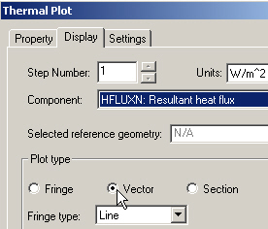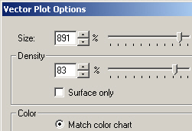

Figure 11 Start and control heat flux vector plot

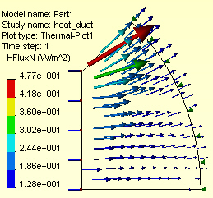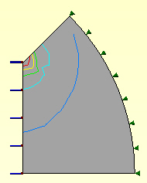

Figure 12 Heat flux vectors and magnitudes

Thermal reactions
A heat flow in or out of the system must occur at every specified temperature in order to maintain that desired temperature. If your finite element system provides those data it is good practice to review them. CosmosWorks provides a way to obtain the thermal reactions.
In this case heat is flowing in along the straight inner side, and an equal amount of heat must flow out of the curved outer side (since there was no internal heat generation). To obtain the reaction heat flow:
- Right click in the graphics area of a heat flux plot, pick List Selected…
- Pick the desired edge (straight side here) as the Selected items.
- Click on Update. The reaction flux values appear in the list at each node, and the Total Heat Flow appears in the Value column. In this case, as seen in Figure 13, the total is listed as 13.75 W flowing into the part.
- To see a graph of the heat flux along the edge select Plot. That graph, in the same figure, indicates a bad mesh if the graph is not smooth. Here it seems smooth, but it has a very sharp gradient at one end.

The heat flow is the area under the curve. In other words, it is the integral of the normal component of the heat flux along the part edge. The sharp gradient occurs at the re-entrant corner of the full part, as seen in Figure 1. That always causes an infinite heat flux to develop at that point, in theory. Here, the outlet side is smooth and should have an equal and opposite value of the reaction heat flow. If not, that shows that the mesh needs to be refined.
Check that side with:
- Right click in the graphics area of a heat flux plot, pick List Selected…
- Pick the desired curved outer side as the Selected items.
- Click on Update. The reaction flux values appear in the list at each node, and the Total Heat Flow appears in the Value column. In this case, as seen in Figure 13, the total is listed as 14.25 W flowing out of the part.
- To see a graph of the heat flux along that edge select Plot.
Your computer model was only 1/8 of the total domain. Therefore, the true heat loss is Q _{total} = 113.6 Watts.
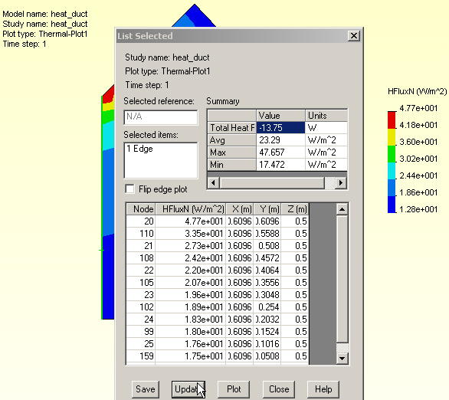

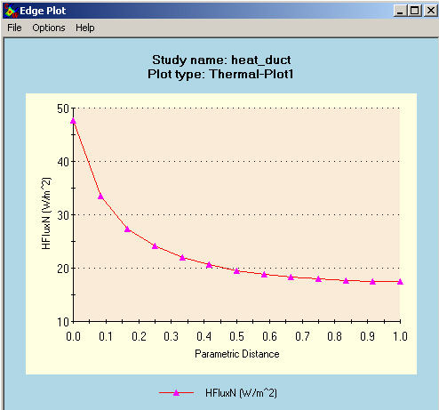

Figure 13 Inner straight edge heat flow data
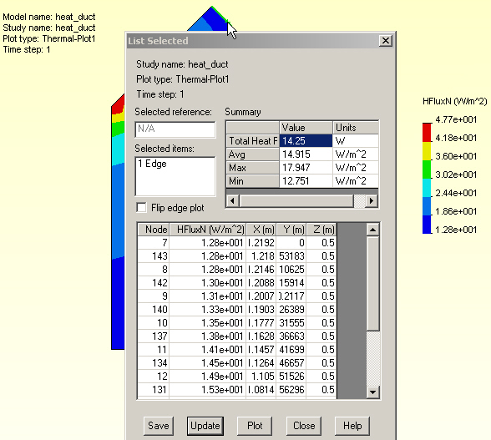

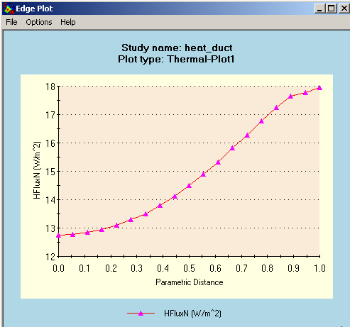

Figure 14 The heat flux data on the outer edge

The lack of balance between the heat flows in and out is only about 4%. Even so, a small refinement of the mesh should give smoother (more accurate) contours and a better heat flow balance. A new mesh is shown in Figure 15. The new values of the heat flow are in better balance, having only a 1% difference. The new values are 14.2 W, as seen in Figure 16.

The corresponding new graphs of the normal heat flux along the inlet and outlet are seen in Figure 17. They are both smoother than before. The maximum value on the outlet side (< 18 W/m^2) has barely changed. However, there has been a large change on the inlet side near the re-entrant corner. Its peak value has doubled, jumping from about 45 to about 90 W/m^2 at the “corner”. Comparing the two graphs clearly shows the effect of the weak local singularity. Reasonable mesh refinement helps, but you will never reach the infinite value at the corner point (because the element smears it out, except for special singularity elements).

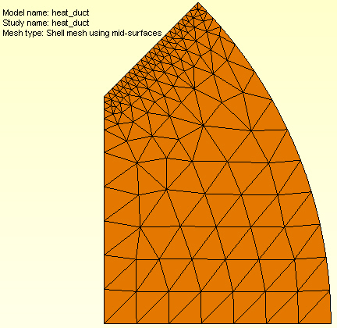

Figure 15 Refined mesh for better heat flow balance

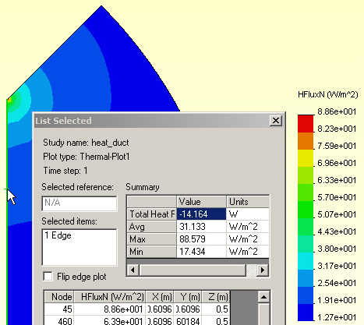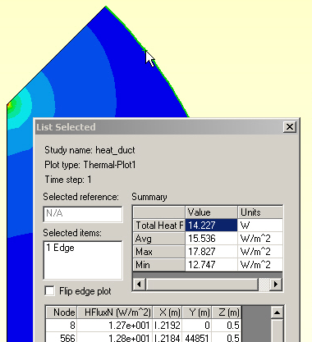

Figure 16 New heat flow values in and out (14.2 W)

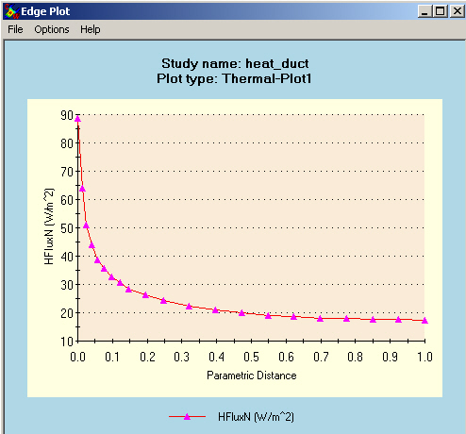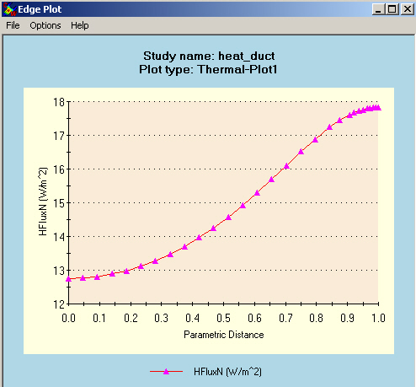

Figure 17 Heat flux graphs in (left) and out for the refined mesh

Validation of computed results

Temperatures
Before beginning the above analysis you should have estimated the temperature result and/or attempted to bound it. For a plane wall with a known inside temperature on one side and convection on the other the exact temperature solution is linear through the wall. The analytic solution for the temperature of the convection surface is

T_{s} = (h _{air} T _{air} + T _{wall} k/L) / (k/L + h _{air}),

where L is the thickness of the wall. The temperature along a line of symmetry can often be modeled with a 1D model that has the same end conditions as the symmetry line. Here those end conditions are the same and it appears that only the lengths vary. The lower length is L₀ = 0.6096 m (2 ft). Therefore, the estimated outside wall temperatures there is

T₀ = (408.8 W/m^2 C * 23.9 C + 298.9 C * 3.462e-2 W/m C / 0.6096 m )
______________________________________________________ = 23.9 C.
(3.462e-2 W/m C / 0.6096 m + 408.8 W/m^2 C)

The T₀ temperature agrees well with the computed result, and suggests a user error in the given data. The convection coefficient is so relatively high (compared to k/L) that it acts almost like an essential boundary condition requiring the outer wall to be at the air temperature of 23.9 C. Most likely the convection coefficient is too high or the conductivity is too low. One of those data items probably has a decimal point error (was off by a factor of 10 or 100). Even so, you can estimate the heat flow through the wall there as q₀ = K (T _{wall} – T _{air} ) / L₀, which gives q₀ = 9.52 W/m^2. The average value in Figure 18 is about 14.2 W/m^2 so the estimated value is reasonable. You might be tempted to also use the above formulas for the upper wall. However, the diagonal corner is a re-entrant corner. Thus, it causes a mild local singularity and a rapid change in the temperature gradient there (which the crude mesh has mainly missed). So you can not use a uniform wall estimate.

Heat flow validation
Some finite element systems do not make it easy to recover those data, but basic engineering will give you an estimate of the total heat flow (per unit length assumed here for the thickness into the page). From the vector plot of heat flow you see that at the outer surface that the flow is basically normal to the surface. (That is approximately true on the inner surface too.)

Integrating the normal heat flux passing through the outer surface gives the total heat lost.
To estimate the heat loss, manually change the color bar to more clearly give the range along the outer surface:
- Right click, Edit Definition→Thermal Plot→Settings
- Set the Display legend to defined
- Assign a minimum value of 10, and maximum of 20 W/m^2, respectively (arrived at by trial and error), for the results in the right part of Figure 18.

Estimate the arc length of the outer surface associated with each solid color heat flux range.
Multiply that distance by the thickness (1 m) to get the heat outflow surface area, and multiply by the average contour value (for that color) for its heat loss, in Watts. The approximate angles from the bottom are 12.1, 13.0, 7.7 and 12.2 degrees. The correspond arc lengths are 0.258, 0.277, 0.164, and 0.260 m, respectively. The corresponding heat flux values (by averaging the color value ranges) are 17.5, 15.9, 14.2, and 12.5 W/m^2, respectively. The total heat loss, per unit length, is estimated at Q = (17.5*0.258 + 15.9*0.277 + 14.2*0.164 + 12.5*0.260)*1.0, or Q = 14.5 W. This agrees very well with the Cosmos value of 14.2 W.

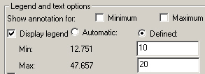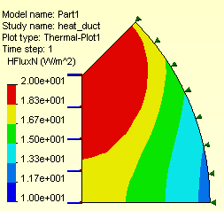

Figure 18 Controlling the outer edge flux contour range

Your computer model was only 1/8 of the total domain. Therefore, the true heat loss is Q _{total} = 116 Watts. Since the heat flow out from the cylindrical insulating surface must equal the heat flow in over the square duct surface you could employ a similar process on the inner edge as a double check (try it).

