Pressure Block Study with CosmosWorks (draft 4 11/19/05)

Introduction

A pressure container is formed from a brick of corrosion resistant steel. The block contains a center large cylindrical hole. Orthogonal to that is a second oval hole coming from the side and also going all the way through the block. The block is 24.75 inches square and 42 inches long. Its cylindrical hole is 18.75 inches in diameter. The oval intersecting passage matches the inner diameter, but has two 5 inch radius semi-circular ends on a rectangular center, as seen in Figure 1. The construction of the part was given in a previous example.
The main purpose of this example is to show how to do an analysis and how to take advantage of the many graphical features that can be selected to enhance your understanding of a component. They also help in documenting your written report.

The container is subjected to a (self-equilibrating) constant pressure of 20 ksi. Due to the symmetry in the geometry, materials, and pressure you can utilize a one-eighth symmetry study, which is also seen in Figure 1. Open that previous part with File→Open→PV_1_8.sldprt.

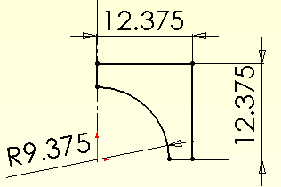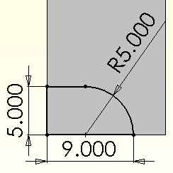

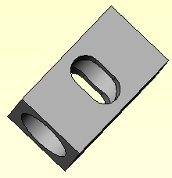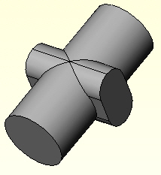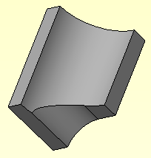

Figure 1 The pressure block , internal volume, and its symmetric corner

Estimated results

(NOTE: A hand calculation was not actually done before picking a wall thickness so the part will be found to be grossly overstressed. This is another example of needing to estimate the answers before you start to plan a component.)

It is desirable to try to estimate the stresses and deflections to be encountered. You will not find a handbook solution for a rectangular block with a pressurized cylindrical hole. However, you can find stresses and deflections for a thick walled cylinder with internal pressure (and free end walls). The axial stress is zero; the maximum radial stress is at the inner radius and is in tension. The hoop stress is tension and also maximum at the inner wall. Thus, you can find the principle stresses, and von Mises stress, at the inner radius. That wall is cut through by the oval channel. The cutout will cause a “stress concentration” where it cuts the inner wall (and elsewhere). There are handbook solutions for very similar elliptical openings. Combining such solutions may get us close to the stresses and deflections.

Young [3] gives the maximum axial, hoop, and radial (principle) stresses in a thick wall cylinder as σ ₁ = 0, σ ₂ = P (R² + r²) / (R² – r²), and σ ₃ = -P, respectively. Here, P is the internal pressure, r the inner radius, and R the outer radius. For your problem only the outer radius is not clear. You could use the inner radius plus the minimum wall thickness, or the average wall thickness. Since the intersection of concern is in the plane of maximum thickness (diagonal of the square) try that value. Then, P = 20 ksi, r = 9.375 inches, and R = 14.5 inches. The approximate values here are σ ₂ = 48.7 ksi and σ ₃ = -20 ksi. The maximum radial displacement is tabulated as δ _{max} = 2 P R r² / [E (R² – r²)], or about δ _{max} = 1.61e-2 inches. That displacement value should be on the low side, since most of the box wall is thinner that the assumed value. You could get an upper bound estimate by using the minimum wall thickness (R = 12.375 inches, so δ _{max} = 2.58e-2 inches).

The stress concentration factor, K, for an elliptical hole in a plane stress surface is known for a few ratios of σ ₂ and σ ₃ [3]. It depends on the ratio of the major and minor diameters of the ellipse. Here that ratio is about A/B = 18/9=2. The closest tabulated case is for equal magnitude tension and compression in the material around the hole. Then K = 2 (1 + A/B) = 6 (but the higher compression stress would possibly lower it to as low as 4). Thus, estimate σ _{max} = K σ ₂ = 292.2 ksi. That is far above the ultimate stress, and the corresponding von Mises stress will be far above the yield. Thus the planned linear solution results will be invalid. However, we can still use these numbers to try to validate the current linear analysis (which is a very poor one).

Begin a CosmosWorks study

Analysis type

Begin by selecting your preferred units:
- Select the CosmosWorks icon to open the Manager menu.
- Tools→Options→Document Properties→Units.
- Check IPS (inch, pound, second) as your Unit System, OK.
- Right click on the Part name→Study for the Study panel, which is seen in Figure 2.
- Enter PV_stress as the Study name, select solid as the Mesh type, and static as the Analysis type.
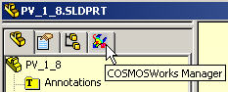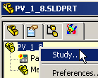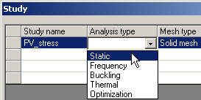

Figure 2 Starting the CosmosWorks analysis from SolidWorks

Material properties

The material is expected to operate at a temperature of about 400 F and contain a corrosive fluid. Either of those two conditions makes it unlikely that the standard library of materials will contain the alloy you need, C276 steel. Define the properties:
- Right click on the solid Part name→Apply/Edit Material in the Manager menu.
- When the Material panel opens check from library files in Selected material source.
- Click on Steel to expand the list of alloys, and check it for C276.
- Since that is not found check custom defined in Selected material source.
- Pick English units under Material model, type C276_steel_400F as Material name.
- Enter all the mechanical material properties. Also enter all the thermal material properties, OK.
The thermal properties are not required here, but you may need to compute a thermal study or a thermal stress study later. To find properties at a specific temperature you may have to search the Web or a materials handbook. Check for units consistent with the table.

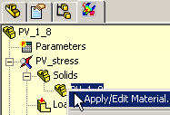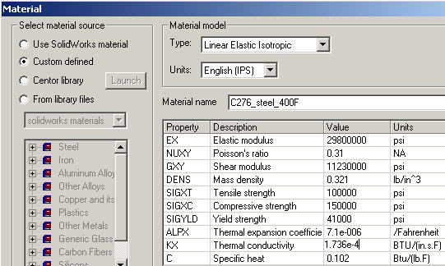

Figure 3 Type in special material properties

Apply displacement restraints on symmetry planes

Define displacement restraints that reflect the chosen symmetry, and eliminate the six rigid body motions (RBM):
- In the Manager menu, select Loads/ Restraints→Restraints to open the first Restraint panel.
- Pick On flat face as the Type and select the long thin rectangular part face as the Selected Entity, and first symmetry plane.
- Set the normal displacement component to zero under Displacement. That choice prevents one translational RBM and two (in plane) rotational RBM components.
- Click Preview (eyeglasses icon) to visually check the prevented motion.
- When satisfied pick OK (the green check mark).

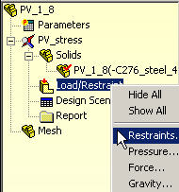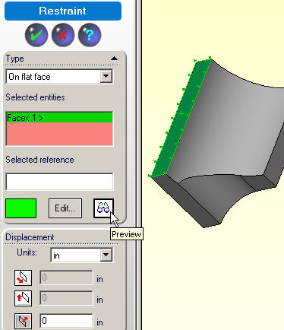

Figure 4 Restrain the first plane and three RBM

The above process is seen in Figure 4. Two model symmetry planes and three RBM still remain to be addressed. In a similar fashion pick the adjacent rectangular face, as seen in Figure 5, and restrain its normal displacement to zero. That prevents a second translational RBM and the remaining rotational RBM. Do the same for the final symmetry plane. That is also seen in Figure 5, and that restraint set eliminates the final translational RBM. Next the loading will be addressed.

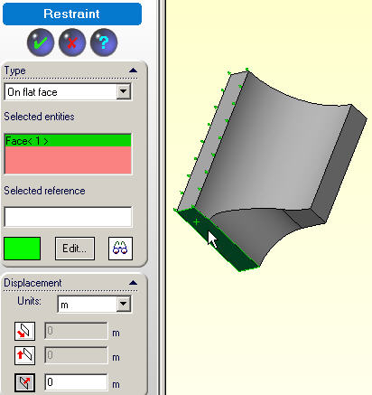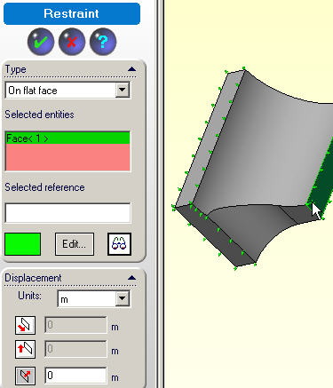

Figure 5 The next two symmetry restraint sets

Apply constant pressure

The entire internal surface will be subjected to the pressure:
- In the Manager menu, select Loads/ Restraints→Pressure to open the Pressure panel.
- Set the Pressure Type to be normal to selected face (in Figure 6).
- Select each of the three internal surfaces to be under Selected entities.
- Under Pressure Value set English Units and type in 20,000 psi as the Value.
- Click Preview to visually check the (red) pressure arrows around the perimeter of each surface. (Changing the sign of the value reverses the arrows.)
- When satisfied pick OK.

Note that a symmetric thermal loading could be included in the study, but gravity directed along the cylinder axis, for example, would require using a half part model and more computer resources. Since this is the first study, you probably will have to edit the part geometry and repeat this study. Avoid larger models until initial refinements are completed.

Use engineering judgment on the mesh

Mesh control

Next the mesh needs to be created. For an initial study you might get by with a default mesh size. However, an accurate mesh almost always requires engineering judgment to control the element sizes (or a high quality automatic error estimator). The three symmetry planes contain the smallest wall thicknesses, so as a first cut the mesh should be make smaller there:
- In the Manager menu, right click on Mesh→Apply Control to open a Mesh Control panel.
- Pick each of the symmetry planes to go in Selected Entities.
- Specify at least 5 Layers of elements in the Control Parameters.
- Also note the suggested default element size there and reduce it to about 0.5 inches (for these 3 inch thick walls).
- Accept the default transition rate of 1.5 for adjacent element sizes (Figure 7).
- Pick Preview to verify the controlled entities (not shown), OK.

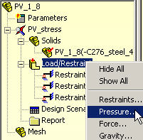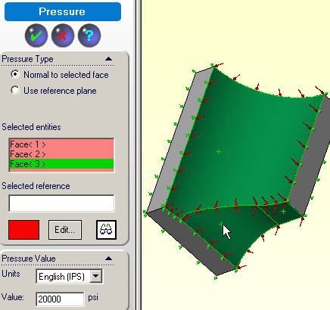

Figure 6 Specify the internal pressure distribution

The curved intersection line of the two passages might also be of concern. If so, you could have a second Apply Control, select those curve segments and specify the desired element sizes on that edge.

Mesh generation

When you are finished using your engineering judgment for planning the mesh, via Apply Control, then:
- In the Manager menu, right click on Mesh→Create to open a Mesh panel.
- There, move the selection bar from medium toward fine to make the average volume elements smaller (Figure 8), OK
- Build the mesh with Mesh→Create.

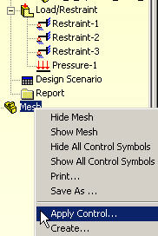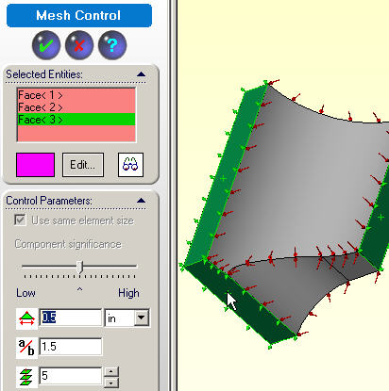

Figure 7 Inital surface mesh size control

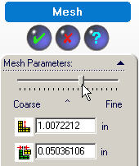

Figure 8 Average volume element size selections

The resulting initial mesh, looking toward the pressure surfaces, is shown in Figure 9. The elements are the default type of linear displacement interpolation elements (tetrahedral with four nodes). Three orthogonal plane views of the mesh are seen in Figure 10.

Compute the displacements

The mesh has three unknown displacements per node (or about 30,000 equations to solve). To execute the static solution and to recovery stresses the right, click on Study name→Run (Figure 11). Passing windows will keep you posted on the number of equations being solved and the status of the displacement solution process and post-processing. You should get a
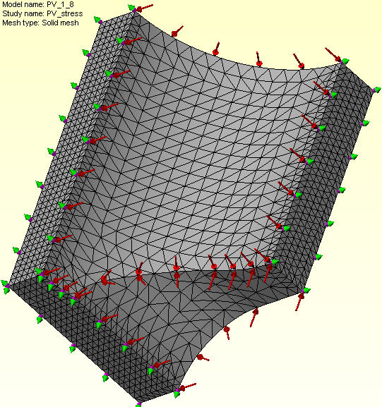

Figure 9 Initial solid element mesh

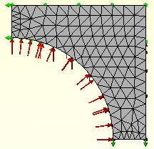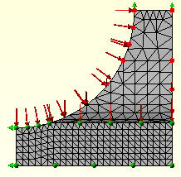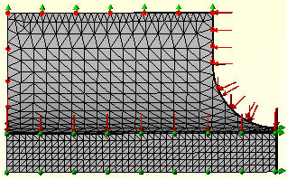
Figure 10 Alternate mesh views

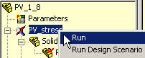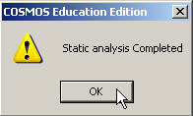

Figure 11 CosmosWorks static solution stage
notice that the analysis was completed (not a failed message). Then you have access to the various CosmosWorks report and plot options needed to review the first analysis.

Post-process the displacements and stresses

The default post-processing plot is a smoothly filled (Gouraud) contour display of the requested variable. If you do not have a color printer and/or if you want a somewhat finer description you may want to change the default plot styles. After a default plot appears:
- Right click in the graphics window and select Edit Definition →Displacement Plot panel→Display.
- Change from the default fringe Gouraud filled image to a Discrete filled or Line contour option.
- Double click again on the Plot icon.

Displacement magnitudes

To review the deformed shape magnitude:
- Double click Plot 1 under Deformation in the Manager menu, Figure 12.
- Double click Plot 1 under Displacement in the Manager menu. Rotate the view.
- Right click in the graphics area and select Color Bar to control the contour ranges seen in Figure 13.
- Right click in the graphics area, Edit Definition→Settings→Include undeformed part.
.

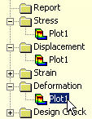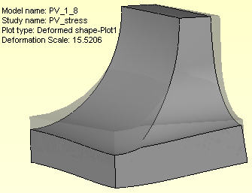

Figure 12 The scaled deformed shape
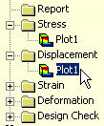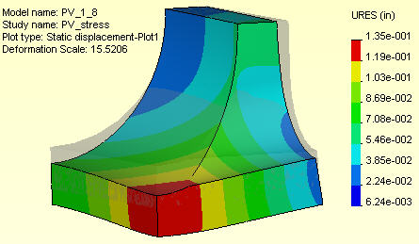

Figure 13 Displacement magnitudes

Displacement vectors

Displacements are vector quantities; therefore consider a vector plot first, as in Figure 14. Access them with:
- Right click in the graphics area, Edit Definitions→Displacement Plot.
- Double click again on the plot icon.
- Edit Definitions→Vector Plot Options

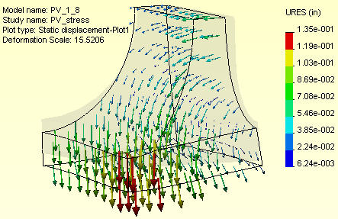

Figure 14 Displacement vectors and undeformed shape

Stress results

Next check the stress component levels by double clicking on Stress→ Plot icon. There are many types of stress evaluations available. The default one is the scalar Von Mises (or effective) stress. It is actually not a stress but a failure criterion, for ductile materials, that has the units of stress.

Von Mises failure criterion

Since you picked a ductile material, the von Mises value should be examined and compared to the material yield stress (greatly exceeded here). That can be done automatically for the whole part with the Design Check feature (as shown later). Figure 15 and Figure 16 show the surface values from three different points of view. The von Mises value is a scalar. To visualize the flow of the stresses you often wish to see the principle stress vectors, as in the next section.

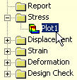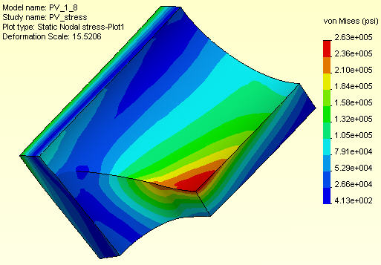

Figure 15 The peak von Mises stress levels

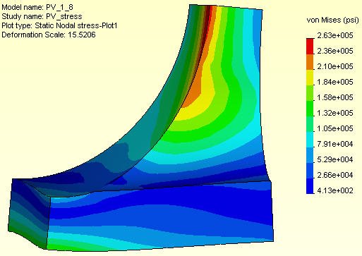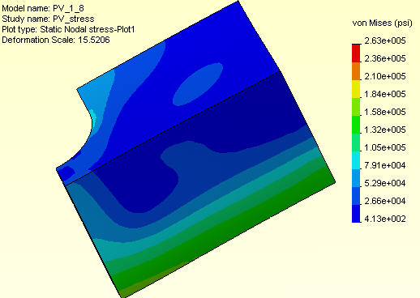

Figure 16 Other views of von Mises stress

Principle stress vectors

The three principle stress vectors are the eigen-vectors of the stress tensor at any point. That is, they are the magnitude and directions of the three extreme normal stresses at the point. The P1 component (Figure 17) will show the maximum tension, if any are present.

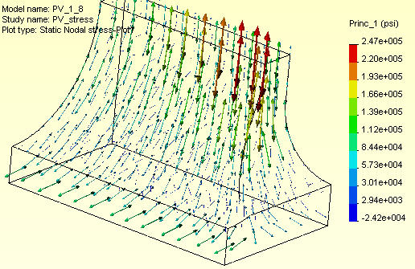

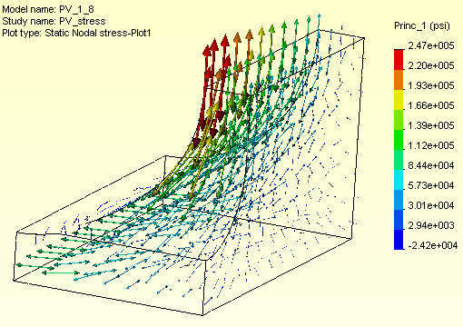

Figure 17 Two views of the maximum tension stress
Views, such as Figure 17, are even more informative when seen in dynamic rotation mode.

The principle stresses also correspond to the principle points in a 3D Mohr’s circle plot. Mohr’s circle is mainly used as an educational device since finite element calculations became wide spread. The P3 plot will show the maximum compression stress, if any compression is present. The maximum shear stress has a magnitude of (P1 – P3 ) / 2.

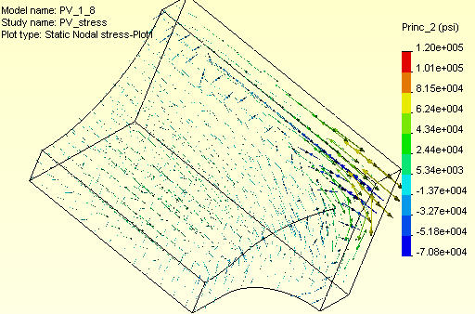

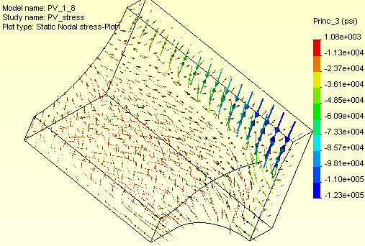

Figure 18 Second and third principle stress vectors

Von Mises isosurfaces

Isosurface displays are surfaces of constant values within the solid elements. They are similar to contours, but are computationally intensive to generate and rotate. It is best to display them with a small number of surfaces. To see isosurfaces of an item:
- Right click in the graphics area and select Edit Definition.
- For a stress item the Stress Plot →Display panel will open (Figure 19).
- Under Plot type check Iso, use a discrete Fringe type and 4 as the No. of surfaces.
- Select the desired Component and nodal values Result Type., OK.

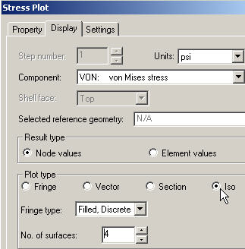

Figure 19 Selecting isosurfaces for stress components

The extreme values of a stress component in a solid will occur on a surface of the solid. There are times where you will be interested in the distribution of the interior values as well. For example, you may wish to see the low stressed volume of material as a guide to later removing it from the part by carrying out and extrude cut. Some optimization software can automatically function in that way.

To potentially identify portions of a ductile material for removal an isosurfaces display of the von Mises value is informative. As seen in Figure 19, only four surfaces were chosen for display. The edges of the part are included as a wireframe model to help you locate the isosurface locations. Typical orientations of those surfaces are shown in Figure 20, using the same contour levels. Even with that small number of surfaces you can see that the relatively low stressed volume is large. Such images are slow to change, in view rotations, even with 3D mouse hardware.
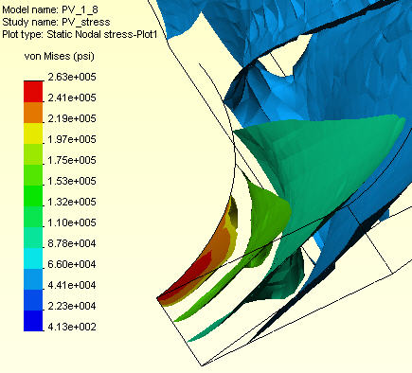

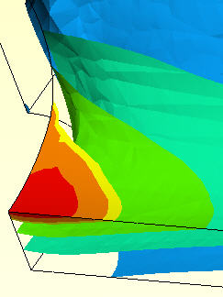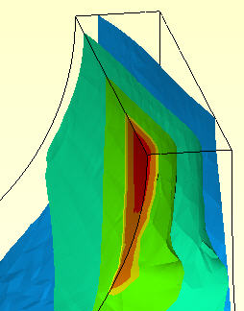

Figure 20 Three views of the von Mises isosurfaces

Von Mises stress on cutting planes

Contours shown on cutting planes can also be useful in seeing the internal distribution of an item. If you utilize only one cutting plane they are basically section views with contours added to them. Then you have the choice of also seeing contours on either the surface in front of, or behind the flat cut plane. CosmosWorks offers the ability to have multiple flat cut planes, with contours displayed, at the same time. Of course, you can control both their orientation and location. To activate such a plot for an item:
- Right click in the graphics area and select Edit Definition.
- For a stress item the Stress Plot →Display panel will open (Figure 21).
- Under Plot type check Section.
- Use a discrete Fringe type and 1 as the No. of sections.
- Select the desired Component and nodal values Result Type, OK.
- Right click in the graphics area, pick Clipping to open a Section Clipping panel.
- There use the slider bars to set the (X, Y, Z) components of the unit vector normal to the cutting plane. See Figure 22
- Use the Distance slider to dynamically position the plane in the part.

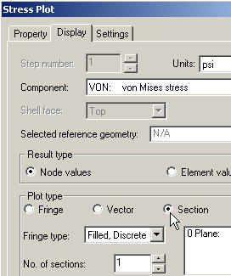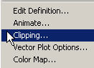

Figure 21 Selecting cutting planes for stress results

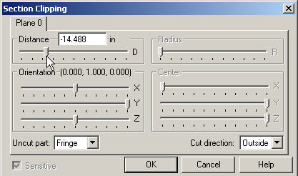

Figure 22 Set plane direction, position, and display choices

Using the cutting plane data in Figure 22 the von Mises value was chosen for display and the resulting image is in Figure 23. The cutting plane was parallel to the original part top sketch plane and was located near the maximum value near the to hole intersections. To show the user control another orientation is illustrated in Figure 24. Of course, line contours can be utilized, as in Figure 25, where a section normal to the X-axis was picked tangent to the cylindrical hole near its intersection with the second opening.

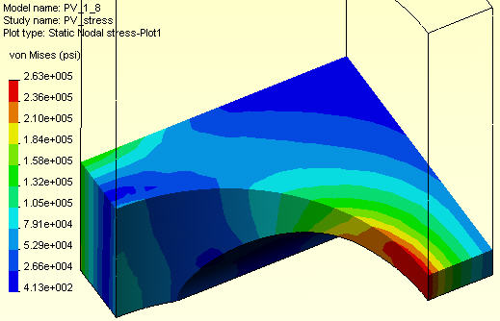

Figure 23 Contour levels at and below the plane of Figure 22

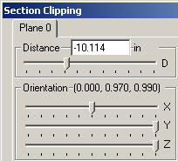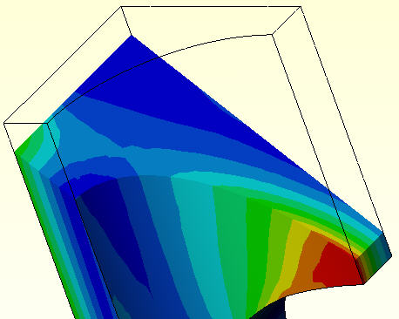

Figure 24 A new orientation and cutting plane display

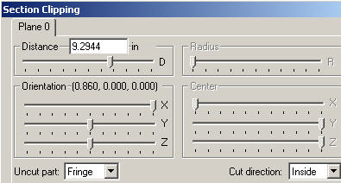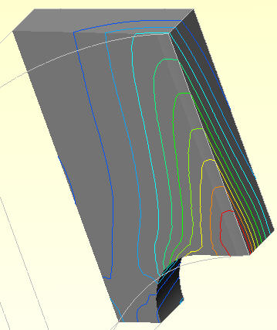

Figure 25 An X-section near the peak value

Factor of safety

(NOTE: A hand calculation was not done before picking a wall thickness so the part will be found to be grossly overstressed. This is another example of needing to estimate the answers before you start to plan a component.)

A useful feature of CosmosWorks is to allow the engineer to select a failure criterion and the plot the value of the factor of safety (FOS) based on that choice. The FOS should be greater than 1, and typically less than 4. Such a plot is obtained with:
- Double click on Design Check→Plot 1 in the Manager menu.
- Select the proper failure criterion for the material you have used.
- Execute the plot.

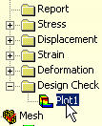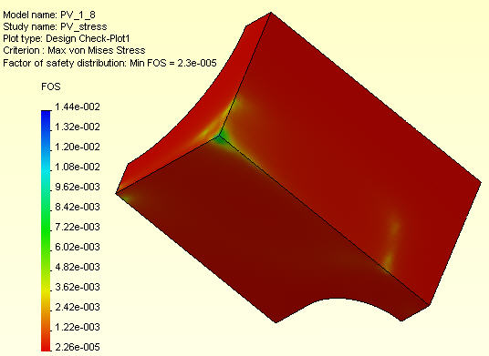

Figure 26 A typical Factor of Safety view

Comparing to estimated results

The computed outer deflection (Figure 14) was about 3.0e-2 inches, which is near the radial estimated range of 1.6e-2 to 2.6e-2 inches. The computed principle stress P1 (Figure 17) was about 247 ksi (compared to the hand estimate of 292 ksi) is closer than expected. The computed von Mises value (Figure 15) of 263 ksi is close to that value and the hand solution, using σ _{eff} = [(σ ₁ - σ ₂)² + (σ ₁ - σ ₃)² + (σ ₂ - σ ₃)²] ^{½} / 2 ^{½} . At least the initial related handbook estimates were less than a factor of three different from the computed ones (in one region).

Discussion and component revision

The computed result here shows extremely low (<< 1) values for the FOS. You must either drastically reduce the design pressure, which is not likely to occur, or significantly increase the wall thickness. You could easily place a small fillet along the high stress hole intersection curve in hopes of reducing peak stress levels.

A less easy task is to envision some way to pre-stress the current part so it would develop some initial compression in the high tension regions seen here.

A completely different approach would be to find a near optimal shape using finite element topological optimization. Then you would build a solid geometry that is very close to the computed optimal shape (which is usually quite irregular at its boundaries).

A less automated way would be to significantly increase the current part’s exterior dimensions, repeat the analysis, and use sectioning contours, like Figure 25, to establish sketch regions to sequentially Extrude Cut away material with a high FOS.

References

- B. Hassani, E. Hinton, Homogenization and Structural Topology Optimization, Springer, London, 1998.
- G.I.N. Rozany, N. Olhoff (Eds.) Topology Optimization of Structures and Composite Continua, Kluwer Academic Publishers, Dordrecht, 2000.
- W.C. Young, Roark’s Formulas for Stress & Strain (6-th Ed.), McGraw-Hill, New York, 1989.

