CosmosWorks Thermal Analysis (draft 2 12/7/05)

Description

A vertical square steel plate is 30.48 cm on each side, has a 1.27 cm radius center hole, and is 1.00 cm thick. The steel is measured to have a thermal conductivity of 25.95 W/m C. The center hole surface is at a temperature of 398.9 C and the left and right faces of the square plate have natural convection to air at 21.26 C and a convection coefficient of 408.9 W/m^2 C. The top and bottom faces of the plate are insulated. Conduct a study of the temperature and heat flux distributions, note the maximum temperature on the convection surface, and estimate the heat input necessary to maintain the center hole temperature.

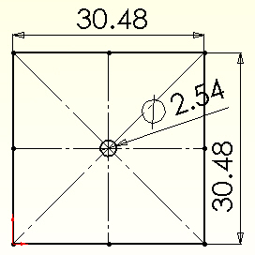

Hint
The software use here will be very similar to the example on under Demo Files→ CosmosWorks Demo Files→Local Singularity Heat Transfer. However, this study does not have a local singularity due to a re-entrant corner. This study is also similar to the original heat transfer tutorial.

Geometry

First select the working units (and a dual dimension display):
- Use Tools→Options→Document Properties→Units
- Set Unit System to centimeters, and Dual units to inches, OK
- Use Tools→Options→System Options→Detailing
- In Dimensioning standard turn on dual dimension display, OK

The problem geometry and material have one-eighth symmetry, but the restraints and thermal load have only one-fourth symmetry. Thus the best we can do from an efficiency point of view is to model one of the 90 degree segments. Note that by “cutting” the part with two symmetry planes, you will have to assign proper boundary conditions on those two planes to account for the removed material. Build the segment in the first quadrant of the x-y coordinate system:
- Use Top→Insert Sketch.
- Insert a 0 and 90 degree construction line through the origin
- Place and dimension the central arc
- Place and dimension the four lines
- Select Extruded Boss/Base (see Figure 1).
- In the Extrude panel set distance D1 to 1 m, and method to Blind, OK

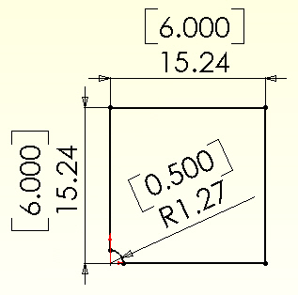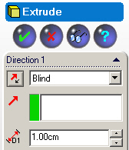

Figure 1 Use the first quadrant to extrude a model

Estimated solution

Before beginning the following finite element analysis you should estimate the temperature results and/or attempted to bound them. For a plane wall with a known inside temperature on one side and convection on the other the exact temperature solution is linear through the wall. The 1D analytic solution for that estimation [1] gives the temperature of the convection surface as

T_{s} = (h _{air} T _{air} + T _{wall} k/L) / (k/L + h _{air}),

where L is the thickness of the wall. The temperature along a line of symmetry can often be modeled with a 1D model that has the same end conditions as the symmetry line. Here those end conditions are the same and mainly their lengths vary. The lower length is L₀ = 0.1524 m, and the vertical and top line combine into L₁ = 0.2921 m. Therefore, the estimated outside wall temperatures here are

T₀ = (408.8 W/m^2 C * 21.26 C + 398.9 C * 25.95 W/m C / 0.1524 m)
______________________________________________________ = 132.3 C,
(25.95 W/m C / 0.1524 m + 408.8 W/m^2 C)

and likewise the top end point is estimated to have a lower value of T₁ = .88.5 C. These two estimates mean we expect the temperature on the convection surface to decrease from bottom to top points.

You can also estimate the heat flow through a 1D wall there (assuming parallel heat flux vectors) as q₀ = K (T _{wall} – T _{air} ) / L₀, which gives estimates of q₀ = 18,900 W/m^2, and q₁ =.9,865 W/m^2 at the same lower and upper points.

You can also anticipate some visual results that should appear in the post-processing. The temperature contours should be parallel to each surface with a given constant temperature (the central hole), and they should be perpendicular to any insulated surface (the top and bottom faces) and any symmetry plane. Neither case should occur at a convection boundary, except for the two special extreme cases of h = 0 so T_{s} = T _{wall} and h = ∞ (or h >> k/L) which gives T_{s} = h _{air}. Those two special conditions can exist, but they usually occur because of user data errors. Finally, the temperature and heat flux contours should be smooth. Wiggles in a contour usually mean that the mesh is too crude there. It wiggles occur in an important region the mesh should be refined there and the analysis repeated.

You can also visualize some of the heat flux vector results. First, they should be parallel to any insulated surface (or symmetry condition). They will change rapidly in magnitude and direction around the point of a re-entrant corner (or re-entrant edge in 3D).

Thermal study and material

To change from SolidWorks to CosmosWorks click on the CosmosWorks icon. In the CosmosWorks Manager panel
- Right click on the Part name and select Study
- In the Study panel set the Study name, static Analysis type, and mid-surface shell Mesh type (see Figure 2)
- Under the part name right click Mid-surface shell→Apply Material to all. A review of the Material panel standard materials yields no match. Thus, turn on Custom defined, in Figure 3, and type in 25.95 W/m C for Thermal conductivity, OK.



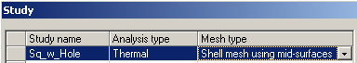

Figure 2 Changing fro SolidWorks to a CosmosWorks study

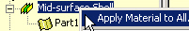

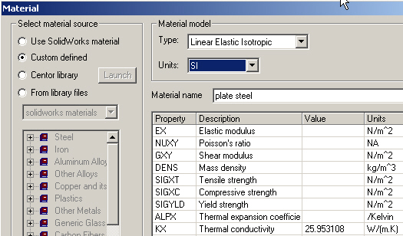

Figure 3 Define and apply a custom material property

Temperature restraint

Apply the only “essential boundary condition” (the known temperature) here. In the CosmosWorks Manager menu:
- Use Load/Restraint→ Temperature to open the Temperature panel.
- Set the Temperature to 398.9 C and pick the cylindrical face as the Selected Entity, in that panel as seen in Figure 4, OK.
Later, you will want to know how much heat must flow into the system to maintain that temperature. That is the thermal reaction.

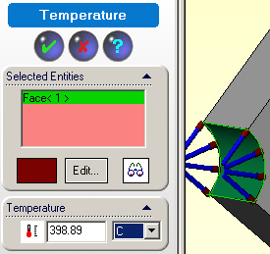

Figure 4 Envoke the essential boundary condition

Convection load
Invoke the right side free convection as the only loading condition. In the Manager menu:
- Use Load/Restraint→Convection to open the Convection panel.
- There, in Figure 5, pick the flat convection face as the Selected Entity
- In Convection Parameters set the convection coefficient, h = 408.8 W/(m^2 C)
- Set the air temperature to 294.26 K (about 70 F), and note that Kelvin is the only allowed input unit.
- Select Preview (eyeglasses icon seen in Figure 5), OK.
Remember that when you create a shell mesh it will be assigned the above extrusion thickness (in Figure 1), and will use it to compute the effective surface area that is subjected to the air convection.

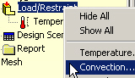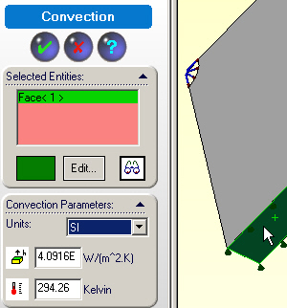

Figure 5 Supplying the free convection load condition data

Insulated surfaces

The insulated surfaces, which correspond to the top plane and the symmetry planes, require no action. That is because in any finite element thermal analysis that state (of zero heat flux) is a “natural boundary condition”. That is, it occurs automatically unless you actively prescribe a different condition on a boundary. This also means that the front and back of the extruded part (i.e., the “top and bottom” of your shell) are automatically insulated.

Mesh generation

The central hole is so small that you should expect to have high temperature gradients there and plan ahead to assure smaller elements there. In the Manager menu:
- Use a right click Mesh→Apply control.
- In Mesh Control (Figure 6) select the cylindrical surface as the Selected entity.
- Observe the default element size and reduce its value in the Control Parameter to 0.08 inch, OK.
- In the Manager menu right click Mesh→Create.
- In the Mesh panel select OK for mesh generation.
- To view the mesh, right click on Mesh→Show, in the Manager menu.

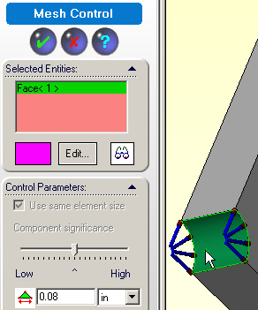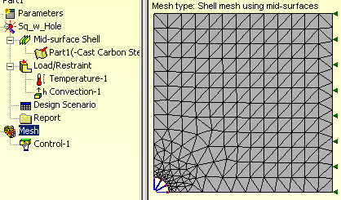

Figure 6 Use engineering judgment to control a mesh

Temperatures computation
Start the temperature solution with right click on the Name→Run. 
Usually you get a solution completed message. Sometimes the fast iterative solver might fail. That causes a “non-existent” data message when you try to review the results. If that happens you need to change to the sparse direct solver (under Tools→Options) which is slower, but more robust.

Post-processing

Temperature results
Begin the results review with a temperature plot. In the Manager menu under Thermal:
- Double click on Temperature→Plot 1. The default contour plot of temperatures would appear as a smoothed (Gouraud) color image. Usually a stepped shaded image gives a better hint of a bad mesh.
- To create one right click in the graphics window, Edit Definition→ Thermal Plot→Display.
- Set Units to Celsius and change Fringe type to discrete filled, OK.
- Right click in the graphics window, select Color map.
- In the Color Map panel pick 8 colors of thin Width and 2 Decimal places, OK.
Such a typical temperature plot is seen in Figure 7, on the left side.
For another type of view generate a temperature line contour:
- Right click in the graphics window, Edit Definition→Thermal Plot→Display.
- Change Fringe type to Line, OK, for the results in the right side of Figure 7.

Either form of the temperature contours display the visual features discussed above at the end of the Estimated Solution section. Also, you do not see wiggles in the temperature contour lines, so the mesh is not obviously poor. It is also possible to display and list the temperatures at any selected nodes. This is called probing the results. To do that you usually want to display the mesh (with or without the contours) and employ the probe command:
- Right click in the graphics window, Edit Definition→Thermal Plot
- Change the display from model to mesh, OK.
- Right click in the graphics window, pick Probe and use the cursor to pick the nodes whose temperatures are to be displayed and listed. The Probe panel lists the node, its temperature, and location coordinates as each one is picked.

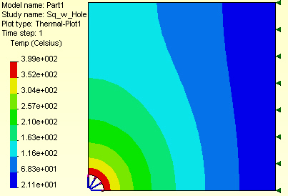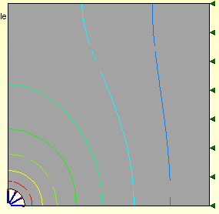

Figure 7 Temperature level contours

.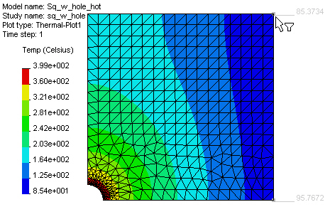 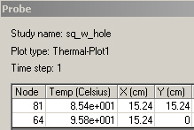

Figure 8 Probing the mesh for selected nodal temperatures (light gray)

You can also obtain graphs of selected results along the boundary of the part.
To obtain a temperature graph:
- Right click in the graphics area of a temperature plot, pick List Selected…
- Pick the desired edge (lower straight symmetry line here) as the Selected items.
- Click on Update. The summary of the temperature values along that path appear in the list at each node on that path. The Avg, Max, and Min temperatures appear in the Value column. In this case, as seen in Figure 9, those values were 237, 399 and 96 C, respectively.
- To see a graph of the temperature along that edge select Plot. That graph, in Figure 10, indicates a bad mesh if the graph is not smooth. Here it seems smooth, but it has a very sharp gradient at one end.

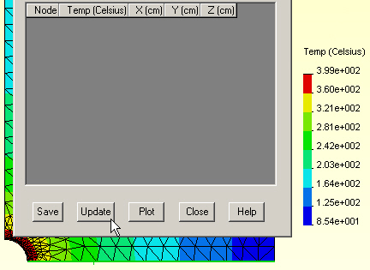

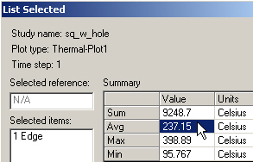

Figure 9 Summarizing the temperatures on a selected edge

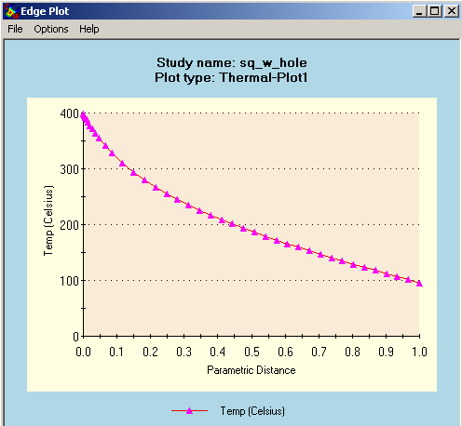

Figure 10 Graph of temperatures along lower symmetry line

Remember that the 1D approximation would give you a straight line between the max and min temperatures, so the actual temperature graph gives you some feel for how much to trust such a 1D estimate. Had you carried out this study with a 3D mesh you would still get the nodal summary data if you picked a surface before choosing Update, but you would not get the graph since the surface nodes occur in random order and are more difficult to represent in a parametric form (parametric surface) for arbitrary geometry.

The temperature distribution on the free convection surface is usually of specific interest. It also can some times be compared to known solution chosen to try to estimate a correct result, as is done here with a 1D estimate. Therefore it is desirable to supplement the above probe operation with an edge temperature summary and a graph. That is accomplished by repeating the last set of operations, but selecting the insulated edge as the selected item. The average temperature there is seen to be 90.4 C, in Figure 11. The corresponding temperature graph is seen in Figure 12, of a non-dimensional distance.
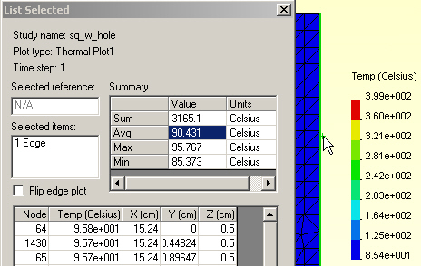

Figure 11 Nodal temperature summary for the convection edge

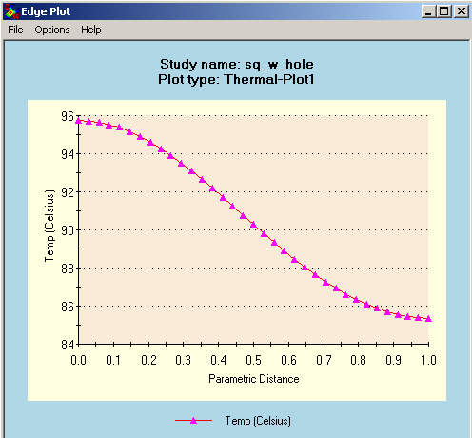

Figure 12 Graph of convection surface temperatures (y-increasing)

Temperature validation check

The 1D hand calculated T₀ temperature range along the convection surface ranged from 132 C down to 88 C. That agrees reasonably well with the computed range of 96 to 85 C for the actual 2D shape.

Heat flux

The heat flux is a vector quantity defined by Fourier’s Law: q = -K grad T. Thus, it is best displayed as a vector plot:
- Right click in the graphics window, Edit Definition→Thermal Plot →Display.
- Set Units to W/m^2.
- Pick Component resultant heat flux.
- Plot type vector.
- Fringe type line, OK.
- Dynamically control the plot with right click in the graphics window, select Vector Plot Options
- Vary the vector Size and Density (of the percent of vectors displayed). The heat flux vector plot is shown on the left in Figure 13 along with the heat flux magnitude on the right.

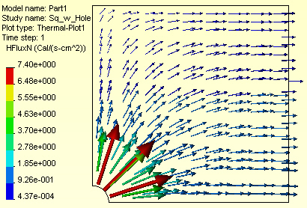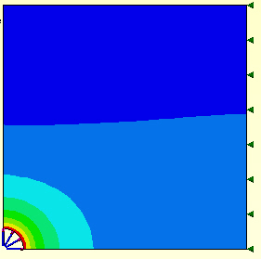

Figure 13 The heat flux (element centroid) vectors and (nodal) magnitudes

Like with the temperatures, one can obtain summary results for the heat flux on a surface or edge. To obtain a heat flux summary and graph for the convection edge:
- Right click in the graphics area of a heat flux plot, pick List Selected…
- Pick the desired edge (right convection line here) as the Selected items.
- Click on Update. The summary of the normal heat flux values along that path appear in the list at each node on that path. The Avg, Max, and Min heat flux magnitudes appear in the Value column. In this case, as seen in Figure 14, the average heat flux magnitude was about 28,400 W/m^2.
- Note that the Value column also contains the Total Heat Flow as 43.2 W (positive out, negative in) across the selected surface. It is the integral of the normal heat fluxes over the surface area selected.
- To see a graph of the normal heat fluxes along that edge select Plot. That graph, in Figure 15, is smooth and indicates a good mesh in that region.

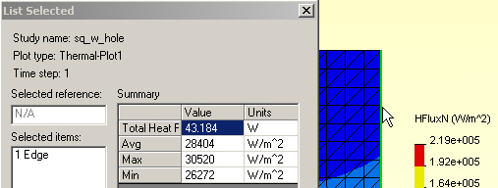

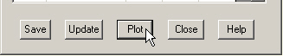

Figure 14 Heat flow and summary heat flux on the convection edge

The above heat flow out of this system (given above) should be equal and opposite to the heat flow coming in at the circular hole (since there were no internal heat generation rate data). If they do not reasonably agree then the mesh should be revised. Such differences occur since they are calculated from the gradients of an approximate temperature solution. The temperatures are always more accurate that the heat flux, but you need to have acceptable accuracy for both. Repeating the above procedure for that arc gives the total heat flow (Figure 16) as -43.1 W, an acceptable difference of about 2%.

Likewise, you can plot the heat flux crossing the circular arc (which is the required thermal reaction necessary to maintain the specified temperature). That graph is given in Figure 17. It is reasonably smooth but does show some wiggles. Since this is a region of high temperature gradients a slightly finer mesh should be considered around the center hole.

Heat flow reaction validation

A heat flow in or out of the system must occur at every specified temperature node and at any convection nodes. If your finite element system provides those data it is good practice to review them. CosmosWorks does allow you to recover those data, as shown above, but if it did not basic engineering would give you an estimate of the total heat flow (per unit length assumed here for the thickness into the page). Such a validation check is

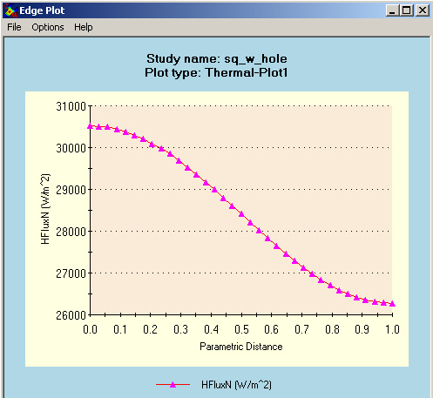

Figure 15 Graph of the normal heat flux out of the convection edge

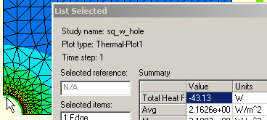

Figure 16 Checking the heat flow balance at the temperature restraint

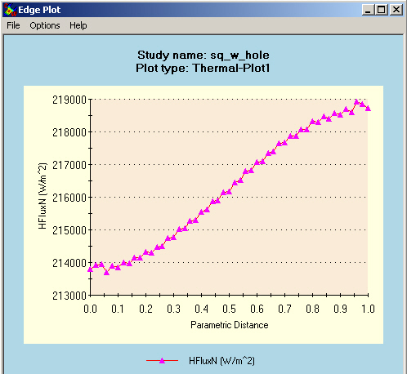

Figure 17 Graph of the normal heat flux into the system

important since it is not unusual for a user to enter incorrect values for the K and h values. The ratio of those values is important in convection calculations.

From the vector plot of heat flow in Figure 13 you see that at both the inner cylindrical surface and the outer insulated surface that the flow is basically normal to the surface. Integrating the normal heat flux passing through either surface gives the total heat lost.
To estimate the heat loss, manually change the color bar to more clearly give the range along the outer surface:
- Right click, Edit Definition→Thermal Plot→Settings
- Set the Display legend to defined
- Assign a minimum value of 0, and maximum of 5,000 W/m^2, respectively (arrived at by trial and error), for the results in Figure 18.

Estimate the length of the outer surface associated with each solid color heat flux range.
Multiply that distance by the thickness (1 m) to get the heat outflow surface area, and multiply by the average contour value (for that color) for its heat loss, in Watts. The length is 0.1524 m. The corresponding heat flux values (by averaging the color value ranges) is about 2.82e4 W/m^2, respectively. The total model heat loss, per unit length, is estimated as the average heat flux (per unit area) times the surface area, or Q = (2.82e4)(0.01*0.1524), or Q = 43.0 Watts. Here, this simple process differs from the numerically integrated result from CosmosWorks by less that 1 %. Your computer model was only 1/4 of the total domain. Therefore, the true heat loss is Q _{total} = 172 Watts.

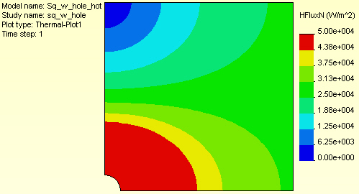

Figure 18 Adjusting the color bar to emphasize the convection surface

Reference:

- J.E. Akin, Finite Element Analysis with Error Estimators, Elsevier, London, 2005.

