Thermal Analysis of a Pressure Block (draft 2, 11/20/05)

Introduction

You previously went through the stress analysis of a (poorly dimensioned) block, shown in Figure 1, with an internal pressure. The cylindrical internal passage carried a fluid at 400 F, while the exterior surface was cooled by natural convection by surrounding cool water (at 45 F). The convection coefficient there is typical for water, h = 2.89e-4 BTU/s in^2 F. A uniform temperature rise of an unrestrained body will not cause thermal stresses to develop. However, here you should expect non-uniform temperatures that will cause thermal stresses. Here you will get the temperature distribution, using a conductivity of k = 1.736e-4 BTU/s in F, but delay the thermal stress load case until later. (Review the CosmosWorks tutorial on thermal stresses.)

The oval hole will be assumed to be filed with another solid surrounded by an insulating material. Later, you could repeat this study in an assembly that has those materials. That would give a more accurate temperature distribution around the oval opening (which is the main location of concern).

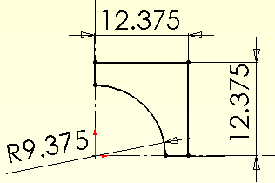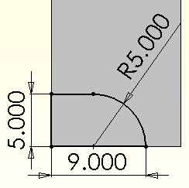

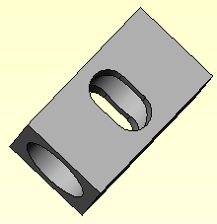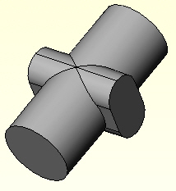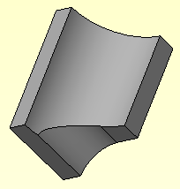

Figure 1 Solid block, its passage, symmetric corner, and material

Estimating a solution

Before beginning a 3D study it is wise to estimate some aspect of the answer in advance. The estimate might be analytic, 1D or 2D finite element, or a combination of those.
For plane walls the exact temperature varies linearly through the wall and linear finite elements can give an exact solution, with a single element through each material. But this part is closer to a thick wall cylinder, which generally has a logarithmic temperature distribution. Thus, a typical 1D finite element solution would need more than one axisymmetric element to get a reasonable approximate solution (as seen later).

There is an exact solution for a thick cylinder with the inside temperature given and convection on the outer surface. Here you could use that to estimate the unknown part temperature at the convecting water surface. You could get bounds by using the minimum and maximum (corner) wall thickness. Jiji [1] gives the analytic solution for the temperature through the cylinder. Let a and b denote the inner and outer radii, respectively. For a conductivity of k and convection to water at a temperature of T _{w} with a convection coefficient of h _{w} the logarithmic temperature distribution is:

T(r) = T _{a} – ln (r/a) (T _{a} – T _{w}) / [k / b h _{w} + ln (b/a)].

The radial heat flow (W/s) per unit length of the cylinder is constant, but the heat flux, q _{r}, is not because the cylindrical area of flux flow, A = 2π r, is not. The heat flux (W/s in^2) is

q _{r} = {(T _{a} – T _{w}) / [ ln (b/a) / k + 1/(b h _{w})]} / r.

To estimate the body temperature at the water simply set r = b. From the given data a = 9.375”, for this part 12.375” ≤ b ≤ 14.5” so say b = 13.4”. Here k = 1.736e-4 BTU /s in F, T _{w} = 45 F, h = 2.89e-4 BTU/s in^2 F so that T (b) = T _{b} = 84.6 F is a reasonable average estimate, and rising to about 98 F at the thinnest section. The heat flux is about q _{r} = 0.020 BTU/ s in^2 at the inner radius, and drops to about 0.015 BTU/s in^2 at the outer radius.

Begin the CosmosWorks thermal study:

The part had one-eighth symmetry, so that relatively simple geometry will be employed again here in a thermal study:
- First copy the geometry file and give it a new name, say Block_thermal.
- New→Part→OK.
- Right click on the Part name→Study to get the Study panel (see Figure 2).
- Enter a Study name, pick thermal as the Analysis type and use a solid mesh for the Mesh type, OK.
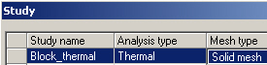

Figure 2 Begin a solid thermal study

Material property

Use the same material properties for C276 steel as before (or simply just the thermal conductivity value of K = 1.736e-4 BTU/in s F).

Temperature restraint

Only the inner circular surface needs a restraint:
- Load/Restraints→Temperature opens the Temperature panel, of Figure 3.
- There pick the cylindrical face as the Selected entity, enter 400 F as the Temperature, OK.

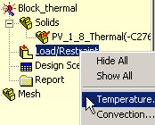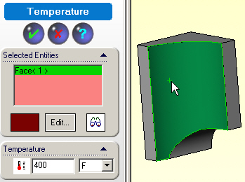

Figure 3 The known temperature restraint

Convection load

Only the two flat outer walls have convection. Apply it via:
- Load/Restraints→Convection to open the Convection panel.
- There pick the two faces as the Selected Entities, as seen in Figure 4.
- Enter 2.89e-4 BTU/s in^2 F for h, and 45 F for the temperature under the Convection Parameters, OK.
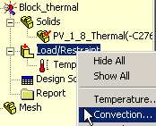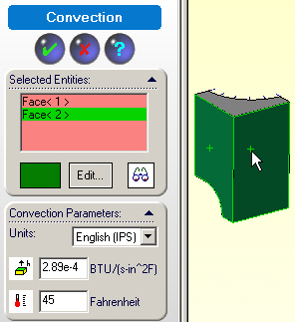

Figure 4 Exterior surface convection loads

Insulated surfaces

The remaining five surfaces are insulated. They include the three flat rectangular symmetry planes, and by assumptions the oval access surface and the top most surface. An insulated surface (zero normal heat flow) is a natural boundary condition in finite element formulations. They require no action or input by the user.

Mesh control and generation

Were the oval hole not present you would expect the temperature contours to be very close to those in a thick cylinder. Handbook 1D solutions are available for thick wall cylinder. That relatively uniform temperature distribution will be disrupted by the (insulated) oval hole. Therefore, you should control the mesh there:
- Right click on Mesh→Apply Control to open the Mesh Control panel.
- There pick all the edge curves on the oval surface to be the Selected Entities, just to be safe.
- Under Control Parameters reduce the element size from the default displayed value to 0.5 inch, OK. This is illustrated in Figure 5.
The resulting mesh given in Figure 6 is reasonable fine.

Temperature calculations

Pick Study name→Run to generate the solution.

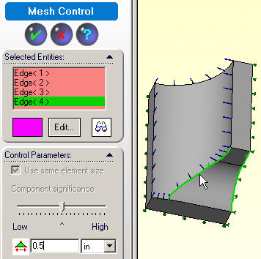

Figure 5 Mesh control at oval intersection edges

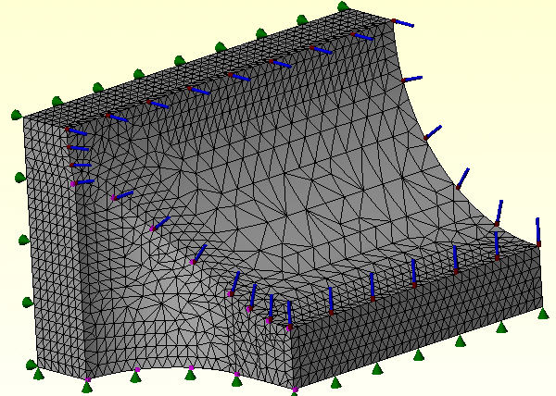

Figure 6 Initial solid mesh with thermal symbols

Post-processing

Temperatures

The only plots and probes are under the thermal report. Start with the default temperature plot:
- Thermal→Plot 1 gives the surface temperature plots. They will include the extreme values since no internal volumetric heat generation was active here.
- Rotate the temperature and search for the region of closest contour lines (highest temperature gradient) since that region would cause the highest thermal stresses.
- As expected, Figure 7 shows that occurs on the internal intersection line between the oval and the cylindrical holes. Examine that region in more detail in the bottom model view of Figure 8.

Even though the highest temperature will be on the surfaces, it may be useful to also plot an interior section so as to see how close most of the body would be to the 1D axisymmetric analytic solution:
- Right click in the graphics area, Edit Definition.
- Select Section and filled fringe, OK.
- Right click in the graphics area, pick Clipping.
- Select the Y-axis plane and move the slider to see various sections.

As expected, Figure 9 shows that the internal contours are almost nested cylindrical isosurfaces like (the logarithmic distribution) of a thick walled cylinder.

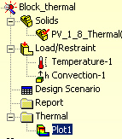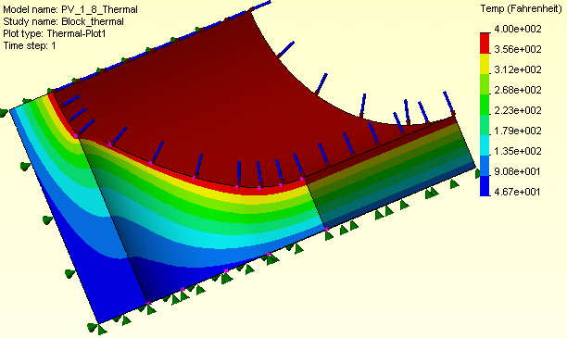

Figure 7 Temperature value surface plots

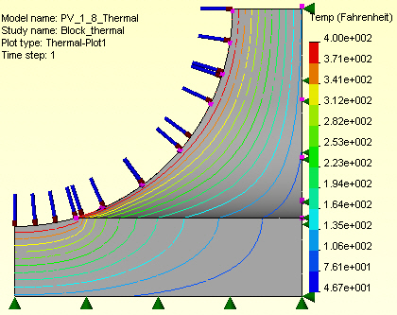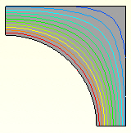

Figure 8 Temperature transition at middle intersection edge, and top surface

Heat flux
Regions of high thermal gradient, and thus high heat flux, may be missed with a smoothed temperature contour plot. Thus, also display them with:
- Right click in the graphics area, Edit Definition.
- Select resultant heat flux (HFLUXN) and the desired units, OK (see Figure 10).

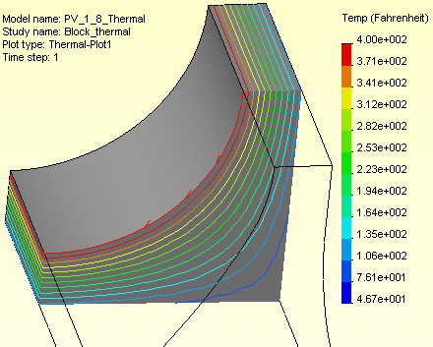

Figure 9 Nearly cylindrical temperature contours in an upper section

The magnitude display of Figure 10 confirms the location of concern for future thermal stress studies. Complete that check by looking at the heat flux vectors:
- Right click in the graphics area, Edit Definition.
- Select Vector, Line, OK.
The display in Figure 11 yields a final verification of the concern about the intersection curve area having high temperature gradients.

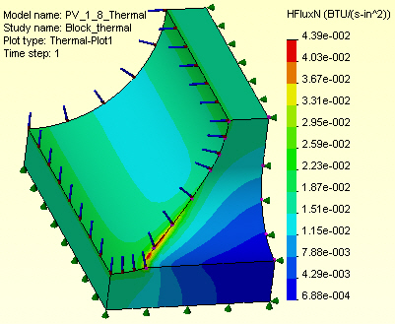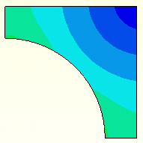

Figure 10 Magnitude of the heat flux peaks at the inner intersection, and top surface

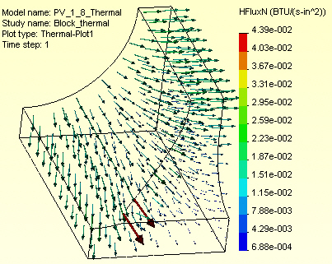

Figure 11 Wireframe view with heat flux vectors

Compare estimated and computer values

The estimated thin wall surface temperature of about 84.4 F agrees very well with the temperature contours seen in Figure 7 and Figure 8. A plot of the estimated 1D temperature is in Figure 12. The approximate average radial heat flux of about 1.8e-2 BTU/s in^2 is also in good agreement with Figure 10 and Figure 11. A plot of estimated heat flux is given in Figure 13. A matlab script for obtaining the two plots is given in Figure 14, of Appendix 1.

If you were not aware of the analytic approximation, or know how to derive it you could find a 1D (axisymmetric) finite element solution to estimate the expected results. The summary of such a solution is given in Appendix 2, based on the typical linear element described in Akin [2] for approximating radially symmetric heat problems. A single element could give an analytic estimate of the surface temperature. Such an element has a constant heat flux, so several should actually be utilized in a 1D validation check.
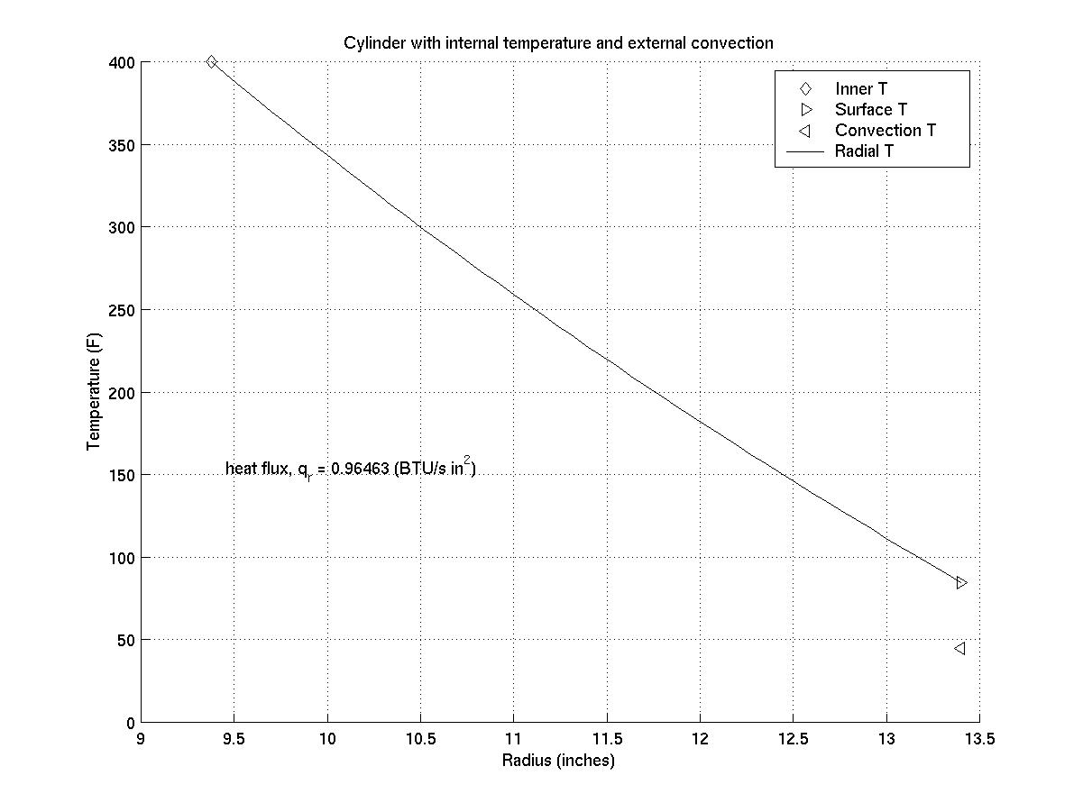
Figure 12 Typical analytic temperature estimate
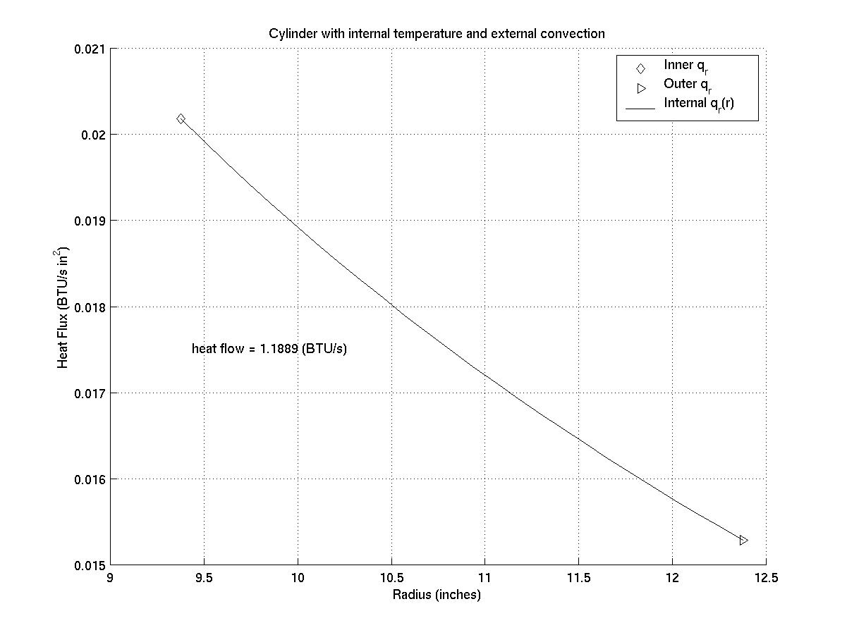
Figure 13 Typical analytic heat flux estimate

References

- L.M. Jiji, Heat Transfer Essentials, Begell House, New York, 2002.
- J.E. Akin, Finite Element Analysis with Error Estimators, Elsevier, 2005.

Appendix 1, Matlab analytic script

% Hollow cylinder with inner temperature and outer convection (part 1)
% Reference: L.M. Jiji, Heat Transfer Essentials,
% Begell House, New York, 2002

% problem constants

r_a = 9.375; r_b = 13.4; % radii (in)
T_a = 400 ; T_w = 45 ; % temperatures (F)
h_w = 2.89e-4 ; % convection (BTU/s in^2 F)
k = 1.739e-4 ; % conductivity (BTU/s in F)

% constant heat flow (BTU/s) = A(r)* q_r(r) = -k*A*dT/dr, A=2pi*r

flow = 2*pi*(T_a - T_w) / (log (r_b/r_a) / k + 1 / (r_b * h_w))
[f_ns] = num2str (flow) ; % convert flow to string and list

% variable temperature

n = 25 ; % number of divisions
dr = (r_b - r_a) / n ; % plot increment
r = [r_a:dr:r_b] ; % radius of interest.
T = zeros (size(r)) ; flux = zeros (size(r)) ; % pre-allocate arrays

T = T_a - log (r/r_a)*(T_a - T_w) / (k/r_b/h_w + log (r_b/r_a)) ;
fprintf ('Surface temperature is %g \n', T(n+1))

% plot temperature

clf ; hold ; grid on; % prepare frame
plot (r_a, T_a, 'kd') % inner temperature
plot (r_b, T(n+1),'k>') % surface temperature
plot (r_b, T_w, 'k<') % water temperature
plot (r, T, 'k-') % draw curve
legend ('Inner T', 'Surface T', 'Convection T', 'Radial T')
title ('Cylinder with internal temperature and external convection')
xlabel ('Radius (inches)') ; ylabel ('Temperature (F)')
[flux] = num2str (q_r) ; % convert flux to string and list
text ((r_a+dr), ((T_a+T_w)/3), ['heat flux, q_r = ', flux, ' (BTU/s in^2)' ])

% (script continues)

% Hollow cylinder with inner temperature and outer convection (part 2)

% heat flux q_r = - k * dT/dr

ratio = flow / 2 / pi ; % constant multipler
for j = 1:n+1 ; % fill array
flux (j) = ratio / r (j) ; % radial heat flux
end % for j

% plot heat flux

clf ; hold ; grid on; % prepare frame
plot (r_a, flux(1), 'kd') % inner heat flux
plot (r_b, flux(n+1),'k>') % surface heat flux
plot (r', flux, 'k-') % draw curve
legend ('Inner q_r', 'Outer q_r', 'Internal q_r(r)')
title ('Cylinder with internal temperature and external convection')
xlabel ('Radius (inches)')
ylabel ('Heat Flux (BTU/s in^2)')
text ((r_a+dr/2), (mean(flux)), ['heat flow = ', f_ns, ' (BTU/s)' ])

% end

Figure 14 Matlab script for analytic approximation

Appendix 2, Finite element line models

The finite element analysis using the two node line element can give good estimates of the neighborhood of the more complicated actual solution. In the current axisymmetric case the 2 by 2 conduction matrix no longer just depends on its length but also its location. That is because the normal area of conduction increases with the radius. Basically, you replace the matrix multiplier of k/L with 2 π k (r ₂ + r ₁) / [ 2 (r ₂ – r ₁)]. Likewise, the convection 1 by 1
square matric and source vector change from h to 2 π r ₂ h, and h T ∞ to 2 π r ₂ h T ∞ , respectively.

For the radial approximation under consideration, a single element model would involve only one unknown and can be solved in closed form to give:
T ₂ = T ₁ + (T ∞ - T ₁) h r ₂ / { k (r ₂ + r ₁) / [ 2 (r ₂ – r ₁)] + r ₂ h }.
That gives a convection wall temperature of about T ₂ = 85 F, which agrees with the 3D model reasonably well.

Using three such elements requires a numerical solution. The resulting temperatures are shown along with the analytic model in Figure 15. While the temperature estimates are surprisingly good the finite element flux results are not accurate, except near the middle of the element. They are shown in Figure 16. A Matlab script to compute these 1D finite element results are in Figure 17.
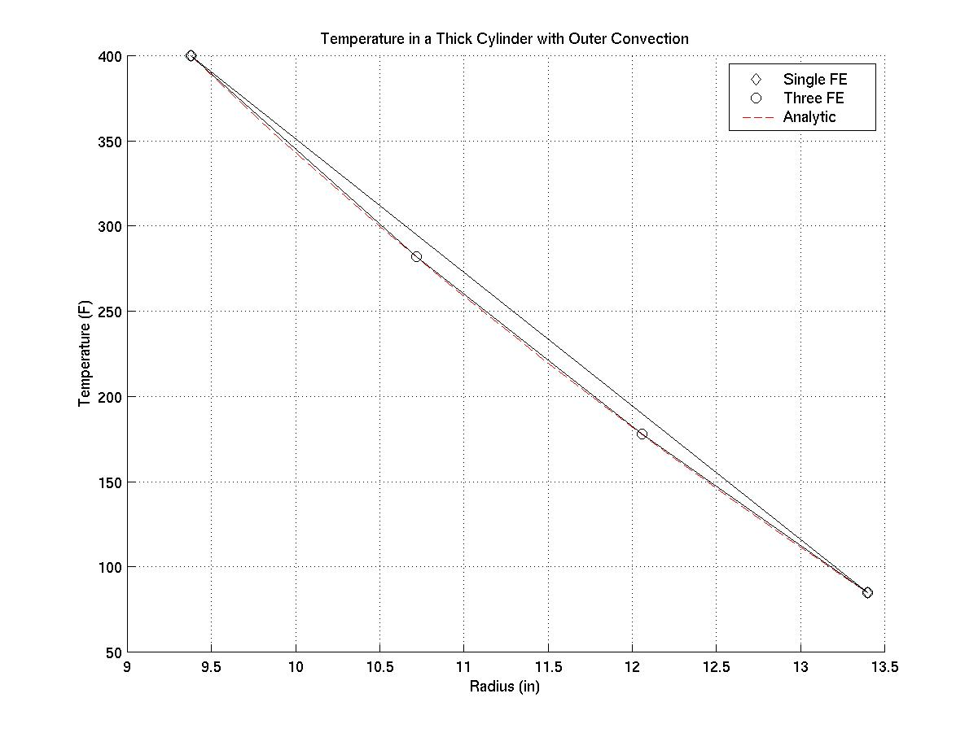
Figure 15 Comparing 1D temperature estimates
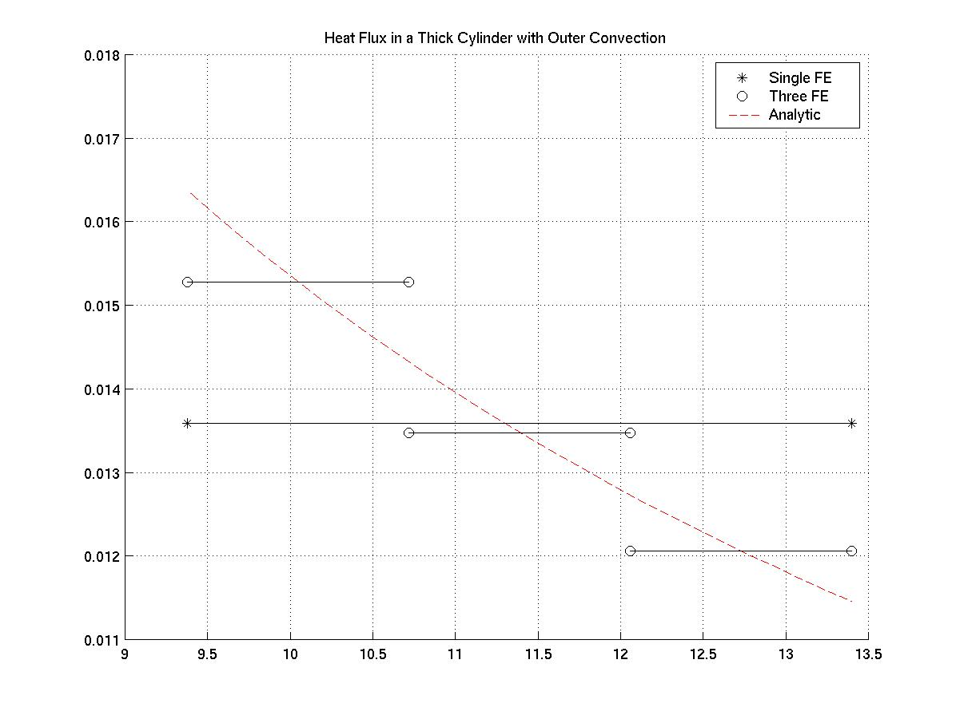
Figure 16 Comparing 1D heat flux estimates
% Three Linear FE Solution to Convection Outside a Thick Cylinder
% r_1 r_2 r_3 r_4
% T_1 *---(1)---*---(2)---*---(3)---* [water, h_w, T_w]
% T_1 T_2 T_3 T_4

% Set constants
r_1 = 9.375 ; r_2 = 10.717 ; r_3 = 12.058 ; r_4 = 13.4 ; % radii
K = 1.736e-4 ; h_w = 2.89e-4 ; % conductivity, convection coeff
T_w = 45 ; T_1 = 400 ; % water , inside temperature

% 3 Elements: Assemble 4 by 4 square matrix terms
X = [r_1, r_2, r_3, r_4 ] ; % merge lengths
S = [ S_1 -S_1 0, 0, ; ...
-S_1 (S_1 + S_2) -S_2 0, ; ...
0, -S_2 (S_2 + S_3) -S_3 ; ...
0, 0, -S_3 (S_3 + r_4*h_w) ] ;

C = [0; 0; 0; r_4*h_w*T_w] ; % Assemble 4 by 1 source terms

% apply essential BC at node 1
C (:) = C (:) - T_1 * S (:, 1) ; % RHS
S (:, 1) = 0 ; S (1, :) = 0 ; % clear, restore symmetry
S (1, 1) = 1 ; C (1) = T_1 ; % trick not to change array size

T = S \ C % Solve system for four temperatures

% Single Linear FE Solution to Convection Outside a Thick Cylinder
% r_1 r_4
% T_1 *--------------(1)------------* [water, h_w, T_w]
% T_1 T_4

% Recover non-constant 3 element heat flux
q_1 = -K * (T(2) - T(1)) / (r_2 - r_1) % Get heat flux through cyl
q_2 = -K * (T(3) - T(2)) / (r_3 - r_2) % Get heat flux through cyl
q_3 = -K * (T(4) - T(3)) / (r_4 - r_3) % Get heat flux through cyl

% Effective K/L for cylindrical conduction element (cancelling 2 pi)
S_s = K * (r_4 + r_1) / (r_4 - r_1) / 2 ; % single element

% 1 Element: Assemble 2 by 2 square matrix terms
Xs = [r_1, r_4 ] ; % length
Ss = [ S_s -S_s ; ...
-S_s (S_s + + r_4*h_w) ] ; % conduction & convection

Cs = [0; r_4*h_w*T_w] ; % Assemble 2 by 1 source terms

% apply essential BC at node 1
Cs (:) = Cs (:) - T_1 * Ss (:, 1) ; % RHS
Ss (:, 1) = 0 ; Ss (1, :) = 0 ; % clear, restore symmetry
Ss (1, 1) = 1 ; Cs (1) = T_1 ; % trick not to change array size

Ts = Ss \ Cs % Solve system for two temperatures
qs = -K * (Ts(2) - Ts(1)) / (r_4 - r_1) % heat flux through cyl

Figure 17 Matlab script for 1D finite element models

