Changing Equation Solvers

Sometimes you will see the CosmosWorks fast iterative solver fail to obtain a solution.
Then you may get a get an error message like “Information is non-existant” when you try to go to post-processing. When that happens change to the more robust , but slower, “Direct sparse” solver. In the Cosmos Manager Menu:
- Right click on the part name→Properties
- In the Thermal panel (or Stress panel) change from FFEplus to Direct sparse→OK.

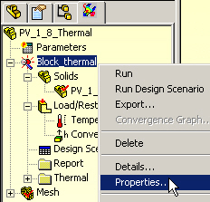

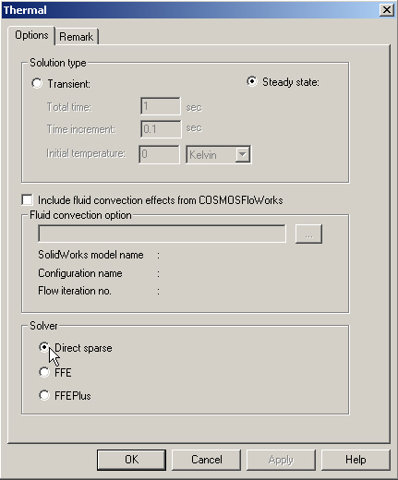
(end)

