What is a Fixed Support? (draft 2 2/19/06)

History

A study of the history of mechanics of materials shows that the concept of a fixed, or cantilever, or encastre support came from elementary beam theory. Originally it meant that a point at the neutral axis of a beam had both a zero displacement and rotation. That also implied that the support was capable of providing a reaction force vector and moment vector. Elementary beam theory neglects several things including Poisson’s ratio.

When a material is loaded in one direction, it will always undergo strains perpendicular to that direction as well as in that direction. The ratio of a transverse strain to the axial strain is a material property called Poisson’s ratio, μ = ε _{lateral} / ε _{axial}.

Engineering practice has developed standard symbols to represent a fixed support. But if you think about it, there are several ways a support can provide a resisting force and moment to prevent a region of material from translating and rotating. Some methods will prevent the secondary contraction required by Poisson’s ratio. Such supports therefore introduce very high transverse stresses to hold the material in place. In theory those “secondary” effects produce stresses that go to infinity at a point. In many applications you ignore those singularities because you know that the material will yield a little (if ductile) and/or the actual support material will move some to allow the point stress to remain finite.

Finite Element Stress Analysis

The use of finite element analysis in 2D or 3D requires you to always consider the effect of Poisson’s ratio and how to avoid or model the point singularity in stresses that it causes due to restraint assumptions that you make. As a typical example, consider a horizontal tapered cantilever beam with a single transverse (vertical) force distributed over its unsupported end. Elementary beam theory gives the horizontal (x) fiber stress as a function of the distance from the free end, without specific regard the supported end. But in a 2D (or 3D) model the stresses will be different. Beam theory assumes that the vertical, or Y, normal stress is zero everywhere. That is basically true in the 2D (or 3D) model because the top and bottom surfaces (and front and back faces) of the beam are free to contract, i.e. move vertically (horizontally), as required by Poisson’s ratio. However, it suddenly stops being true when you consider the support region.

At the wall in a 2D model the top fiber is being stretched horizontally. Due to Poisson’s ratio, that same point wants to contract downward. If that motion is prevented, as it is in the common assumption for a fixed support, then the vertical stress must suddenly jump from basically zero to an extremely high value over a small area to develop the support force necessary to prevent that contraction. Then theoretical stress singularities develop in the 2D (and 3D) theory of elasticity solutions, but probably not in the physical entities.

Exercise modeling choices

With finite element models you are no longer restricted to using a handful of standard symbols to represent a fixed support (or any other of the “stand” support types). You can examine the actual application and extend the solid model to include your knowledge of the actual support conditions.

For the cantilever example, assume it is steel and you know it will be welded to a much larger steel vertical member. Saint-Venant’s principle, from the theory of elasticity, basically says that the statically equivalent forces or supports located a few “typical dimensions” away on an object will not affect results in the main regions of the object. Therefore, consider a finite element model where the classic “fixed” support is replaced by a semi-circular region of the vertical steel member. Pick its radius as the depth of the cantilever, and fix (in the classical sense) the outer half circle. That will be statically equivalent to the standard symbol but will produce more realistic stresses near the support region.

Example: End wall tapered (1:3) cantilever, images only

Dimensions
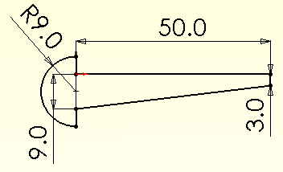 Thickness = 2

Displacements

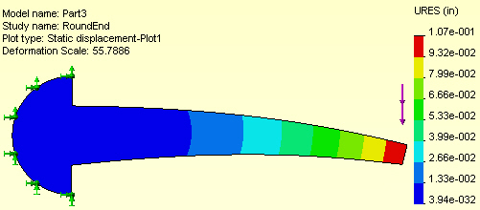

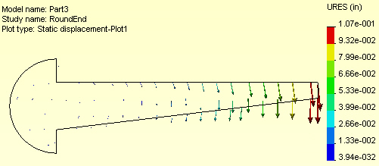

Stress results

Effective stress

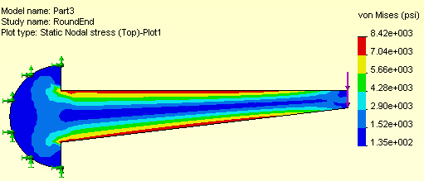

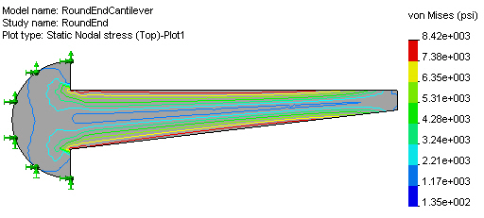

Horizontal and Vertical Stresses

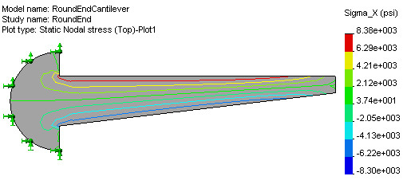

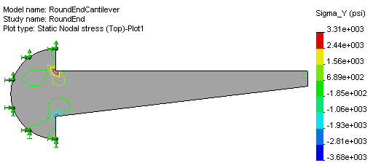

Shear stress

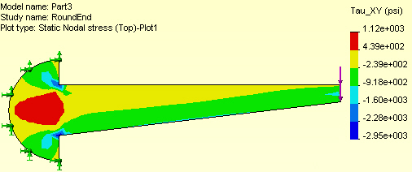

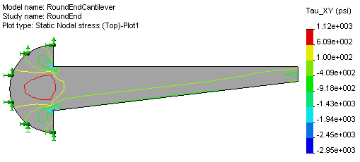

Principal stresses

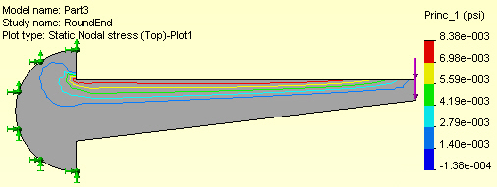

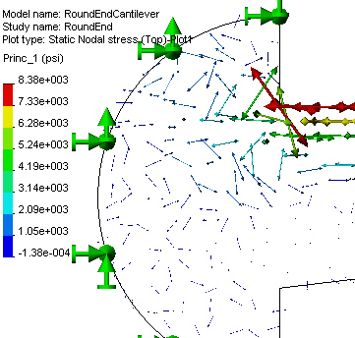

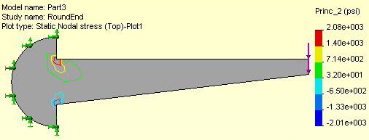

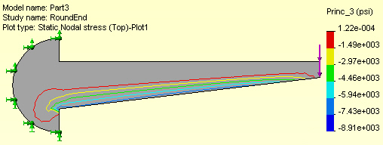

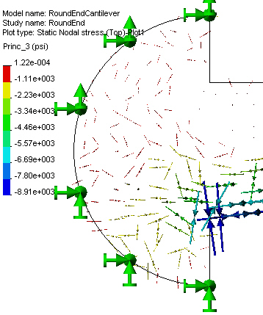

Factor of safety

