Changing SolidWorks Background Color

Screen captures look and print better with a light background color, like yellow or white, rather that the more eye pleasing default blue or green. Use the defaults for you studies, but when you go to save images with a Windows Print Page command, or the SangIt program use the following steps to temporally change the colors.
- Pick Tools→Options→System Options→Colors
- Select View Port Background so current color appears
- Hit Edit
- Select a light color from the Color panel→OK
- Repeat for the Top Gradient Color of the graphics window
- Repeat for the Bottom Gradient Color of the graphics window
Produce and save your documentation images, then repeat the above steps and return items to your favorite default colors.

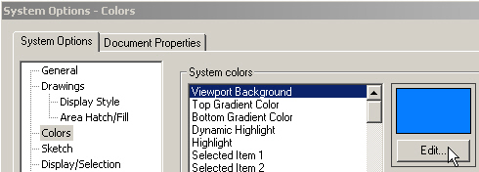
Steps 2 and 3

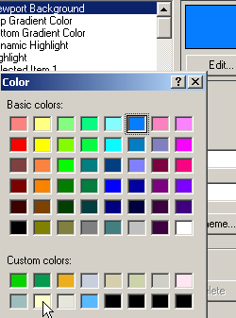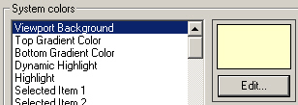
Step 4

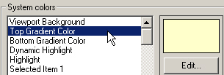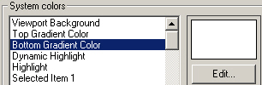
Steps 5 and 6

