Building a Pressure Block with SolidWorks (draft 1)

Introduction

The goal here is to form a pressure container from a brick of corrosion resistant steel. The block contains a center large cylindrical hole. Orthogonal to that is a second oval hole coming from the side and also going all the way through the block. Start SolidWorks and select your preferred units:
- Tools→Options→Document Properties→Units.
- Check IPS (inch, pound, second) as your Unit System (see Error: Reference source not found).
- If dual unit displays may be needed select millimeters as the Dual units, OK.
- To optionally show the dual units, Document Properties→Details, check Display dual units.
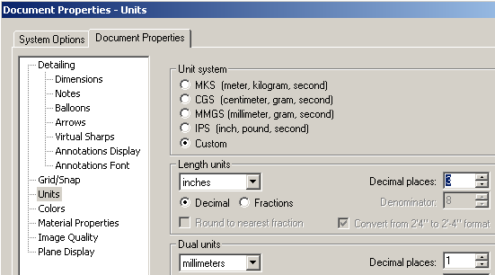 | 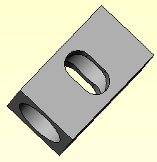
Figure 1 Selecting preferred display units | Figure 2 The full part

Build a one-eight segment

The full model, illustrated in $, could be built with two extrusions. However, you will build a one-eighth symmetry model to minimize the finite element recourses for studying the press loading. Mirroring that segment will build the full model, but the intermediate stages can be efficiently used for combined gravity and pressure loads, and the final full model for any general, non-symmetric load states.

Main segment

The main cylindrical hole will be vertical so begin work in the top plane:

- Right click Top→Insert sketch. | 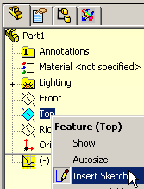
- Insert two centerlines from the axis origin, and then construct a quarter circle. | 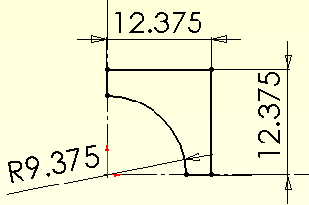
- From the bottom of the arc insert two horizontal and vertical lines to close the segment.
- Use the Smart dimension to set the arc to 18.75/2 inches, and the outer two sides to 24.75/2 inches.
- Select Extrude Boss/Base to open the Extrude panel. | 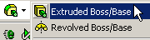
- Select blind for Direction 1 and D1 to 21 inches, OK (see Error: Reference source not found). | 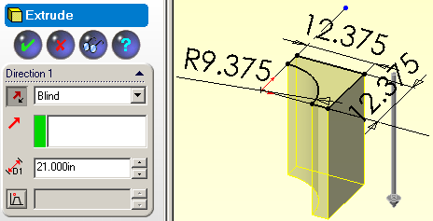
- Verify the final shape. | 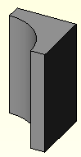

Cross passage

The oval intersecting passage matches the inner diameter, but has two 5 inch radius semi-circular ends on a rectangular center. Build one-fourth of the area and cut it out:
- Click on one of the rectangular walls, Insert sketch.
- Sketch and dimension the area to be cut out.
- Pick Extruded Cut to open the Cut-Extrude panel.
- Select through all as the Direction 1, OK.

Verify the completed 1/8 symmetry part as summarized in Figure 3. (Rotate it by holding down the center mouse button and move the mouse). When you are satisfied that it is correct save this stage, using PV as short for Pressure Vessel:
- File→Save as PV_1_8.sldprt (for pressure or thermal loading only).
- Continue the construction process as described next.

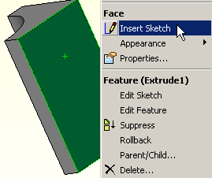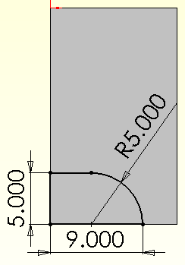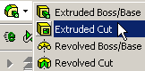

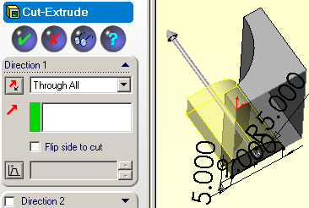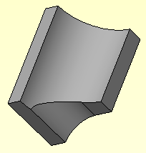

Figure 3 Completing the 1/8-th symmetry section

Mirror for quarter model

Continue the construction with:
- Insert→Pattern/Mirror→Mirror to open the Mirror panel.
- Select the small rectangular face to be the Mirror Face, open Bodies to Mirror.
- Select the original body and preview the new shape.
- Check Merge bodies, OK.
- File→Save as PV_1_4.sldprt.

These steps are outlined in Figure 4. Next you generate the half body.

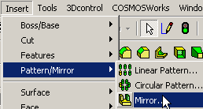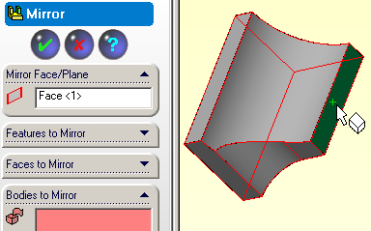
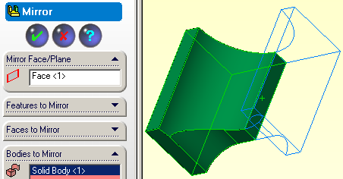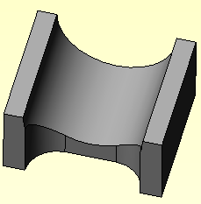

Figure 4 Completing the 1/4-th symmetry body
.

Mirror for half model and full model
Continue this approach:
- Mirror and merge using either of the flat center planes, as in Figure 5.
- File→Save as PV_1_2.sldprt for pressure and gravity loading.

That gives the half model. One more repeat finishes the initial part:
- Again, Mirror and merge using either of the flat long rectangular planes illustrated in Figure 6.
- File→Save as PV_1_1.sldprt for arbitrary loadings.

Now any of the saved part stages can be used to minimize the CosmosWorks resources, and engineer’s time. The choice will, of course, depend on the load conditions. (Look for a similarly named CosmosWorks demonstration.)
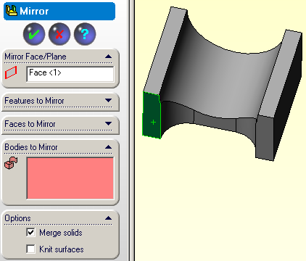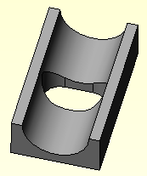

Figure 5 Mirror again for half the part.

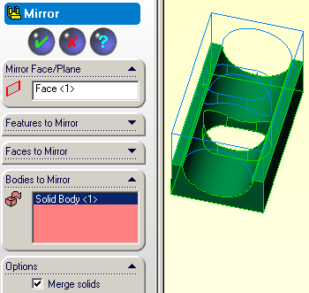

Figure 6 Completing the part with another mirror operation

