Sample Part Mirroring

Introduction

When you know in advance that the part has symmetry that needs to be used in a finite element analysis you can start with the smaller symmetric region model and then use mirror operations to fill out the full part. As an example, consider a thick wall acrylic fish tank. A quarter symmetry analysis part is given in Figure 1. The colors of the faces were changed as a reminder, during the analysis, that they were subject to different boundary conditions (restraints) or loads.

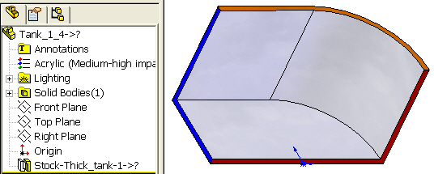

Figure 1 Initial quarter symmetry part

Mirroring a part

We start with Insert→Pattern/Mirror→Mirror, as in Figure 2.

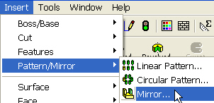

Figure 2 Beginning a mirror operation

That leads use to the Mirror panel, which has several options. First for the Mirror Face/Plane pick the flat front L-shaped (red) plane; next select Bodies to Mirror and Merge solids to make half of the complete tank, as shown in Figure 3 and Figure 4.
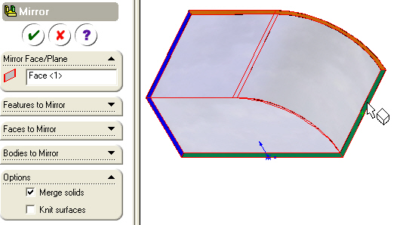
Figure 3 Selecting the X-Z flat face

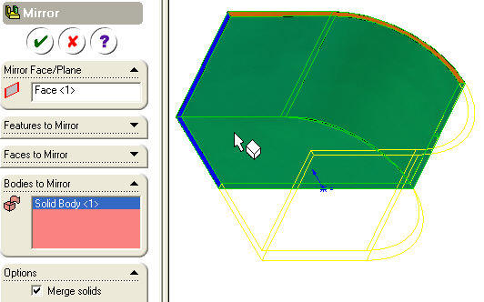
Figure 4 Selecting the body

In Figure 5, note that the (red) mirror face vanished in the merging process. You repeat the Insert→Pattern/Mirror→Mirror operations using the U-shaped (blue) flat face (Figure 5).

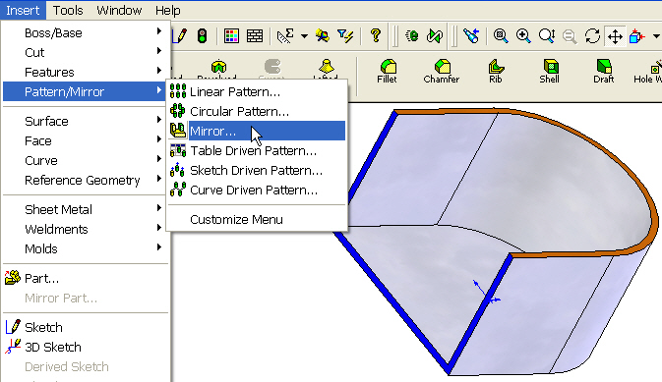
Figure 5 Preparing the second mirror operation
Next you again do a mirror Insert→Pattern/Mirror→Mirror of the half body by picking the Y-Z flat face, as in Figure 6Figure 6 Picking symmetry plane of the half body will form a full oval shaped tank.

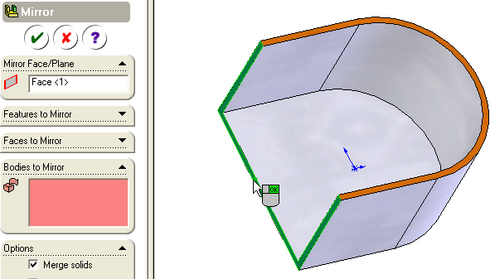

Figure 6 Picking symmetry plane of the half body

Picking the new half body, as seen in Figure 7 Previewing the oval tank, gives a preview of the resulting oval tank.

: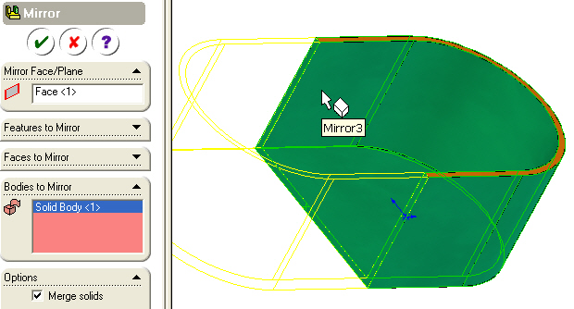

Figure 7 Previewing the oval tank

Now you have the full tank model, given in Figure 8. Again, the merge operation removed the U-shaped construction plane.

You should recognize that if you needed a closed thank of this shape you could continue and mirror about the top oval plane. That would correspond to what is called using one-eight symmetry and that resulting shape is given in Figure 9.

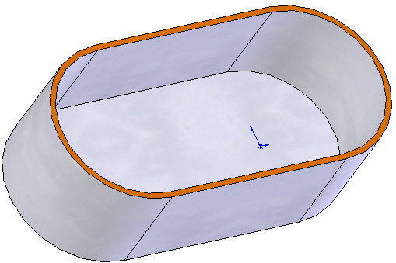

Figure 8 The completed full tank model

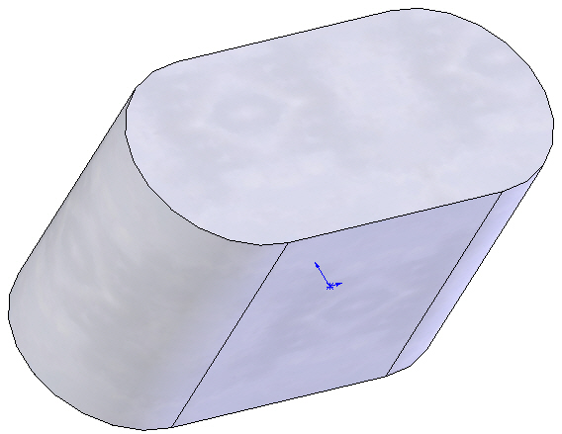

Figure 9 Closed tank from one-eight symmetry

One alternate design option would have been to have a fish tank with a curved bottom. For that you could have picked the (orange) flat curved face (of Figure 6), as illustrated in Figure 10.

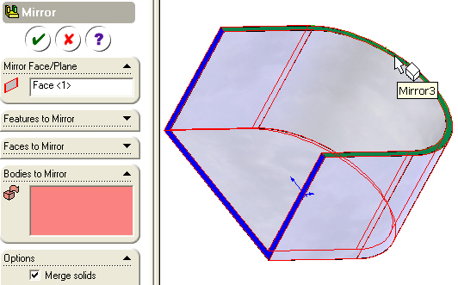

Figure 10 Planning for a curved bottom

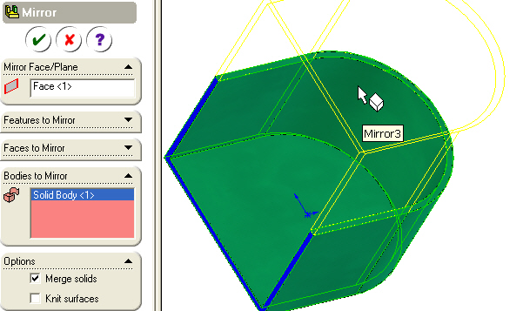

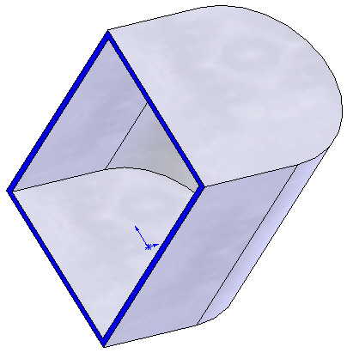

Figure 11 Preview and final curved base tank
Other types of products could be made from the original model as seen in Figure 12 and Figure 13.

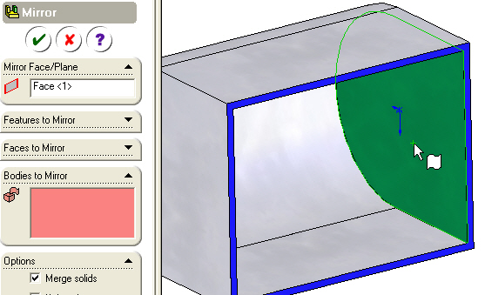

Figure 12 Planning for a trough

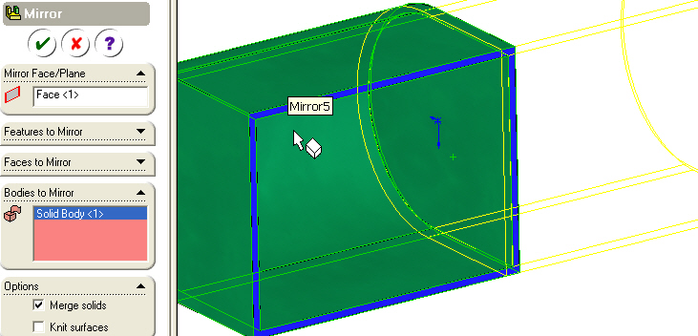
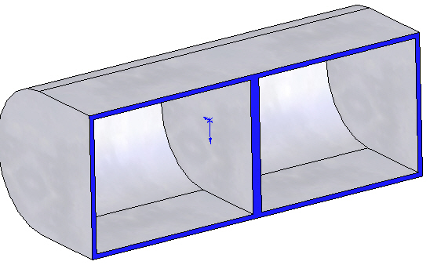

Figure 13 Previewed and final trough

