Simple Assembly Mirrors

It is often desirable to use symmetry in an analysis phase. One question a user faces is whether to start with the symmetric piece and then build the full model, or split the full part to extract the symmetric segment. Recall that the chip thermal tutorial used only a one-quarter symmetry part as shown below.
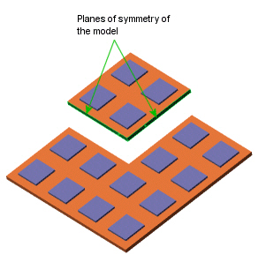After you are satisfied with the results and find no need to change the part you can create the whole part by making mirror copies that, by default, are joined at their common face. Begin with the quarter symmetry assembly:

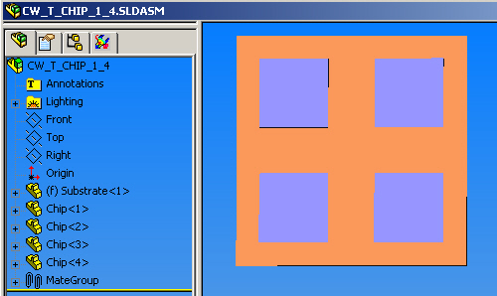

Then select Insert, Mirror Components

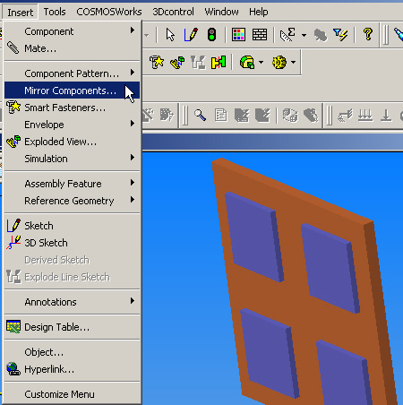

The Mirror Components panel appears. First you select the face, or plane, that is to be used as the mirror. Next select all components to be in the mirrored segment, and select OK. That doubles the part. Now repeating the mirror process along the bottom (to be center) edge you get the full part. In this case it contains a total four merged copies of the original assembly.
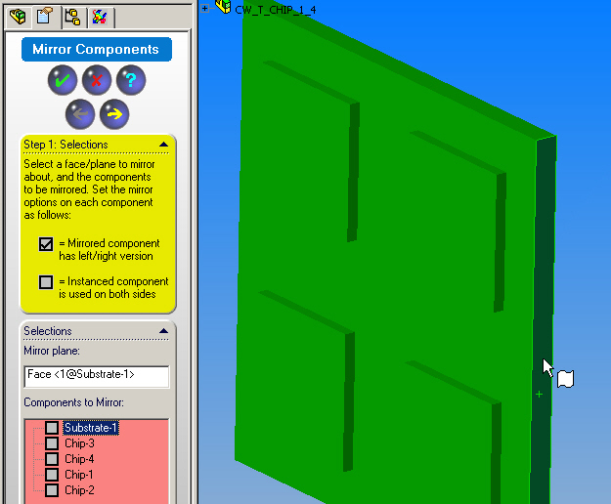

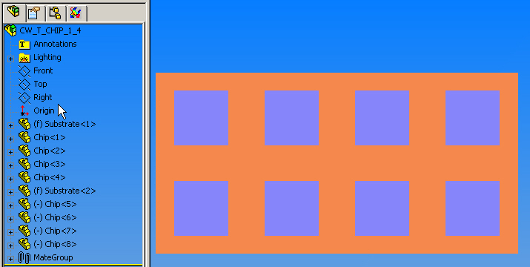

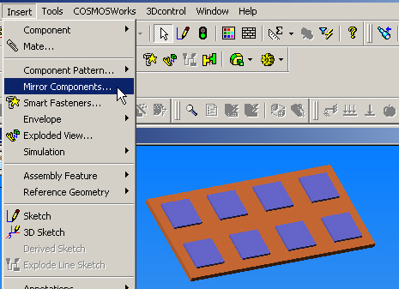

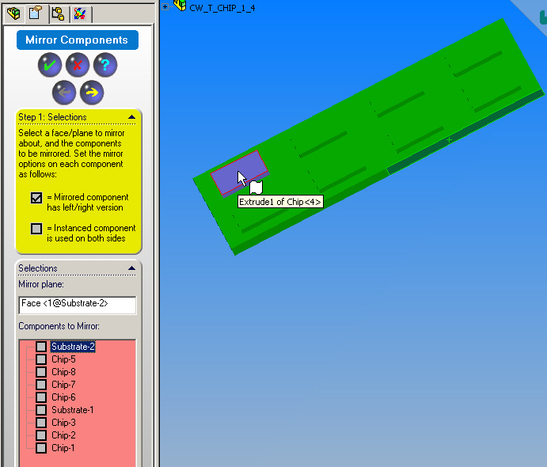
The final result is shown below.

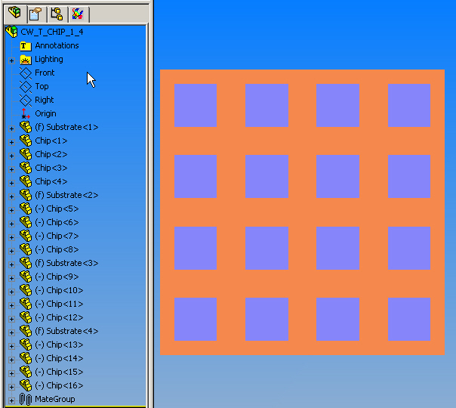

Note the full list of all the components begins with your quarter segment part.

---------------- end --------------

