Splitting Parts in SolidWorks (draft 2, 12/1/05)

Introduction

You probably have seen how you can split surfaces or curves with “split lines” so as to accurately apply loads or restraint data. For analysis reasons it is often more efficient to likewise split a part in half, or multiple times to take advantage of quarter symmetry, 1/8th symmetry, etc. To illustrate these concepts for splitting parts you will begin with a thick walled tank similar to the one in the CosmosWorks hydrostatic pressure tutorial. You should open that part and save it with a new name to practice the part splitting. To open it use:
- File→Open→\COSMOSWorks_Installation_directory\ Examples\ fuel_tank.SLDPRT.
- Verify that you have the part seen in Figure 1.
- Since you are only interested in the geometry select the SolidWorks icon, .

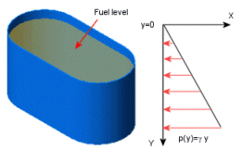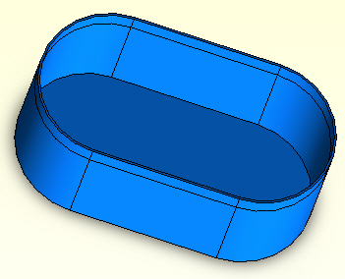

Figure 1 An open tank part

Construct the split lines

In that tutorial you should recognize that the geometry, material, supports and pressure loads exhibit one-quarter symmetry. Thus, you will locate the base center and then insert an “L” shaped parting line that lies in the two symmetry planes that meet at the center of the part:
- In the SW management menu select Top→Insert Sketch. .
- If the part was constructed with the coordinate axes at the center then use that reference point. Otherwise insert two diagonal construction lines from the inner walls to locate the center of the base. (see Figure 2)
- From the base center point sketch two orthogonal lines from the center to slightly outside the part. They will serve as your part trim tools to split the part.

Split the part

To proceed with utilizing the two lines to split the original part:
- Insert→Features→Split to open the Split panel.
- Accept the current sketch (sketch6) as the Trim Tools.
- Check Show bodies, as shown in Figure 3
- Select Cut Part. The split creates two bodies as you can see from the new surface lines as viewed in Figure 4.

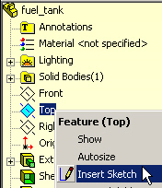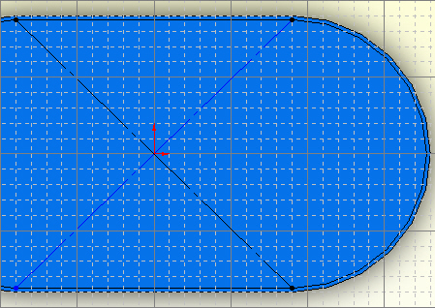

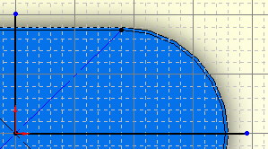

Figure 2 Locate the base center and insert two split lines

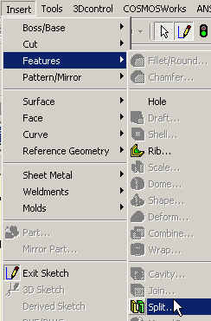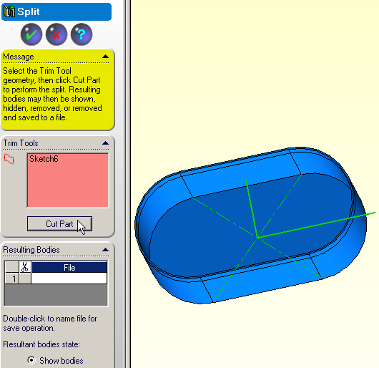

Figure 3 Select the part splitting trim tools

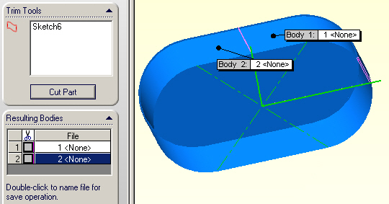

Figure 4 Original part split into two bodies

Name and save the split part(s)

You need to be able to keep one or both split parts and to save either one with a new part name. To save the new smaller body:
- Double click in the Resulting Bodies section to name and save any split part.
- When the Save window opens type in the desired name→Save. Here the name Tank_1_4 was selected, as illustrated in Figure 5, and that body is shown in Figure 6.

Changing colors of split material

Since you have cut away material on two “L” shaped surfaces you must later apply restraints to act like the removed material. You can change the appearance of such surfaces to indicate their special nature in later applications. Using this model would require less than one-fourth of the previous storage, and about 1/64 the number of calculations necessary to solve for the displacements (in a direct solver), and ¼ the calculations necessary to recover the strains, stresses, and failure criterion. Sooner or later you will need to use this type of operation since one never seems to have a computer big enough to build all the analysis models one might need.

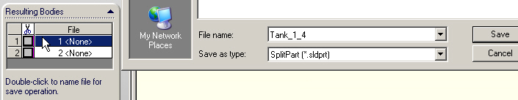

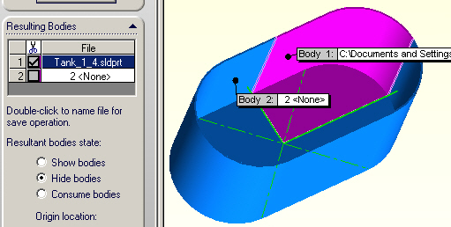

Figure 5 Naming and saving the new quarter symmetry part

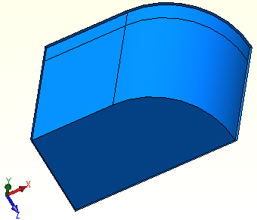

Figure 6 The resulting new split part

To change the colors of the surfaces formed in the split operation:
- Click on the new front “L-shaped” surface →Appearance→Color.
- In the Color and Optics panel pick the color desired (red here), OK (as illustrated in Figure 7).
- Repeat for the new left surface and change it to green, OK (Figure 8).

The final part with its highlighted surfaces that will require the later application of symmetry restraints are seen in Figure 9.

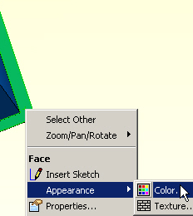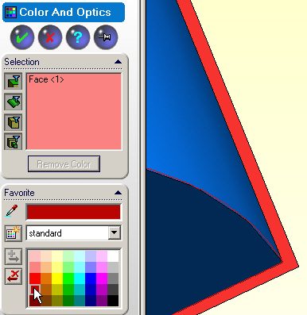

Figure 7 Color highlighting the new front symmetry plane.

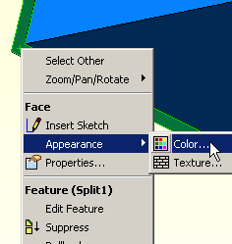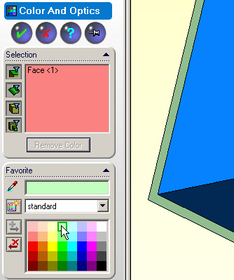

Figure 8 Color highlighting the new left symmetry plane

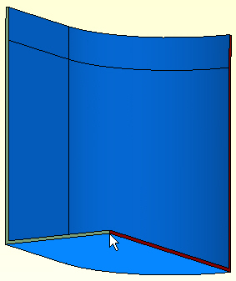

Figure 9 The final part with highlighted symmetry planes

