Using Equations in SolidWorks, Example 2
(Draft 3, 5/15/2006, SolidWorks 2006)

Introduction
The goal here is to construct a linkage rocker with two arms offset by a specific angle. The arm lengths are related by an equation and so is the angle between the two arms. After those planar design equations are implemented the part will be extruded with different thicknesses. Cutting the center support hole yields a part such as that in Figure 1. The specific shape of the part depends on the global variables supplied to the equations.
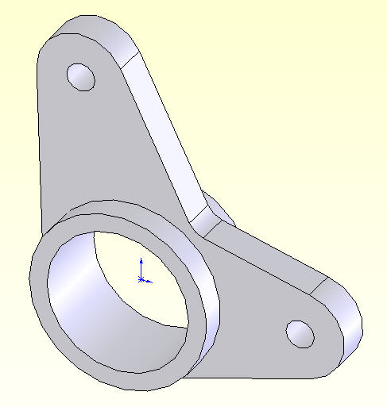
Figure 1 One instance of a parametric part

Initial construction

In this design you will need to see each dimension name so that you have the option to rename them. Here almost every dimension is renamed. That would be overkill for many parts. While individual dimension names can be hidden, it usually best to just rename those dimensions that you expect to appear in you design expressions. Begin a new part and turn on dimension name display:
- New→ Part→OK
- Tools→Options→System Options→Show dimension names→OK
- Annotations→Show Feature Dimensions
- Sketching in the front plane, construct the outer cylinder diameter. Use Smart Dimensions to show the diameter you drew and the default name that SW has assigned to that dimension.
- Double click on that default dimension so that the Modify panel opens, and type in the desired diameter of 100 mm.
- Change the dimension name by right clicking in the graphics area and picking Properties (while the dimension is highlighted) to open the Dimension Properties panel.
- There type the desired name, say Max_D→OK, as seen in Figure 2.

To continue with building the geometry, add a horizontal centerline from the origin to the right, and a second centerline through the origin near 100 degrees CCW from the first. Repeat steps 5-7 above to set the angle to 105 degrees, and to name it Arm_Ang. On the horizontal centerline center a small circle that is about 15 mm in diameter. Use Smart Dimensions to display the default name and constructed size. Place a dimension between the two center points. That dimension will govern the length of the first arm, so rename it to Arm_1. These changes are illustrated in Figure 3.
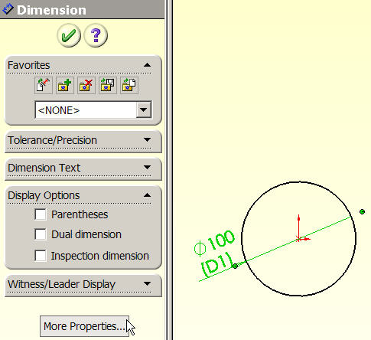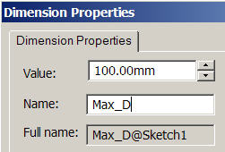

Figure 2 Specify the outer cylinder diameter size and name

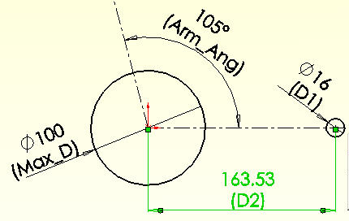

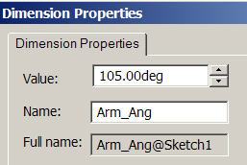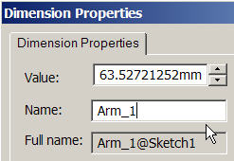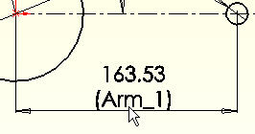

Figure 3 Renaming dimensions related to arms.

The dimension Arm_1 will now be defined in an equation by making it a function of a global design parameter. There are two ways to start up design equations. Here you begin with the existing Arm_1 dimension, in Figure 3 lower right and top of Figure 4:
- Double click on the dimension (Arm_1). Rather than change the value (163.5), click on the down arrow for two available options, Link Value or Add Equation. For versions earlier than SW 2006, use Tools→Equations to open the equation panel.
- Select the Add Equation option. Since there are currently no equations defined SW jumps to the Add Equation panel of the Equations panel. The default name (in quotes) of the selected dimension automatically appears to start the equation.
- Use the lower calculator panel to add the desired initial length, say = 150 mm, OK (see middle of Figure 4).
- The result appears as the first equation in the Equations panel. In (bottom) the green checkmark indicates that SW could solve the equation. A red exclamation mark would mean that an equation has failed to solve.

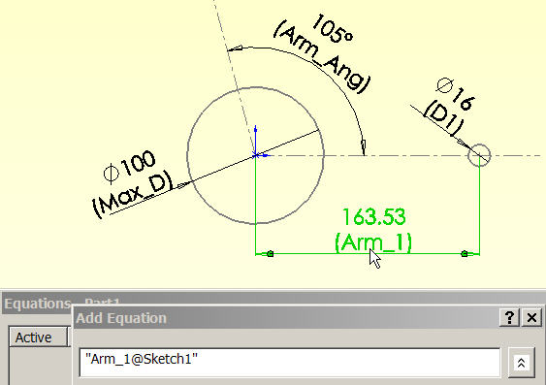

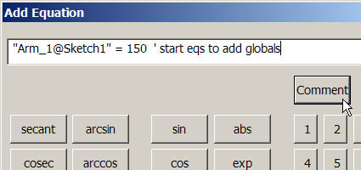

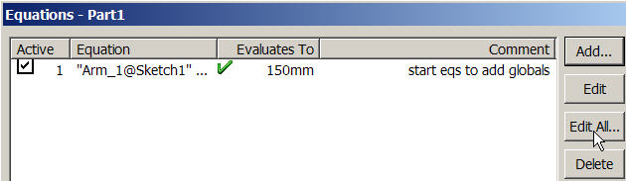

Figure 4 Beginning the design equations process.

One way to insert specific global design variables into the front of equation list is to:
- Select the Edit All tab in the Equations panel ().
- That opens the Edit Equations panel and displays all the equations (one here).
- Place the cursor at the very front of the first equation. Type in the name, say “Length”, value, = 150, and a description of the first global design constant and enter return (Figure 5, top).
- Picking OK places the Equations icon in the Feature Manager.

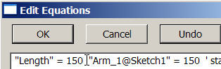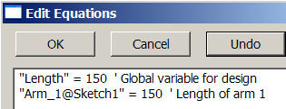

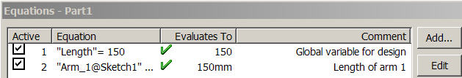

Figure 5 Inserting a global design variable in front of an equation

To use the global variable “Length” in the second equations use:
- Feature Manager → Equations →Edit Equation (Figure 6 top left)
- Select the second equation, replace 150 with “Length”, OK
- The revised expression appears in the Equations panel (Figure 6).
- Rebuild, verify that the equation symbol, , appears before the dimension value (Figure 7).

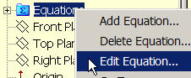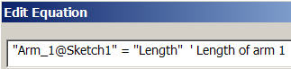

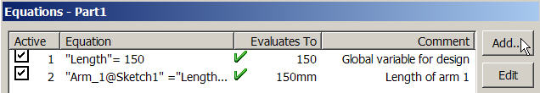

Figure 6 Linking the second equation to a design parameter

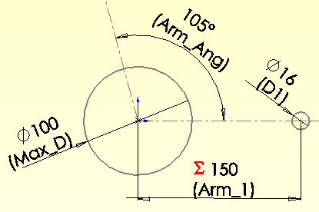

Figure 7 Dimension Arm_1 is governed by an equation

The angle between the two arms (currently under construction) is to also depend on the distance between the hole centers on the horizontal arm (Arm_1). Add this as the third equation:
- Feature Manager→Equations→Add Equation to open the Add Equation panel.
- In Add Equation, initialize the equation by clicking on the Arm_Ang dimension.
- Then the name “Arm_Ang@Sketch1” appears in the Add Equation panel, Figure 8.

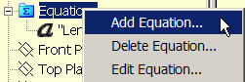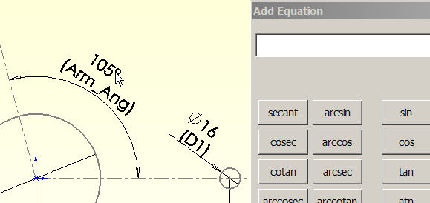

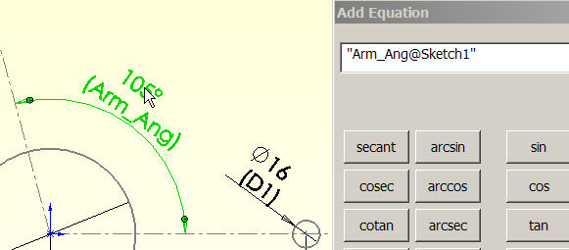

Figure 8 Clicking a dimension brings its name into an equation

For this equation you wish to use VBA logic to set the angle to be either 90 degrees for Length less than 110 mm, or 104 degrees when Length is greater than or equal to 110 mm. The one ‘line if-then-else’ of the VBA immediate if statement, iif (note the two i’s in the name), does that. Its syntax is

iif ( logical_expression, result_if_true, result_if_false).

The actual expression is seen in Figure 9, along with a user comment. Hitting OK places the third equation in the Equations panel. However, this new equation does not take effect until the part is rebuilt. Then the angle assumes the desired value, and the equation symbol appears in front of the dimension value to indicate that it depends on an expression. Those two changes are displayed in Figure 10. (See the appendix for other VBA equation examples.)

The remainder of the final geometry construction (found in Figure 11) begins by locating another drill hole on the second centerline at Arm_Ang. The design intent calls for this hole to move with the second centerline and to be the same size as the first drill hole:

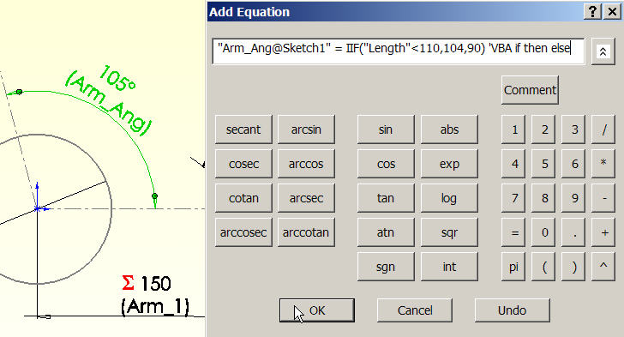

Figure 9 A new equation tied to parametric constant “Length”

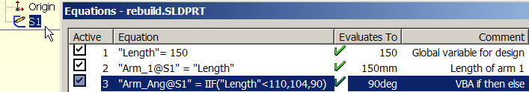

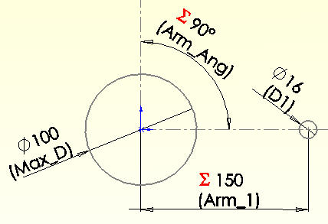

Figure 10 Equation 3 activated via a Rebuild

- Check that the center of the hole is coincident with the centerline. If not, enforce that relation with Relations→Upper_circle_center→Upper_centerline→coincident→OK.
- Change the name of the drill hole dimension (D1, Figure 10) to Drill_D.
- For the second drill hole, click on its dimension, and select the Link Value option at the down arrow in the numerical value box. Double click on the first Drill_D to link their name and value. Note that a red chain symbol appears at both dimensions to show that they are linked.
- Use Smart Dimensions to place a radial dimension from the origin to the center of the second drill hole, and name it Arm_2.
- Use Add Equation to set Arm_2 = 1.25 * Length. Verify that the equation symbol appears before its numerical value.
- Cap each arm end with an almost closed arc of radius 25 and name it End_R. When you create the second one use the Link Value pull down to tie them together.
- From each arm end arc draw two lines tangent to both the arc and the Max_D circle. If needed, use Relations to enforce the tangency. Trim off the extra parts of the End_R arc ends.
- Where the two tangent lines cross, add a fillet, name its dimension Fillet, and use Add Equation to set its value to half the radius End_R. See Figure 11 for the starting sketch.

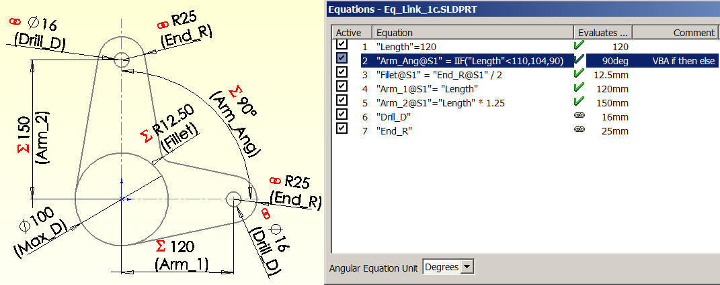

Figure 11 Original configuration of the sketch

To see the effect of the global variable Length:
- Right click on Equations in the Feature Manager and select Edit Equation.
- Change the Length value from 120 to 95. Rebuild. The new sketch appears in Figure 12.

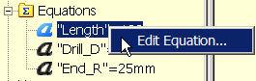

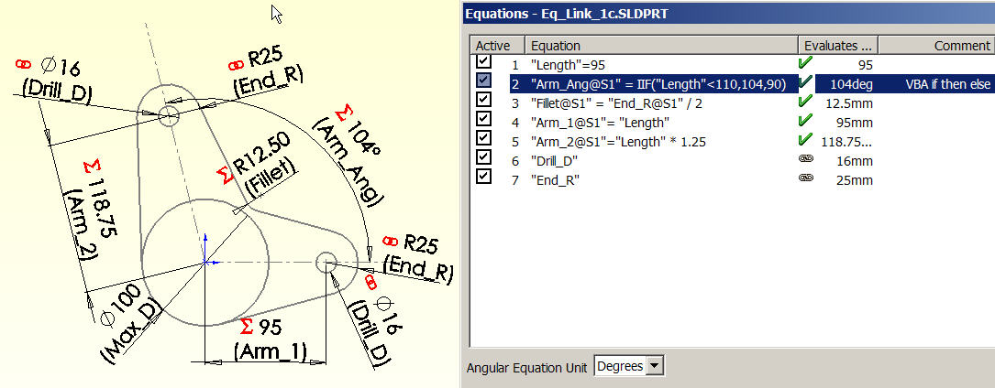

Figure 12 Second sketch configuration

Continuing on to form the solid part from this sketch:
- Features→Boss→Mid-plane→Select contours.
- Pick the region inside Max_D and assign an extrusion length of 50.
- Boss→Mid-plane→Select contours.
- Pick the regions outside Max_D and assign an extrusion length of 20. (Figure 13)
- Cut a hole of 90, centered on the origin, and the parts are finished (see Figure 14).

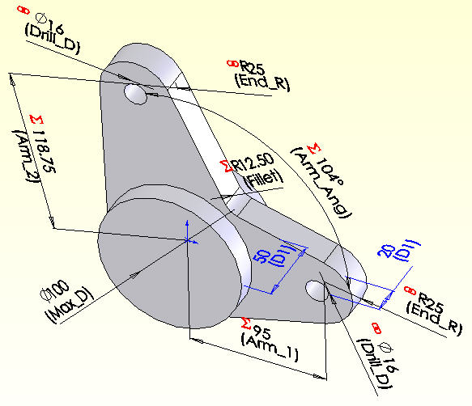
Figure 13 Extruded parametric sketch

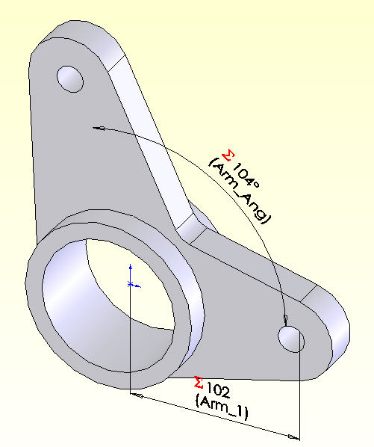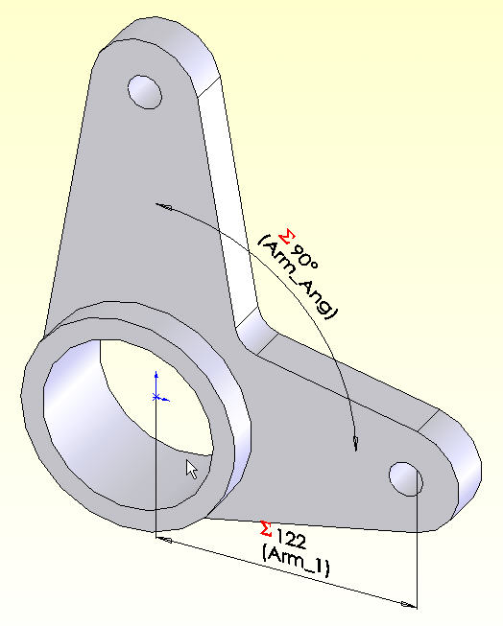

Figure 14 Two finished parametric solids

Closure

This relatively simple set of parts should illustrate the potential power of parametric designs.
Review the appendix to see other examples of logic operations that can be utilized in the SolidWorks equations.

References

TriAxial Design and Analysis, ”Adding Logic to Equations: How VBA can be utilized to do amazing things”, SW Tips & Tricks, v. 4-07, July 2004.

TriAxial Design and Analysis, ”Links, Equations, and Design Tables”, SW Tips & Tricks, v. 2-02, April 2000.

- W.E. Howard, J.C. Musto, “Use of Parametric Modeling Techniques”, in Introduction to Solid Modeling Using SolidWorks, McGraw Hill, 2006.

- M. Spens, Automating SolidWorks 2004 using Macros, SDC Publications, 2004.

- SDRC, Exploring IDEAS Design, v. II, Structural Dynamics Research Corp., 1996.

Appendix: Example of valid VBA equations



