Plane Frame FEA Solution via Matlab
(Draft 1, 4/16/06)

Introduction

The test problem is an aluminum planar frame with two members, fixed at the two end points. At the center node (1) there is a vertical force of 32 Kip (1e3 lb) and a z-moment of -1050 in-K. Using the dimensions and properties given by Weaver [1] find the deflections and reactions.

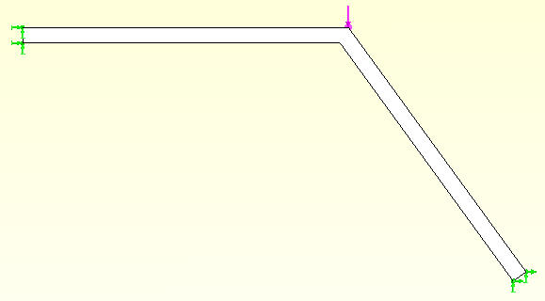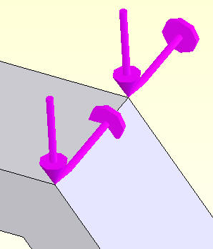

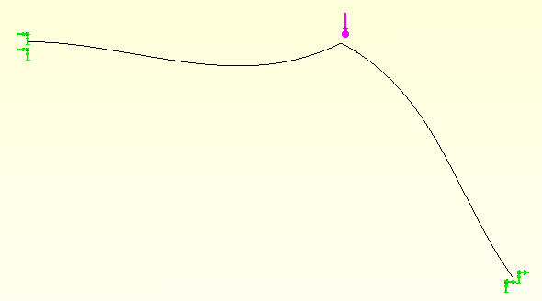

Matlab validation test

A frame element is the combination of an axial bar with two nodes and a beam with the same two nodes. Therefore it has three degrees of freedom (DOF) at each node. Locally the DOF are the axial displacement, transverse displacement, and the (differential) rotation vector (slope) perpendicular to the above displacements. In the global coordinates the DOF are the x-, and y-displacements, and the z-rotation. The corresponding reactions at supports are the x-, y-force and z-moment when the associated DOF is restrained. The element is formulated locally and its matrices are rotated to the global coordinates. Once the global displacements are obtained they could be rotated to the local axes (not shown) and used to find the local axial load, etc. (no shown). Using the modular source given in the appendix this test run gives the exact results as follows:

>> Modular_2D_Frame(1) % 1 = logical flag for point sources
Read 3 nodes.
Node, BC_Flag, Coordinates
1 0 100 75 0
2 111 0 75 0
3 111 200 0 0

Read 2 elements.
Elem, Type, Connectivity_List
1 1 2 1
2 1 1 3
Maximum element type number = 1

Read 6 essential boundary condition sets.
Node DOF Value_EBC
2 1 0
2 2 0
2 3 0
3 1 0
3 2 0
3 3 0

Read 2 point sources.
Node DOF Source_value
1 2 -32
1 3 -1050

Application properties are:
Elastity modulus = 10000
Cross-sectional area = 10
Moment of inertia = 1000
Line Load = [ 0 0 ]

Node, DOF, Resultant input sources
1 2 -32
1 3 -1050
3 DOF Totals = 0 -32 -1050

Computed nodal displacements at 3 nodes
Node DOF_1 DOF_2 DOF_3 DOF_4 DOF_5 DOF_6
1 -0.0202608 -0.09936 -0.00179756
2 0 0 0
3 0 0 0

Recovered 6 Reactions
Node, DOF, Value of reaction
2 1 20.2608
2 2 1.13783
2 3 236.648
3 1 -20.2608
3 2 30.8622
3 3 -639.525
3 DOF Totals = -0.0000 32.0000 -402.8773

>> addpath /net/course-a/mech517/public_html/Matlab_Plots
>> mesh_shrink_plot

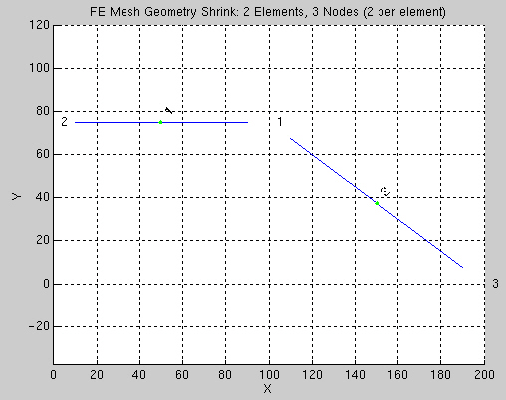

>> bc_flags_plot

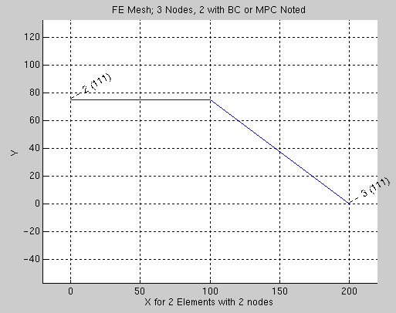

>> frame_defl_plot
Suggested scale = 100.644
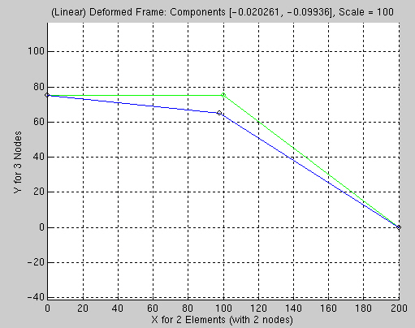

>> quiver_reaction_vec_mesh(0.25) % forces only
Using a scale of 0.25 and vector increment of 1
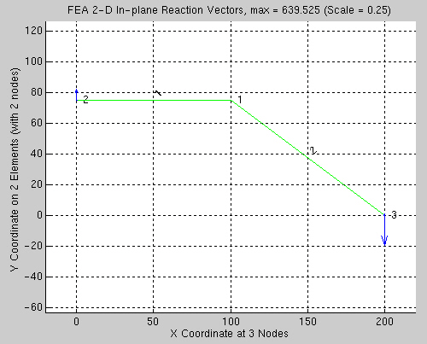

Planar frame source listing

function Modular_2D_Frame (load_pt)
%.............................................................
% Classic cubic beam for point loads & couples, line load
% XY COORDINATES CLOSED FORM INTEGRALS
%.............................................................
% pre_e = # of dummy items before el_type & connectivity
% pre_p = # of dummy items before BC_flag % coordinates
pre_e = 0 ; pre_p = 0 ; % default, consistent with plots
if ( nargin == 0 ) ; % check for optional data
load_pt = 0 ; % no point source data
end % if from argument count

% Application and element dependent controls
n_g = 3 ; % number of DOF per node (axial_d, transverse_d, rot)
n_q = 0 ; % number of quadrature points required
n_r = 1 ; % number of rows in B_e matrix

% Read mesh input data files
[n_m, n_s, P, x, y, z] = get_mesh_nodes (pre_p) ;
[n_e, n_n, n_t, el_type, nodes] = get_mesh_elements (pre_e) ;
n_d = n_g*n_m ; % system degrees of freedom (DOF)
n_i = n_g*n_n ; % number of DOF per element
S = zeros (n_d, n_d) ; C = zeros (n_d, 1) ; % initalize sums
M = zeros (n_d, n_d) ; ; % initalize sums

% Extract EBC flags from packed integer flag P
[EBC_flag] = get_ebc_flags (n_g, n_m, P) ; % unpack flags
EBC_count = sum( sum ( EBC_flag > 0 ) ) ; % # of EBC

% Read EBC values, if any
if ( EBC_count > 0 ) ; % need EBC data
[EBC_value] = get_ebc_values (n_g, n_m, EBC_flag) ; % read data
end % if any EBC data expected

% Read point loads or moments, if any, and insert in C
if ( load_pt > 0 ) ; % need point loads data
[C] = get_and_add_point_sources (n_g, n_m, C); % add point loads
end % if any point source expected

% ============== ASSUMING HOMOGENOUS PROPERTIES =================

% GENERATE ELEMENT MATRICES AND ASSYMBLE INTO SYSTEM
% Assemble n_d by n_d square matrix terms from n_e by n_e

for j = 1:n_e ; % loop over elements ====>> ====>>
S_e = zeros (n_i, n_i) ; M_e = zeros (n_i, n_i) ; % sys arrays
C_p = zeros (n_i, 1) ; C_e = zeros (n_i, 1) ; % sys arrays
s_L = zeros (n_i, n_i) ; m_L = zeros (n_i, n_i) ; % loc arrays
t_L = zeros (n_i, n_i) ; c_L = zeros (n_i, 1) ; % loc arrays
e_nodes = nodes (j, 1:n_n) ; % connectivity

% SET ELEMENT PROPERTIES & GEOMETRY
Option = 1 ; % select analysis case
[A, E, I, Line_e, Rho] = set_2D_frame_properties (n_n, Option) ;
%--> find member length and direction cosines
dx = x(e_nodes(2)) - x(e_nodes(1)) ; % x length
dy = y(e_nodes(2)) - y(e_nodes(1)) ; % y length
L_e = sqrt (dx * dx + dy * dy) ; % total length
cx = dx / L_e ; cy = dy / L_e ; % direction cosines
IbL = I / L_e ; IbL2 = I / L_e^2 ; % bending constants

% ELEMENT CONDUCTION AND INTERNAL SOURCE MATRICES
% for q = 1:n_q ; % Loop over quadrature points ----> ---->

% Linear axial bar and cubic bending. DOF = u, v, r, u, v, r
% Form arrays in local axes, transform. 1 2 3 4 5 6

% stiffness
axial = [ 1, 0, 0, -1, 0, 0 ;
0, 0, 0, 0, 0, 0 ;
0, 0, 0, 0, 0, 0 ;
-1, 0, 0, 1, 0, 0 ;
0, 0, 0, 0, 0, 0 ;
0, 0, 0, 0, 0, 0 ] * E * A / L_e ;
bend = [ 0, 0, 0, 0, 0, 0 ;
0, 12*IbL2, 6*IbL, 0, -12*IbL2, 6*IbL ;
0, 6*IbL, 4*I, 0, -6*IbL, 2*I ;
0, 0, 0, 0, 0, 0 ;
0, -12*IbL2, -6*IbL, 0, 12*IbL2, -6*IbL ;
0, 6*IbL, 2*I, 0, -6*IbL, 4*I ] * E / L_e ;
s_L = axial + bend ;

% Map line load to node forces & moments; c_L = p_2_F * Line_e
if ( any (Line_e) ) ; % then form forcing vector
p_to_F = [ 0, 0 ; % pressure to forces and moments
21, 9 ;
3*L_e, 2*L_e ;
0, 0 ;
9, 21 ;
-2*L_e -3*L_e ] * L_e / 60

c_L = p_to_F (1:n_i, 1:n_n) * Line_e ; % force moment @ nodes
end % if for set up line load nodal resultants

% Optional local mass matrix
if ( Rho > 0 )
m_L = [140, 0, 0, 70, 0, 0 ;
0, 156, 22*L_e, 0, 54, -13*L_e ;
0, 22*L_e, 4*L_e^2, 0, 13*L_e, -3*L_e^2 ;
70, 0, 0, 140, 0, 0 ;
0, 54, 13*L_e, 0, 156, -22*L_e ;
0, -13*L_e, -3*L_e^2, 0, -22*L_e, 4*L_e^2 ]*Rho*A*L_e
disp(m_L)
end % if mass requested
% end % for loop over n_q element quadrature points <---- <----

% Define local to system DOF transformation matrix
t_L = [ cx cy 0 0 0 0 ; % (inverse t_L = transpose t_L)
-cy cx 0 0 0 0 ;
0 0 1 0 0 0 ;
0 0 0 cx cy 0 ; % joint 2
0 0 0 -cy cx 0 ;
0 0 0 0 0 1 ] ;

% Transform from local to system
S_e = t_L' * s_L * t_L ; M_e = t_L' * m_L * t_L ;
C_e = t_L' * c_L ;

% SCATTER TO (ASSEMBLE INTO) SYSTEM ARRAYS
% Insert completed element matrices into system matrices
[rows] = get_element_index (n_g, n_n, e_nodes); % eq numbers
S (rows, rows) = S (rows, rows) + S_e ; % add to system sq
C (rows) = C (rows) + C_e ; % add to sys column
end % for each j element in mesh <<====

% ALLOCATE STORAGE FOR OPTIONAL REACTION RECOVERY
if ( EBC_count > 0 ) ; % reactions occur
[EBC_row, EBC_col] = save_reaction_matrices (EBC_flag, S, C);
end % if essential BC exist (almost always true)

% ECHO PROPERTIES
fprintf ('Application properties are: \n')
fprintf ('Elastity modulus = %g \n', E)
fprintf ('Cross-sectional area = %g \n', A)
fprintf ('Moment of inertia = %g \n', I)
fprintf ('Line Load = [ %g %g ] \n', Line_e(1), Line_e(2))

% ENFORCE ESSENTIAL BOUNDARY CONDITIONS
save_resultant_load_vectors (n_g, C)
[S, C] = enforce_essential_BC (EBC_flag, EBC_value, S, C);

% COMPUTE SOLUTION & SAVE
T = S \ C ; % Compute displacements & rotations
%B list_save_2D_frame_displacements (n_g, n_m, T) ; % save and print
list_save_displacements_results (n_g, n_m, T)

% OPTIONAL REACTION RECOVERY & SAVE
if ( EBC_count > 0 ) ; % reactions exist ?
[EBC_react] = recover_reactions_print_save (n_g, n_d, ...
EBC_flag, EBC_row, EBC_col, T); % reaction to EBC
end % if EBC exist

% POST-PROCESS ELEMENT REACTIONS (MEMBER FORCES)
% output_2D_frame_el_reactions (n_e, n_g, n_n, n_q, nodes, x, y, T)

% End finite element calculations.
% See /home/mech517/public_html/Matlab_Plots for graphic options
% http://www.owlnet.rice.edu/~mech517/help_plot.html for help
% end of Modular_2D_Frame

% +++++++++++++ functions in alphabetical order +++++++++++++++++

function [S, C] = enforce_essential_BC (EBC_flag, EBC_value, S, C)
% modify system linear eqs for essential boundary conditions
% (by trick to avoid matrix partitions, loses reaction data)
n_d = size (C, 1) ; % number of DOF eqs
if ( size (EBC_flag, 2) > 1 ) ; % change to vector copy
flag_EBC = reshape ( EBC_flag', 1, n_d) ;
value_EBC = reshape ( EBC_value', 1, n_d) ;
else
flag_EBC = EBC_flag ;
value_EBC = EBC_value ;
end % if
for j = 1:n_d % check all DOF for essential BC
if ( flag_EBC (j) ) % then EBC here
% Carry known columns*EBC to RHS. Zero that column and row.
% Insert EBC identity, 1*EBC_dof = EBC_value.
EBC = value_EBC (j) ; % recover EBC value
C (:) = C (:) - EBC * S (:, j) ; % carry known column to RHS
S (:, j) = 0 ; S (j, :) = 0 ; % clear, restore symmetry
S (j, j) = 1 ; C (j) = EBC ; % insert identity into row
end % if EBC for this DOF
end % for over all j-th DOF
% end enforce_essential_BC (EBC_flag, EBC_value, S, C)

function [a, b, c, center, two_A] = form_T3_geom_constants (x, y, e_nodes)
% Planar 3 node triangle geometry: H_i (x,y) = (a_i + b_i*x + c_i*y)/two_a
% define nodal coordinates, ccw: i, j, k
x_e = x(e_nodes) ; y_e = y(e_nodes) ; % coord at el nodes
x_i = x_e(1) ; x_j = x_e(2) ; x_k = x_e(3) ; % change notation
y_i = y_e(1) ; y_j = y_e(2) ; y_k = y_e(3) ; % change notation

% define centroid coordinates (quadrature point)
center (1) = (x_i + x_j + x_k)/3 ;
center (2) = (y_i + y_j + y_k)/3 ;

% geometric parameters: H_i (x,y) = (a_i + b_i*x + c_i*y)/two_a
a_i = x_j * y_k - x_k * y_j ; b_i = y_j - y_k ; c_i = x_k - x_j ;
a_j = x_k * y_i - x_i * y_k ; b_j = y_k - y_i ; c_j = x_i - x_k ;
a_k = x_i * y_j - x_j * y_i ; b_k = y_i - y_j ; c_k = x_j - x_i ;

a (1:3) = [a_i, a_j, a_k] ;
b (1:3) = [b_i, b_j, b_k] ;
c (1:3) = [c_i, c_j, c_k] ;

% calculate twice element area
two_A = a_i + a_j + a_k ; % = b_j*c_k - b_k*c_j also
% end form_T3_geom_constants (x, y, e_nodes)

function [C] = get_and_add_point_sources (n_g, n_m, C)
load msh_load_pt.tmp ; % node, DOF, value (eq. number)
n_u = size(msh_load_pt, 1) ; % number of point sources
if ( n_u < 1 ) ; % missing data
error ('No load_pt data in msh_load_pt.tmp')
end % if user error
fprintf ('Read %g point sources. \n', n_u)
fprintf ('Node DOF Source_value \n')
for j = 1:n_u ; % non-zero Neumann pts
node = msh_load_pt (j, 1) ; % global node number
DOF = msh_load_pt (j, 2) ; % local DOF number
value = msh_load_pt (j, 3) ; % point source value
fprintf ('%g %g %g \n', node, DOF, value)
Eq = n_g * (node - 1) + DOF ; % row in system matrix
C (Eq) = C (Eq) + value ; % add to system column matrix
end % for each EBC
fprintf ('\n')
% end get_and_add_point_sources (n_g, n_m, C)

function [EBC_flag] = get_ebc_flags (n_g, n_m, P)
EBC_flag = zeros(n_m, n_g) ; % initialize
for k = 1:n_m ; % loop over all nodes
if ( P(k) > 0 ) ; % at least one EBC here
[flags] = unpack_pt_flags (n_g, k, P(k)) ; % unpacking
EBC_flag (k, 1:n_g) = flags (1:n_g) ; % populate array
end % if EBC at node k
end % for loop over all nodes
% end get_ebc_flags

function [EBC_value] = get_ebc_values (n_g, n_m, EBC_flag)
EBC_count = sum( sum ( EBC_flag > 0 ) ) ; % # of EBC
EBC_value = zeros(n_m, n_g) ; % initialize to zero
load msh_ebc.tmp ; % node, DOF, value (eq. number)
n_c = size(msh_ebc, 1) ; % number of constraints
fprintf ('Read %g essential boundary condition sets. \n', n_c)
if ( n_c ~= EBC_count ) % then probable user error
fprintf ('WARNING, expected %g EBC sets. \n', EBC_count)
end % if error expected
fprintf ('Node DOF Value_EBC \n')
%B disp(msh_ebc) ; % echo input

for j = 1:n_c ; % loop over ebc inputs
node = round (msh_ebc (j, 1)) ; % node in mesh
DOF = round (msh_ebc (j, 2)) ; % DOF # at node
value = msh_ebc (j, 3) ; % EBC value
% Eq = n_g * (node - 1) + DOF ; % row in system matrix
EBC_value (node, DOF) = value ; % insert value in array
fprintf ('%g %g %g \n', node, DOF, value)
if ( EBC_flag (node, DOF) == 0 ) % check data consistency
fprintf ('WARNING: EBC but no flag at node %g & DOF %g. \n', ...
node, DOF)
% EBC_flag (node, DOF) = 1; % try to recover from data error
end % if common user error
end % for each EBC

EBC_count = sum (sum ( EBC_flag > 0 )) ; % check input data
if ( EBC_count ~= n_c ) ; % probable user error
fprintf ('WARNING: mismatch in bc_flag count & msh_ebc.tmp \n')
end % if user error
fprintf ('\n')
% end get_ebc_values

function [rows] = get_element_index (n_g, n_n, e_nodes)
% calculate system DOF numbers of element, for gather, scatter
rows = zeros (1, n_g*n_n) ; % allow for node = 0
for k = 1:n_n ; % loop over element nodes
global_node = round (e_nodes (k)) ; % corresponding sys node
for i = 1:n_g ; % loop over DOF at node
eq_global = i + n_g * (global_node - 1) ; % sys DOF, if any
eq_element = i + n_g * (k - 1) ; % el DOF number
if ( eq_global > 0 ) ; % check node=0 trick
rows (1, eq_element) = eq_global ; % valid DOF > 0
end % if allow for omitted nodes
end % for DOF i % end local DOF loop
end % for each element node % end local node loop
% end get_element_index

function [n_e, n_n, n_t, el_type, nodes] = get_mesh_elements (pre_e) ;
% MODEL input file controls (for various data generators)
if (nargin == 0) ; % default to no proceeding items in data
pre_e = 0 ; % Dummy items before el_type & connectivity
end % if

load msh_typ_nodes.tmp ; % el_type, connectivity list (3)
n_e = size (msh_typ_nodes,1) ; % number of elements
if ( n_e == 0 ) ; % data file missing
error ('Error missing file msh_typ_nodes.tmp')
end % if error
n_n = size (msh_typ_nodes,2) - pre_e - 1 ; % nodes per element
el_type = round (msh_typ_nodes(:, pre_e+1)); % el type number >= 1
n_t = max(el_type) ; % number of element types
nodes (1:n_e, 1:n_n) = msh_typ_nodes (1:n_e, (pre_e+2:pre_e+1+n_n));
fprintf ('Read %g elements. \n', n_e)
fprintf ('Elem, Type, Connectivity_List \n')
for j = 1:n_e
if ( n_n == 1 )
fprintf ('%g %g %g \n', j, el_type(j), nodes(j,:));
elseif ( n_n == 2 )
fprintf ('%g %g %g %g \n', j, el_type(j), nodes(j,:));
elseif ( n_n == 3 )
fprintf ('%g %g %g %g %g \n', j, el_type(j), nodes(j,:));
elseif ( n_n == 4 )
fprintf ('%g %g %g %g %g %g \n', j, el_type(j), nodes(j,:));
elseif ( n_n == 5 )
fprintf ('%g %g %g %g %g %g %g \n', j, el_type(j), nodes(j,:));
elseif ( n_n == 6 )
fprintf ('%g %g %g %g %g %g %g %g \n', j, el_type(j), nodes(j,:));
else
fprintf ('%g %g \n', j, el_type(j)); dips( nodes(j,:));
end % if
end % for each element
fprintf ('Maximum element type number = %g \n \n', n_t)
% end get_mesh_elements

function [n_m, n_s, P, x, y, z] = get_mesh_nodes (pre_p) ;
% MODEL input file controls (for various data generators)
if (nargin == 0) % set usual default
pre_p = 0 ; % Dummy items before BC_flag % coordinates
end % if

% READ MESH AND EBC_FLAG INPUT DATA
% specific problem data from MODEL data files (sequential)
load msh_bc_xyz.tmp ; % bc_flag, x-, y-, z-coords
n_m = size (msh_bc_xyz,1) ; % number of nodal points in mesh
if ( n_m == 0 ) ; % data missing !
error ('Error missing file msh_bc_xyz.tmp')
end % if error
n_s = size (msh_bc_xyz,2) - pre_p - 1 ; % number of space dimensions
msh_bc_xyz (:, (pre_p+1))= round (msh_bc_xyz (:, (pre_p+1)));
P = msh_bc_xyz (1:n_m, (pre_p+1)) ; % integer Packed BC flag
x = msh_bc_xyz (1:n_m, (pre_p+2)) ; % extract x column
y (1:n_m, 1) = 0.0 ; z (1:n_m, 1) = 0.0 ; % default to zero

if (n_s > 1 ) ; % check 2D or 3D
y = msh_bc_xyz (1:n_m, (pre_p+3)) ; % extract y column
end % if 2D or 3D
if ( n_s == 3 ) ; % check 3D
z = msh_bc_xyz (1:n_m, (pre_p+4)) ; % extract z column
end % if 3D
%b if ( pre_p ~= 1 ) % not given node number, sequential data
fprintf ('Read %g nodes. \n', n_m)
fprintf ('Node, BC_Flag, Coordinates \n')
for j = 1:n_m ; % list nodes
fprintf ('%g %g %g %g %g \n', j, P(j), x(j), y(j), z(j)) ;
end % for j DOF
fprintf ('\n')
% end get_mesh_nodes

function list_save_beam_displacements (n_g, n_m, T)
fprintf ('\n') ;
fprintf('Node Y_displacement Z_rotation at %g nodes \n', n_m)
T_matrix = reshape (T, n_g, n_m)' ; % pretty shape
% save results (displacements) to MODEL file: node_results.tmp
fid = fopen('node_results.tmp', 'w') ; % open for writing
for j = 1:n_m ; % node loop, save displ
fprintf (fid, '%g %g \n', T_matrix (j, 1:n_g)) ; % to file
fprintf ('%g %g %g \n', j, T_matrix (j, 1:n_g)) ; % to screen
end % for j DOF
% end list_save_beam_displacements (n_g, n_m, T)

function list_save_displacements_results (n_g, n_m, T)
fprintf('Computed nodal displacements at %g nodes \n', n_m)
fprintf('Node DOF_1 DOF_2 DOF_3 DOF_4 DOF_5 DOF_6 \n')
T_matrix = reshape (T, n_g, n_m)' ; % pretty shape
%B disp (T_matrix) ; % print displacements
% save results (displacements) to MODEL file: node_results.tmp
fid = fopen('node_results.tmp', 'w') ; % open for writing
for j = 1:n_m ; % save displacements
if ( n_g == 1 )
fprintf (fid, '%g \n', T_matrix (j, 1:n_g)) ;
fprintf ('%g %g \n', j, T_matrix (j, 1:n_g)) ;
elseif ( n_g == 2 )
fprintf (fid, '%g %g \n', T_matrix (j, 1:n_g)) ;
fprintf ('%g %g %g \n', j, T_matrix (j, 1:n_g)) ;
elseif ( n_g == 3 )
fprintf (fid, '%g %g %g \n', T_matrix (j, 1:n_g)) ;
fprintf ('%g %g %g %g \n', j, T_matrix (j, 1:n_g)) ;
elseif ( n_g == 4 )
fprintf (fid, '%g %g %g %g \n', T_matrix (j, 1:n_g)) ;
fprintf ('%g %g %g %g %g \n', j, T_matrix (j, 1:n_g)) ;
elseif ( n_g == 5 )
fprintf (fid, '%g %g %g %g %g \n', T_matrix (j, 1:n_g)) ;
fprintf ('%g %g %g %g %g %g \n', j, T_matrix (j, 1:n_g)) ;
elseif ( n_g == 6 )
fprintf (fid, '%g %g %g %g %g %g \n', T_matrix (j, 1:n_g)) ;
fprintf ('%g %g %g %g %g %g %g \n', j, T_matrix (j, 1:n_g)) ;
else
error ('reformat list_save_displacements_results for n_g > 6.')
end % if
end % for j DOF
fprintf ('\n') ;
% end list_save_displacements_results (T)

function list_save_temperature_results (T)
n_m = size (T, 1) ; % get size
fprintf('Temperature at %g nodes \n', n_m) ; % header

% save results (temperature) to MODEL file: node_results.tmp
fid = fopen('node_results.tmp', 'w') ; % open for writing
for j = 1:n_m ; % save temperature
fprintf ( fid, '%g \n', T (j)) ; % print
fprintf (' %g %g \n', j, T (j)) ; % sequential save
end % for j DOF
% end list_save_temperature_results (T)

function output_PlaneStress_stresses(n_e, n_g, n_n, n_q, nodes, x,y,T)
% POST-PROCESS ELEMENT STRESS RECOVERY & SAVE
fid = fopen('el_qp_xyz_fluxes.tmp', 'w') ; % open for writing
fprintf ('\n') ; % blank line
fprintf('Elem, QP, X_qp, Y_qp \n') ;% header
fprintf('Elem, QP, Stress_qp: xx yy xy \n');% header

for j = 1:n_e ; % loop over elements ====>>
e_nodes = nodes (j, 1:n_n) ; % connectivity
[a, b, c, center, two_A] = form_T3_geom_constants (x, y, e_nodes);
[t_e, Body_e, E_e] = set_constant_plane_stress_prop; % properties

% get DOF numbers for this element, gather solution
[rows] = get_element_index (n_g, n_n, e_nodes) ; % eq numbers
T_e = T (rows) ; % gather element DOF

for q = 1:n_q ; % Loop over element quadrature points ---->

% H_i (x,y) = (a_i + b_i*x + c_i*y)/two_A % interpolations
B_e (1, 1:2:5) = b (1:3)/two_A ; B_e (2, 2:2:6) = c (1:3)/two_A ;
B_e (3, 1:2:5) = c (1:3)/two_A ; B_e (3, 2:2:6) = b (1:3)/two_A ;

% COMPUTE GRADIENT & HEAT FLUX, SAVE LOCATION AND VALUES
Strains = B_e * T_e ; % mechanical strain
Stress = E_e * Strains ; % mechanical stress
fprintf (fid,'%g %g %g %g %g \n', center(1), center(2), ...
Stress(1), Stress(2), Stress(3));% save
fprintf ('%g %g %g %g \n', j, q, center(1:2));% prt
fprintf ('%g %g %g %g %g \n', j, q, Stress(1:3));% prt
fprintf ('\n') ;% prt
end % for loop over n_q element quadrature points <----
end % for each j element in mesh
% end output_PlaneStress_stresses (n_e, n_g, n_n, n_q, nodes, x, y, T)

function output_T3_heat_flux (n_e, n_g, n_n, n_q, nodes, x, y, T)
% POST-PROCESS ELEMENT HEAT FLUX RECOVERY & SAVE
fid = fopen('el_qp_xyz_fluxes.tmp', 'w') ; % open for writing
fprintf ('\n') ; % blank line
fprintf('Elem, X_qp, Y_qp, HeatFlux_x, HeatFlux_y \n');% header

for j = 1:n_e ; % loop over elements ====>>
e_nodes = nodes (j, 1:n_n) ; % connectivity
[a, b, c, center, two_A] = form_T3_geom_constants (x, y, e_nodes);
[t_e, Body_e, E_e] = set_constant_plane_stress_prop; % properties

% get DOF numbers for this element, gather solution
[rows] = get_element_index (n_g, n_n, e_nodes) ; % eq numbers
T_e = T (rows) ; % gather element DOF

for q = 1:n_q ; % Loop over element quadrature points ---->

% H_i (x,y) = (a_i + b_i*x + c_i*y)/two_A % interpolations
B_e (1, 1:3) = b(1:3) / two_A ; % dH/dx
B_e (2, 1:3) = c(1:3) / two_A ; % dH/dy

% COMPUTE GRADIENT & HEAT FLUX, SAVE LOCATION AND VALUES
Gradient = B_e * T_e ; % gradient vector
HeatFlux = E_e * Gradient ; % heat flux vector
fprintf (fid, '%g %g %g %g \n', center(1:2), HeatFlux(1:2));% save
fprintf ('%g %g %g %g %g \n', j, center(1:2), HeatFlux(1:2));% prt
end % for loop over n_q element quadrature points <----
end % for each j element in mesh <<====
% end output_T3_heat_flux (n_e, n_g, n_n, n_q, nodes, x, y, T)

function [EBC_react] = recover_reactions_print_save (n_g, n_d, ...
EBC_flag, EBC_row, EBC_col, T)
% get EBC reaction values by using rows of S & C (before EBC)
n_d = size (T, 1) ; % number of system DOF
% n_c x 1 = n_c x n_d * n_d x 1 + n_c x 1
EBC_react = EBC_row * T - EBC_col ; % matrix reactions (+-)
% save reactions (forces) to MODEL file: node_reaction.tmp
fprintf ('Recovered %g Reactions \n', ...
sum (sum (EBC_flag > 0))) ; % header
fprintf ('Node, DOF, Value of reaction \n')
fid = fopen('node_reaction.tmp', 'w') ; % open for writing
if ( size (EBC_flag, 2) > 1 ) ; % change to vector copy
flag_EBC = reshape ( EBC_flag', 1, n_d) ; % changed
else
flag_EBC = EBC_flag ; % original vector
end % if
Totals = zeros (1, n_g) ; % zero input totals
kount = 0 ; % initialize counter
for j = 1:n_d ; % extract all EBC reactions
if ( flag_EBC(j) ) ; % then EBC here
% Output node_number, component_number, value, equation_number
kount = kount + 1 ; % copy counter
node = ceil(j/n_g) ; % node at DOF j
j_g = j - (node - 1)*n_g ; % 1 <= j_g <= n_g
React = EBC_react (kount, 1) ; % reaction value
fprintf ( fid, '%g %g %g \n', node, j_g, React);% save
fprintf ('%g %g %g \n', node, j_g, React); % print
Totals (j_g) = Totals (j_g) + React ; % sum all components
end % if EBC for this DOF
end % for over all j-th DOF
fprintf ('%g DOF Totals = ', n_g) ; disp(Totals) ; % echo totals
fprintf ('\n') ; % Skip a line
% end recover_reactions_print_save (EBC_row, EBC_col, T)

function [EBC_row, EBC_col] = save_reaction_matrices (EBC_flag, S, C)
n_d = size (C, 1) ; % number of system DOF
EBC_count = sum (sum (EBC_flag)) ; % count EBC & reactions
EBC_row = zeros(EBC_count, n_d) ; % reaction data
EBC_col = zeros(EBC_count, 1) ; % reaction data
if ( size (EBC_flag, 2) > 1 ) ; % change to vector copy
flag_EBC = reshape ( EBC_flag', 1, n_d) ; % changed
else
flag_EBC = EBC_flag ; % original vector
end % if
kount = 0 ; % initialize counter
for j = 1:n_d % System DOF loop, check for displacement BC
if ( flag_EBC (j) ) ; % then EBC here
% Save reaction data to be destroyed by EBC solver trick
kount = kount + 1 ; % copy counter
EBC_row(kount, 1:n_d) = S (j, 1:n_d) ; % copy reaction data
EBC_col(kount, 1) = C (j) ; % copy reaction data
end % if EBC for this DOF
end % for over all j-th DOF % end sys DOF loop
% end save_reaction_matrices (S, C, EBC_flag)

function save_resultant_load_vectors (n_g, C)
% save resultant forces to MODEL file: node_resultants.tmp
n_d = size (C, 1) ; % number of system DOF
fprintf ('\n') ; % Skip a line
% fprintf ('Node, DOF, Resultant Force (1) or Moment (2) \n')
fprintf ('Node, DOF, Resultant input sources \n')
fid = fopen('node_resultant.tmp', 'w'); % open for writing
Totals = zeros (1, n_g) ; % zero input totals
for j = 1:n_d ; % extract resultants
if ( C (j) ~= 0. ) ; % then source here
% Output node_number, component_number, value
node = ceil(j/n_g) ; % node at DOF j
j_g = j - (node - 1)*n_g ; % 1 <= j_g <= n_g
value = C (j) ; % resultant value
fprintf ( fid, '%g %g %g %g \n', node,j_g,value,j);% save
fprintf ('%g %g %g \n', node, j_g, value); % print
Totals (j_g) = Totals (j_g) + value ; % sum all inputs
end % if non-zero for this DOF
end % for over all j-th DOF
fprintf ('%g DOF Totals = ', n_g) ; disp(Totals) ; % echo totals
% end save_resultant_load_vectors (n_g, n_m, C)

function [I, E, Rho, Line_e]=set_constant_beam_prop (n_n, Option);
if ( nargin == 1 )
Option = 1 ;
elseif ( nargin == 0 )
n_n = 2 ; Option = 1 ;
end % if problem Option number
Line_e = zeros (n_n, 1) ; % default line load at nodes
switch Option
case 1 % Propped cantilever with uniform load, L, L/4
% Wall reactions: V=37*Line*L/64 M=7*Line*L^2/64
% Roller reaction: R= 43*Line*L/64
% Total vertical load: 5*Line*L/4
% *-----(1)-----*-----(2)-----*--(3)--* EI
% Fixed@1 L/2 2 Roller@3 L/4 4
I = 1.0 ; E = 1.0 ; Rho = 0.0 ; Line_e = [1.0; 1.0] ;
case 2 % cantilever with uniform load, L
I = 1.0 ; E = 1.0 ; Rho = 0.0 ; Line_e = [1.0; 1.0] ;
otherwise
I = 1.0 ; E = 1.0 ; Rho = 0.0; % default shape & material
end % switch
% end set_constant_beam_prop;

function [t_e, Body_e, E_e] = set_constant_plane_stress_prop ;
t_e = 1 ; Body_e (1:2) = 0. ; % defaults
% case 1
t_e = 5e-3 ; % thickness
Body_e (1:2) = [5e5, 0.] ; % components
E = 15e9 ; % Elastic modulus
nu = 0.25 ; % Poisson's ratio
% plane stress
E_v = E/(1 - nu^2) ; % constant
E_e (1, 1) = E_v ; E_e (1, 2) = E_v * nu ; % non-zero term
E_e (2, 1) = E_v * nu ; E_e (2, 2) = E_v ; % non-zero term
E_e (3, 3) = E_v * (1 - nu) / 2 ; % non-zero term
%end set_constant_plane_stress_prop

function [t_e, Q_e, E_e] = set_constant_2D_conduction_prop
% Manually set constant element properties (Fig 11.9 text)
q_e = 0. ; t_e = 1. ; % defaults
% case 1
Kx = 8. ; Ky = 8. ; Kxy = 0. ; % thermal conductivity
% case 2
kx = 1. ; Ky = 1. ; Kxy = 0. ;
% insert
E_e = zeros (2, 2) ; % constitutive matrix
E_e (1, 1) = Kx ; E_e (1, 2) = Kxy ; % non-zero term
E_e (2, 1) = Kxy ; E_e (2, 2) = Ky ; % non-zero term
% end set_constant_2D_conduction_prop

function [A, E, I, Line_e, Rho] = set_2D_frame_properties (n_n, Option)
if ( nargin == 1 )
Option = 1 ;
elseif ( nargin == 0 )
n_n = 2 ; Option = 1 ;
end % if problem Option number
Line_e = zeros (n_n, 1) ; % default line load at nodes
switch Option
case 1
% Weaver plane frame example X--------\ F_y=-32 K,
% E=10000ksi, A=10 in sq 2 (1) 1 \ M_z=-1050 in-K,
% I=1000 in^4, L_1=100 in (2)\ at node 1.
% L_2x=100 in, L_2y=-75 in \ [no line load]
% Node 1 disp: -0.02026 in, -0.09936 in, X
% and -0.001798 radians 3
% Reactions, node 2: 20.261 K, 1.1378 K, 236.65 in K
% node 3:-20.261 K, 30.862 K, -639.52 in-K
A=10; I=1e3; E=1e4; Rho=0; Line_e = [0.0; 0.0] ;
case 2 % cantilever with uniform load, L
A = 1 ; I = 1 ; E = 1 ; Rho = 0 ; Line_e = [1.0; 1.0] ;
otherwise
A = 1 ; I = 1 ; E = 1 ; Rho = 0; % default shape & material
end % switch
% end set_2D_frame_properties (n_n, Option)

function [flags] = unpack_pt_flags (n_g, N, flag)
% unpack n_g integer flags from the n_g digit flag at node N
% integer flag contains (left to right) f_1 f_2 ... f_n_g
full = flag ; % copy integer
check = 0 ; % validate input
%b size(flag)
%b size(full)
for Left2Right = 1:n_g ; % loop over local DOF at k
Right2Left = n_g + 1 - Left2Right ; % reverse direction
work = floor (full / 10) ; % work item
keep = full - work * 10 ; % work item
flags (Right2Left) = keep ; % insert into array
full = work ; % work item
check = check + keep * 10^(Left2Right - 1) ; % validate
end % for each local DOF
if ( flag > check ) ; % check for likely error
fprintf ('WARNING: bc flag likely reversed at node %g. \n', N)
end % if likely user error
% end unpack_pt_flags

References

